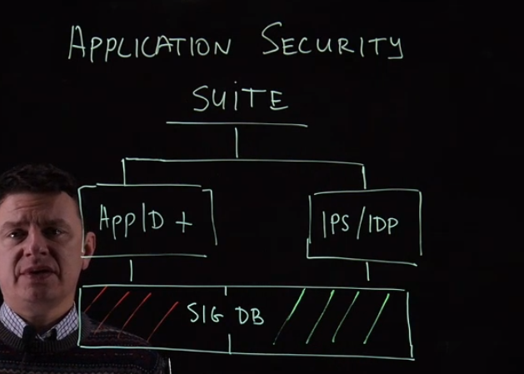

App Security Database consists of two parts, the App IDs or signatures (red) and malware/anomalies (blue) signatures. If you have IDP license and you download its database, it will download both and that is the reason you do not download App ID separately when it comes to IPS signature. However if you only have App Sec license then it will download only the App ID signature database.
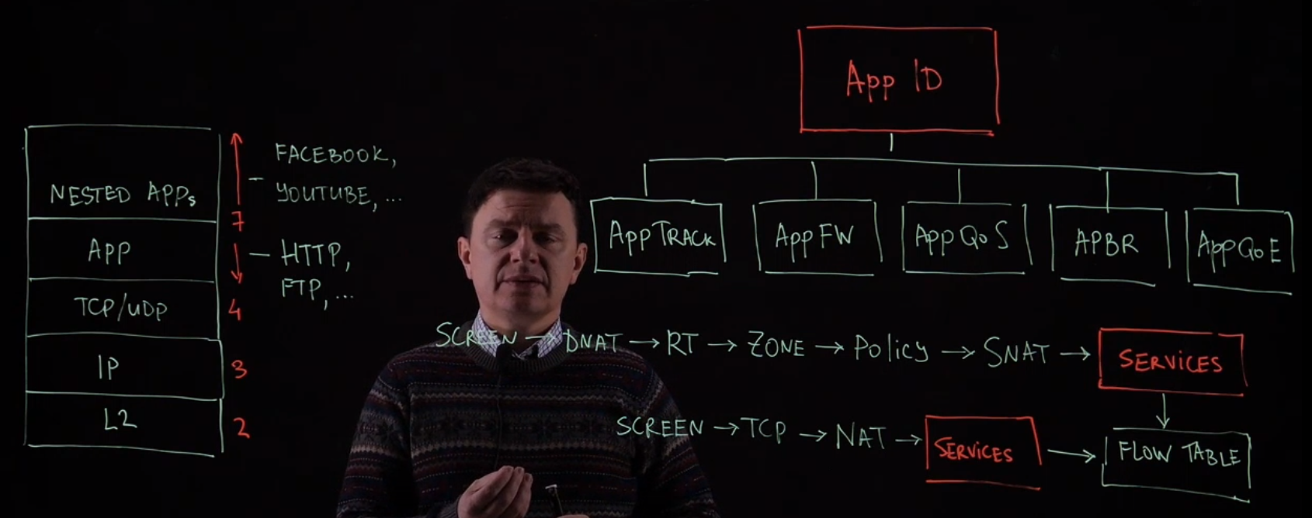

App ID works at the layer 7 of the OSI layers, we need to identify between the Application (layer 7 protocols) and the nested applications (layer 7 applications).
The layer 7 protocols are for example (http, https, ftp, telnet, ssh, tftp, dns, dhcp, etc..)
The layer 7 application are for example (Facebook, YouTube, Dropbox, etc..)
The App ID is processed in the services module (Purple) in the SRX flow processing as shown above.

App Track: identifies the application
App FW: block applications
App QoS: classify application and give them priority
APBR: route the traffic based on application
AppQoE: monitor the links for the APBR

Recommendation to block unwanted traffic using the prior modules in the flow (Screen, Policies) to avoid processing traffic in the services module, which will consume resources.

Download latest App ID signatures via J-Web:

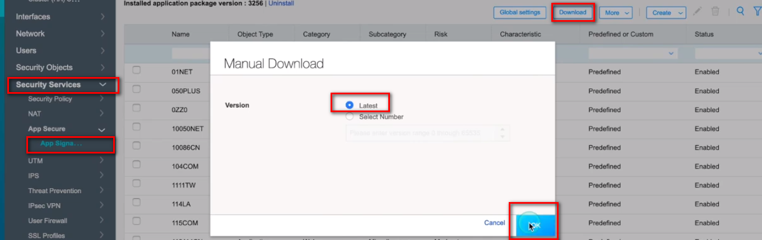

Go to Global settings to control the parameters like cache and automatic updates
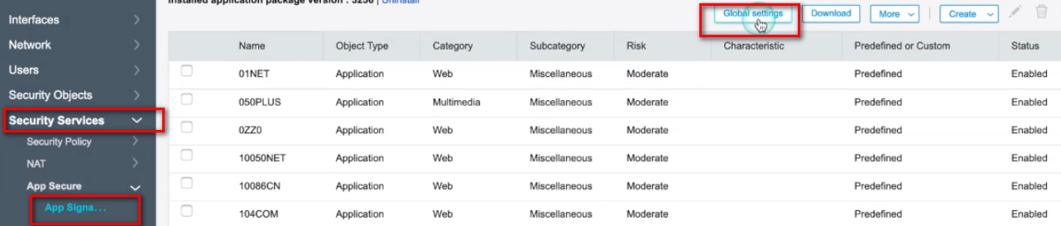

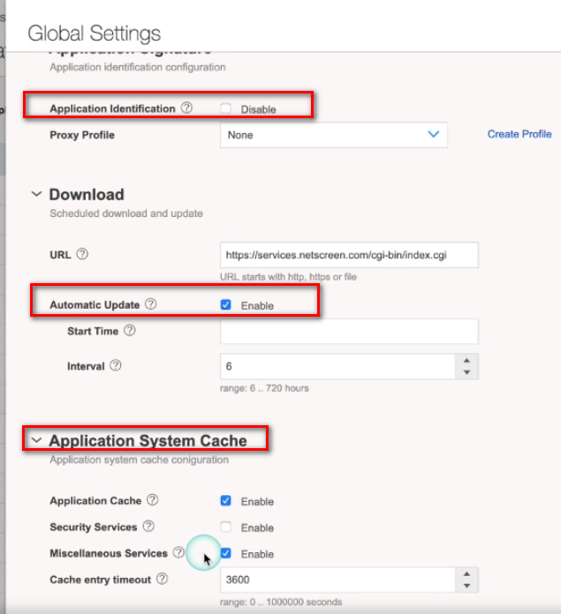

Download signature via CLI:

Check status of download using this command:
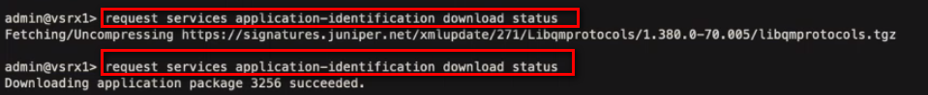

Install the signatures:

Check all the details after installation (Package and engine version…):

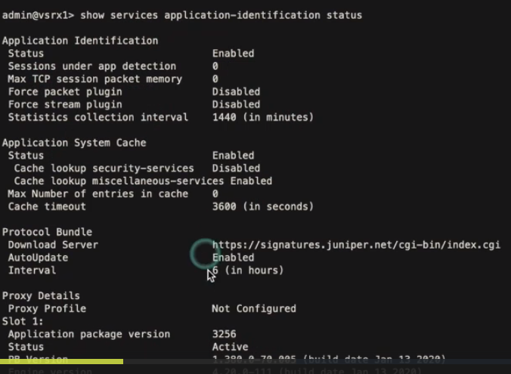

Configure automatic download of signatures via CLI:
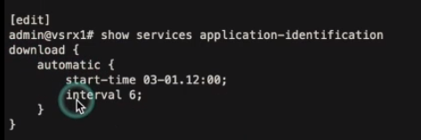

To check the App signatures in the SRX:
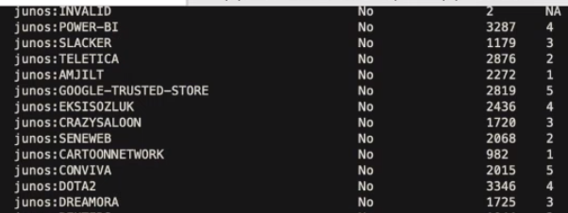

To show details of an application, type:
“Show services application-identification application detail junos:DOTA2”

Create custom App via J-Web:
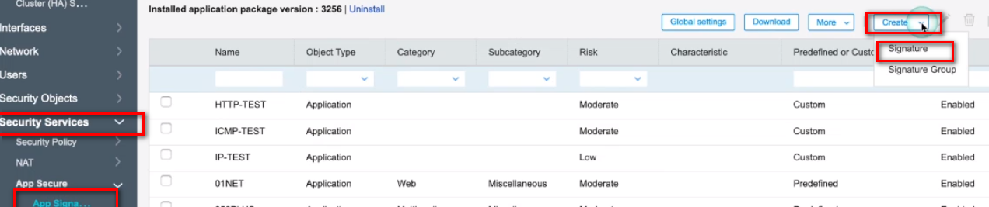
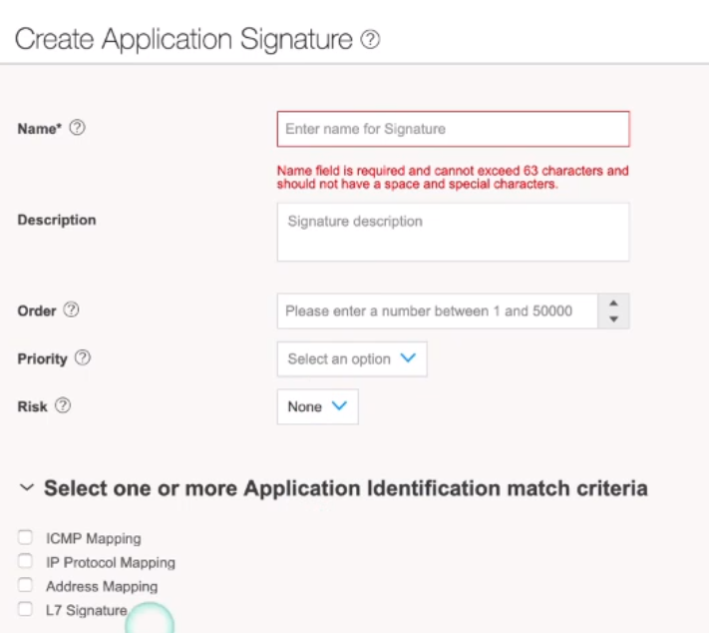

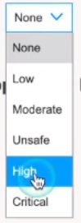

Concerning the order, the lower order number has the highest priority. In case of overlapping between a predefined and customized application in terms of traffic the SRX looks at the lower order to match criteria. To see the order value of a predefined junos application, use the command “show services application-identification application summary” and it will show you.

There are four categories for applications in SRX:

1- ICMP: Differentiate ICMP messages via type and code
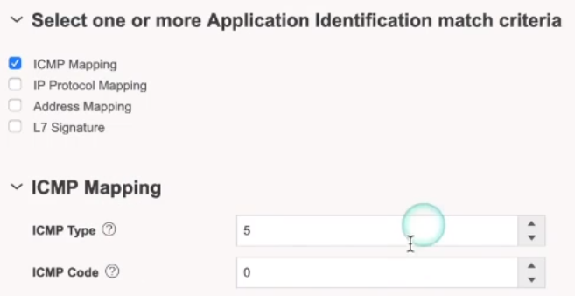

2- IP Protocol Mapping: Map signatures based on any TCP or UDP protocols

3- Address Mapping: select IP address (subnet) with range of ports
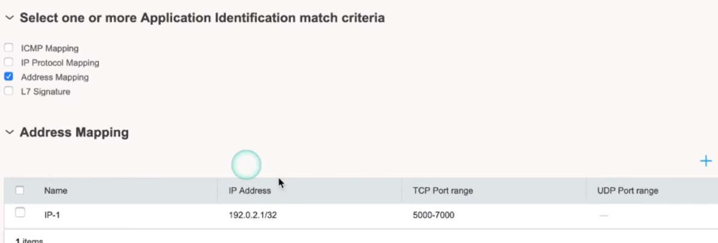

4- L7 Signature: Context, Direction, Pattern

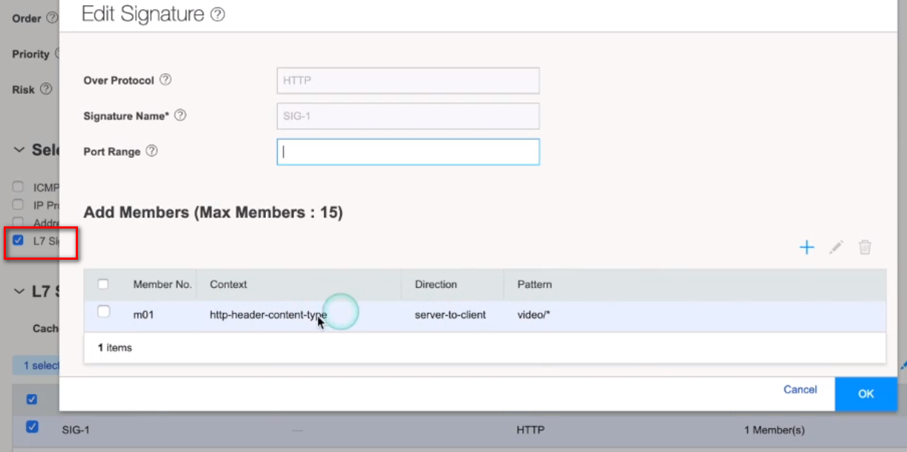

Define the custom applications via CLI:
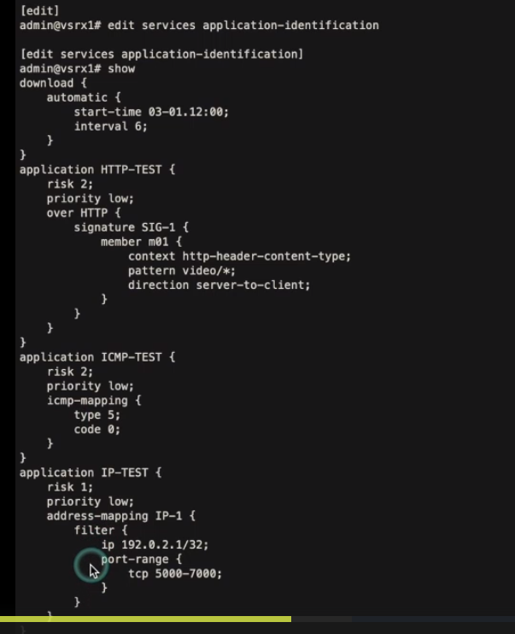

Application Tracking:

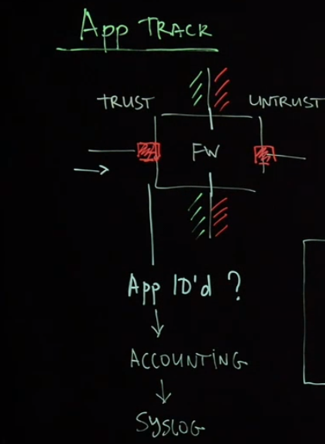
You need to enable App Track per zone to track Apps.
After the application is identified it collects accounting data (Number of packets, duration statistics), and sends it to the syslog server. By default, the App Track sends syslog entries at the closing of the session and you can change it to at the session initialization. App Track also send periodic updated to syslog every 5min and it can be changed.

App Track Global settings via J-Web:
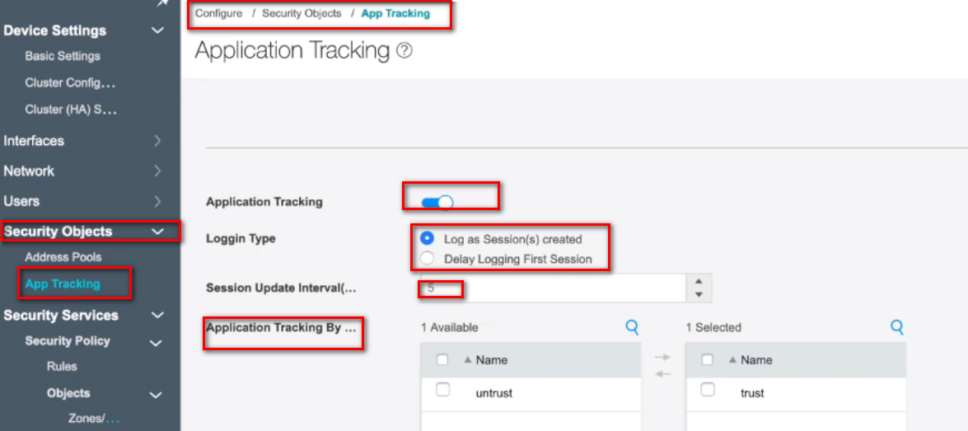

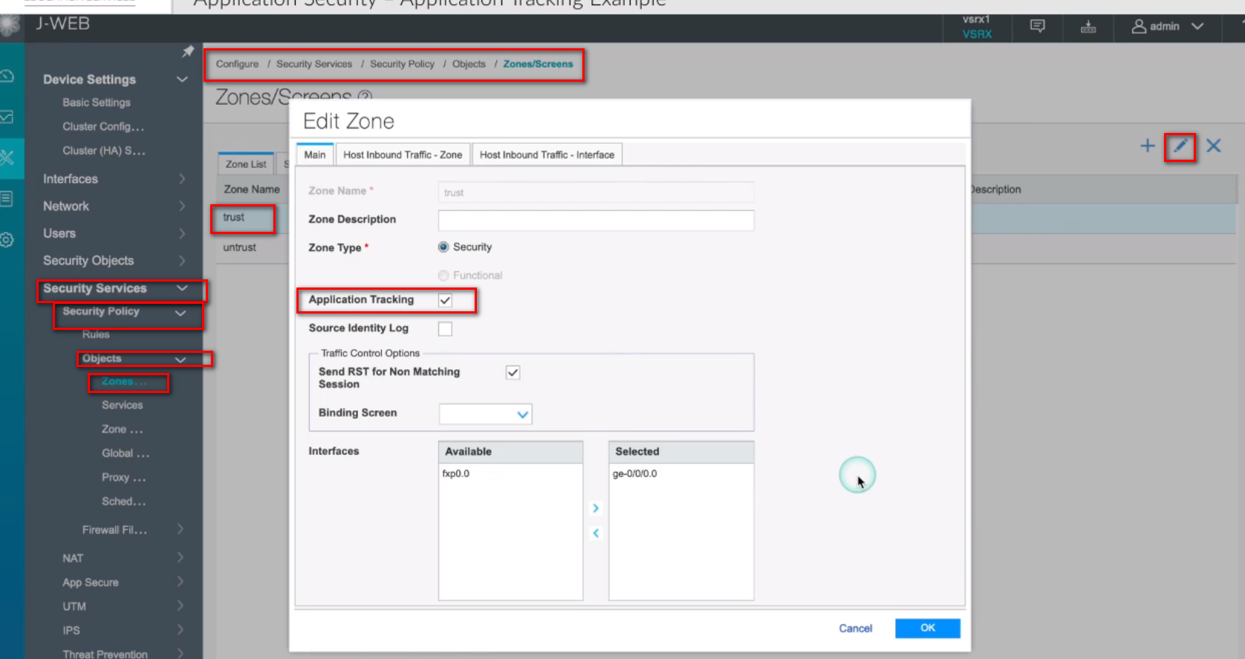
Enable App Track via J-Web:

Enable App Track via CLI:
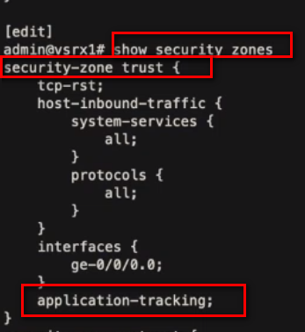

Configure syslog server and send traffic to it:
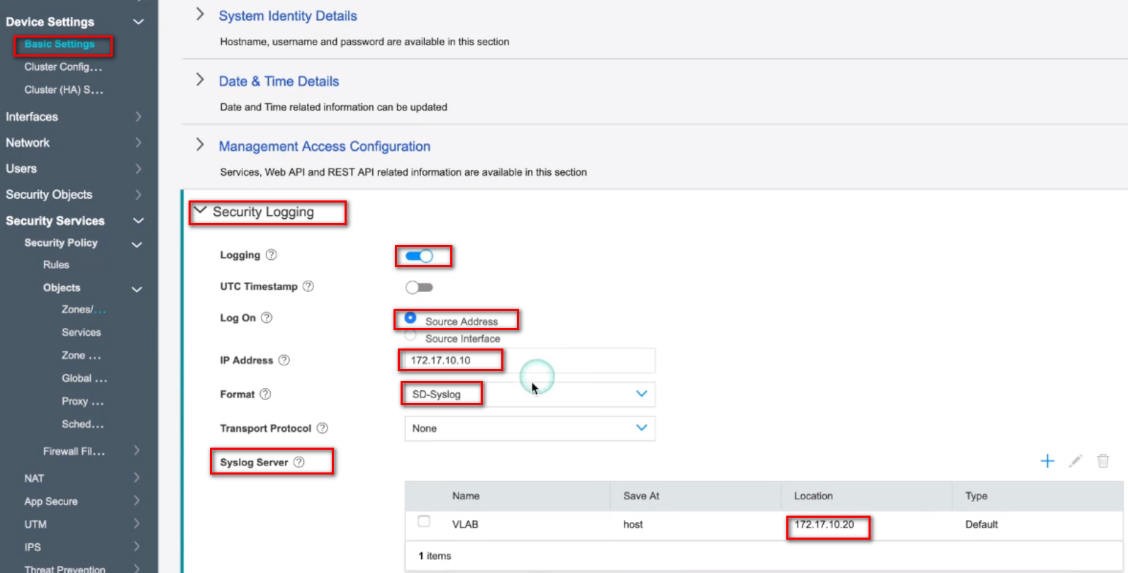

Configure syslog server via CLI:
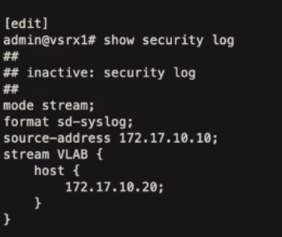

Show monitor for App Track via J-Web:
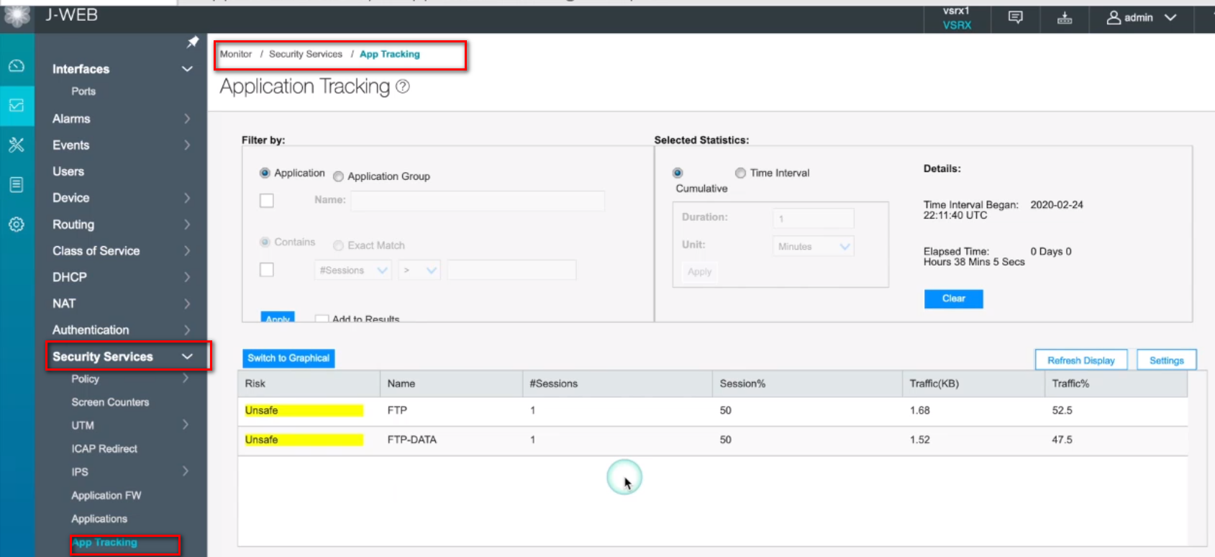
Show commands for App Track via CLI:
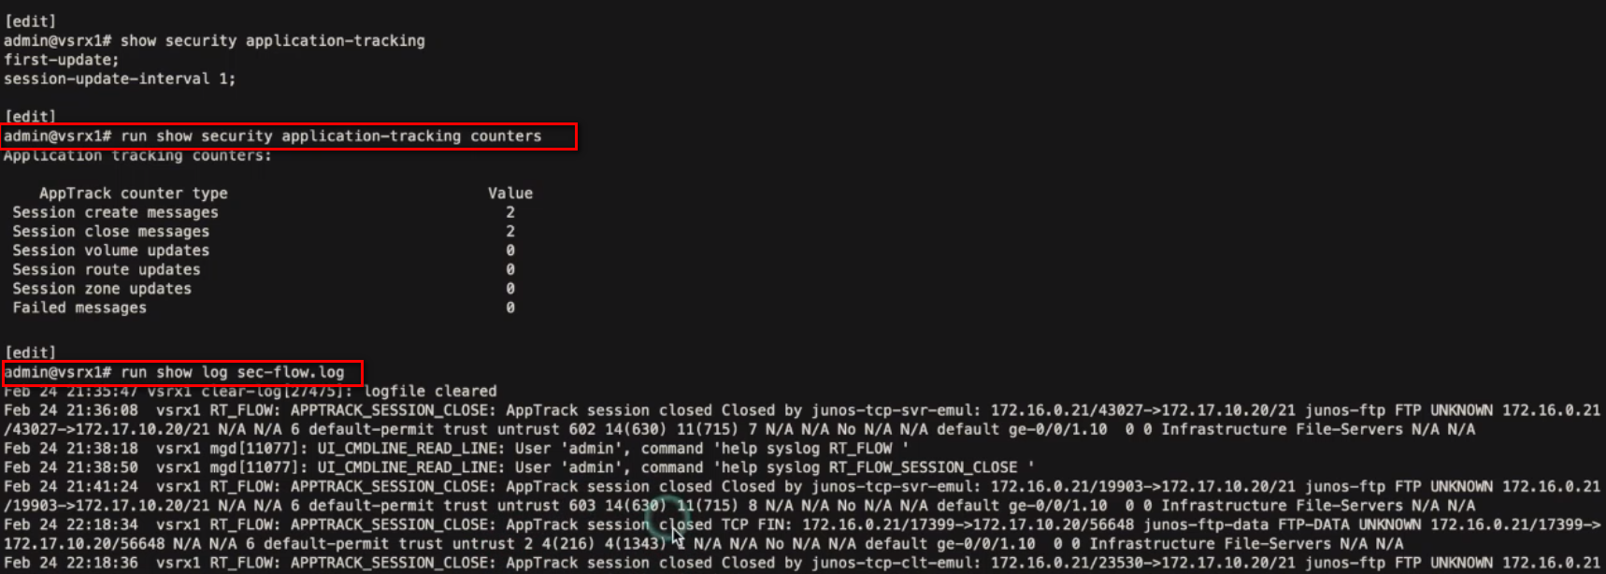

Application Firewall:
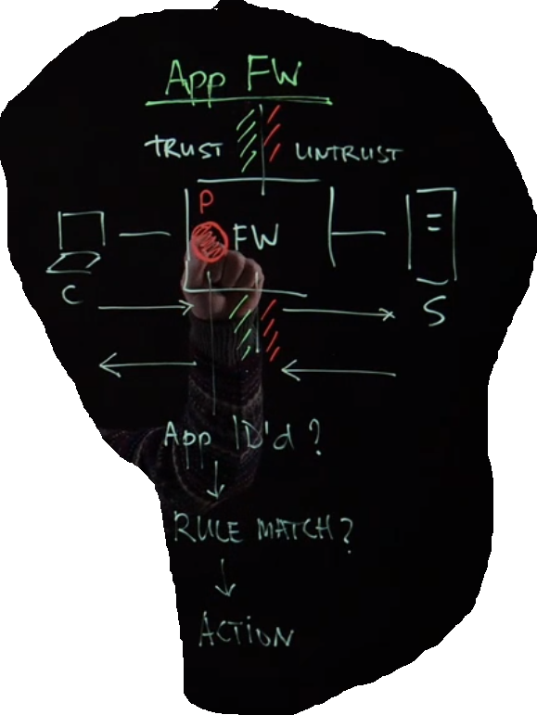

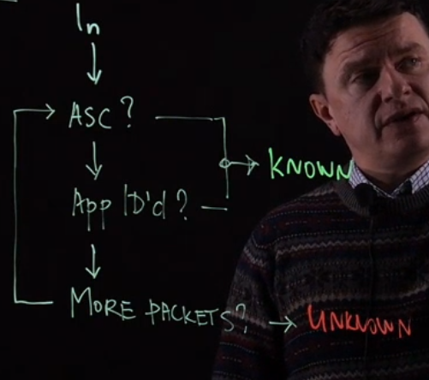
The traffic goes in the firewall and the App Identity module starts analyzing packets, if it has it in cache in the ASC (Application System Cache) it will become known and passed to other rule criteria, if not cached, it will wait to process further packets and either become known or unknown.

If you specify the Dynamic-Application in the policy to be a match criteria, either a specific App or set to be any. Then it this means if the firewall does not see an App ID, it will not match. You need to enable App Track in the zone before using Dynamic-Application.
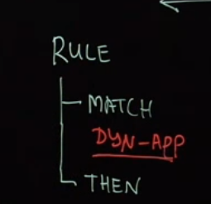

Block YouTube application by policy via CLI:
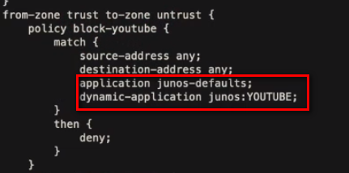

Show command to give more details about the policy:
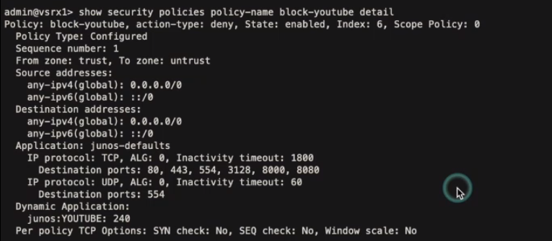

App QoS:
It can be Configured only via CLI until now:
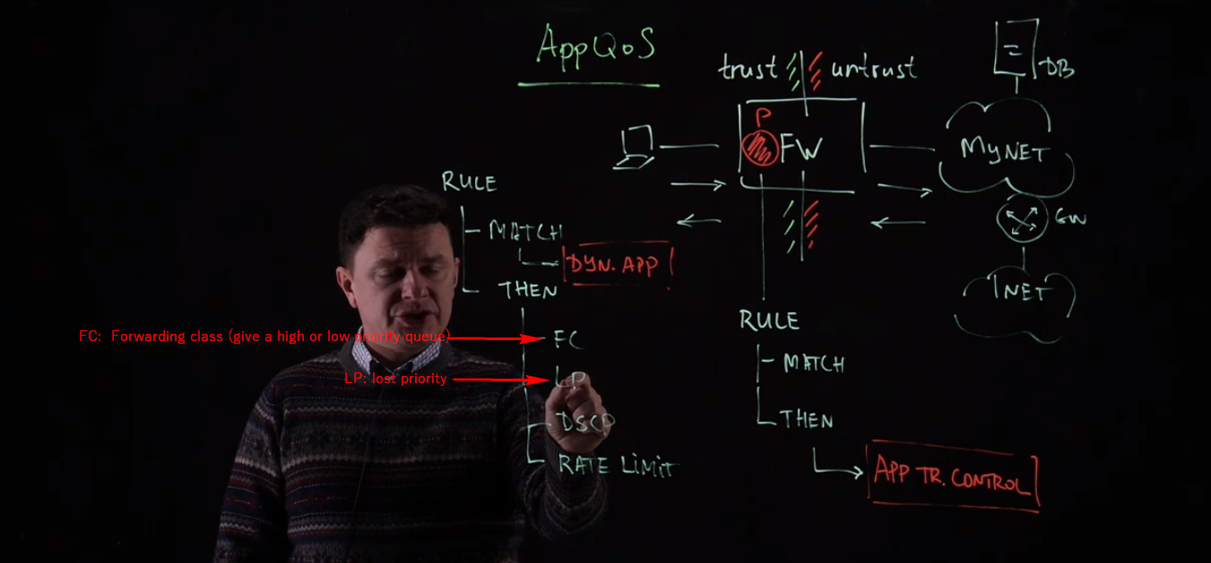

Configuration via CLI (not available on J-Web):
This is the rate-limiter; we are limiting traffic to be 128 kbps
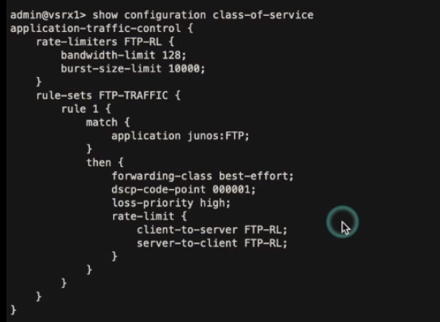
We are calling the limiter above
We don’t want loss in packets packets
Give it a DSCP tag
Forward Options: check URL
Has specific calculations: check URL
value-in-kbps

Policy configuration:
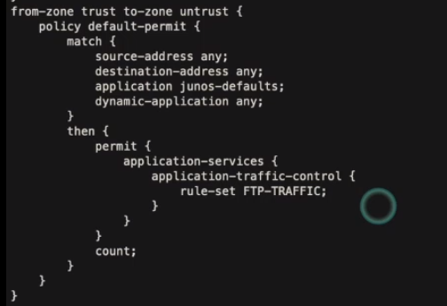

Show commands:
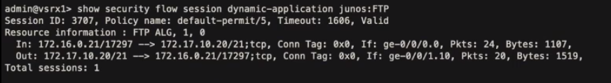
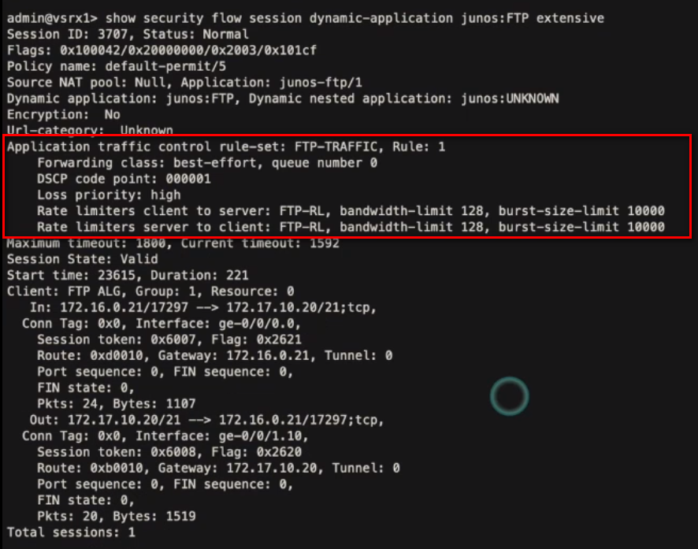

We had 38 session hits shown below
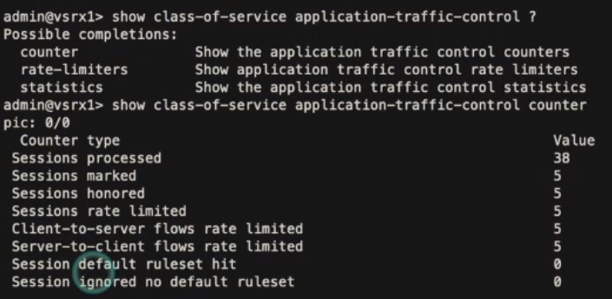

APBR (Advanced Policy Based Routing)
You configure it only in CLI
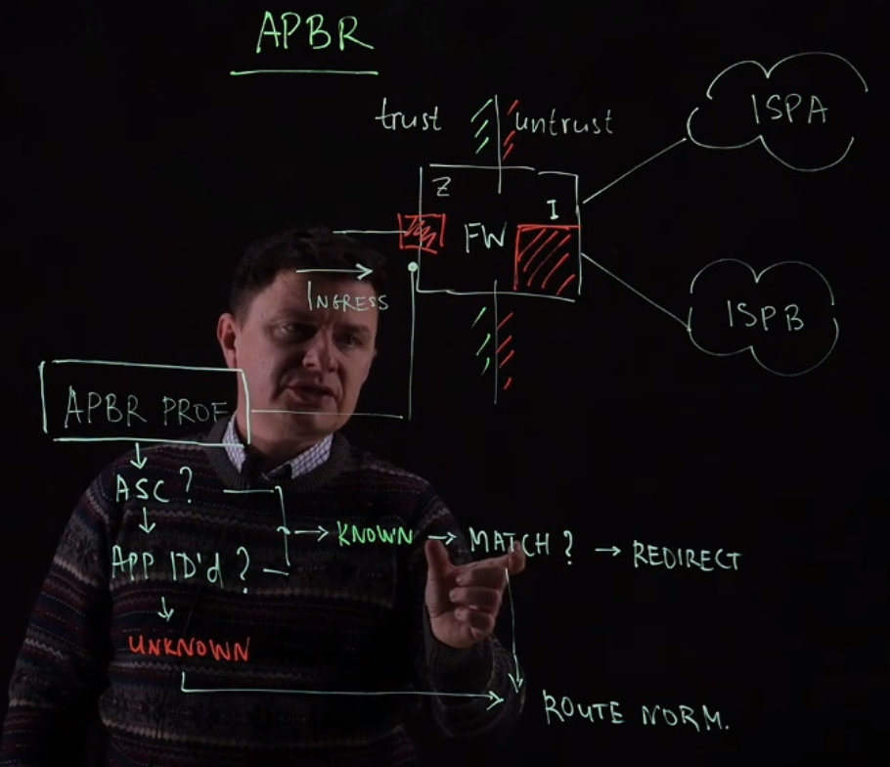

Configuration:
Interface configuration:
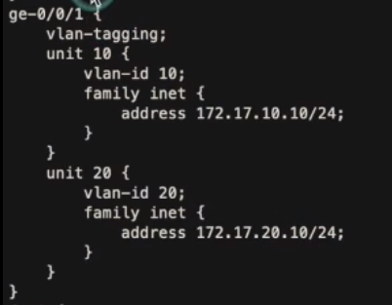
We have two sub-interfaces, one for each ISP (ISP-1 and ISP-2)

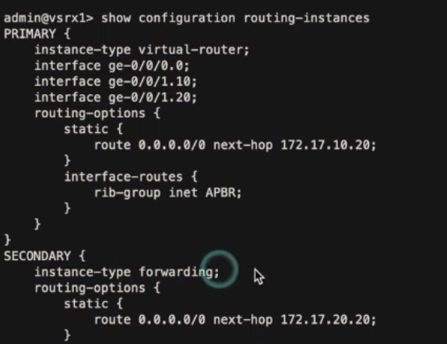
We configure the master routing instance, which will have for sure the type virtual-router; it will have all interfaces under it.
Forwarding-Instance does not have its own interfaces; it shares the interfaces with the master virtual-router
We share the interfaces between Primary and Secondary routing-instances via rib-group and we specify which interface to be shared through a filter inside import-policy shown later.
We specify different next-hop for the default routes in Primary and Secondary routing-instances.

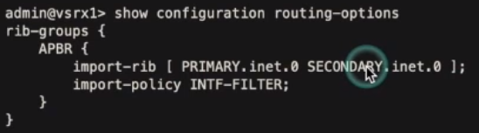
With the command import-rib [PRIMARY.inet.0 SECONDARY.inet.0] we share all the interfaces between the routing instances,
Then we apply the INTF-FILTER to specify what exact interface to share between the instances

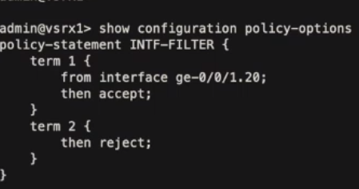
In this filter we accept interface ge-0/0/1.20 that is the interface pointing to ISP-2, then we reject all the other interfaces. This means that we only share the ge-0/0/1.20 between Primary and Secondary

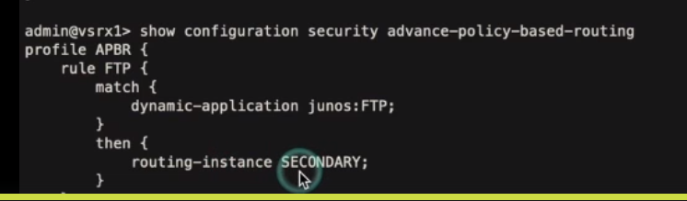
We create the APBR that says whenever we see FTP traffic, forward it to the SECONDARY routing-instance

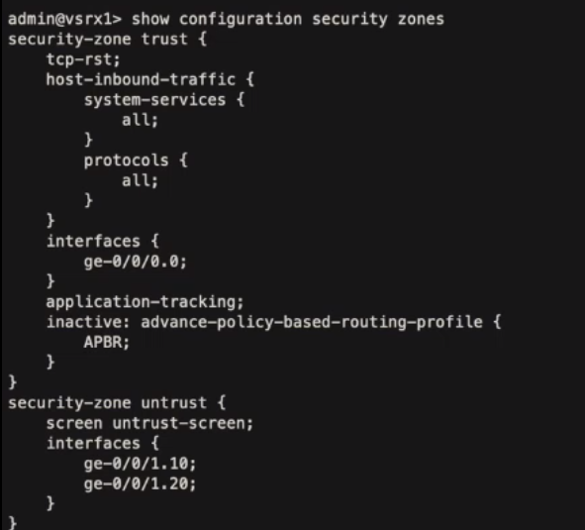
Finally apply it to the ingress security zone which is the users(trust) zone.
Here is showing inactive, but you must activate it for sure.

App QoE (Quality of Experience)

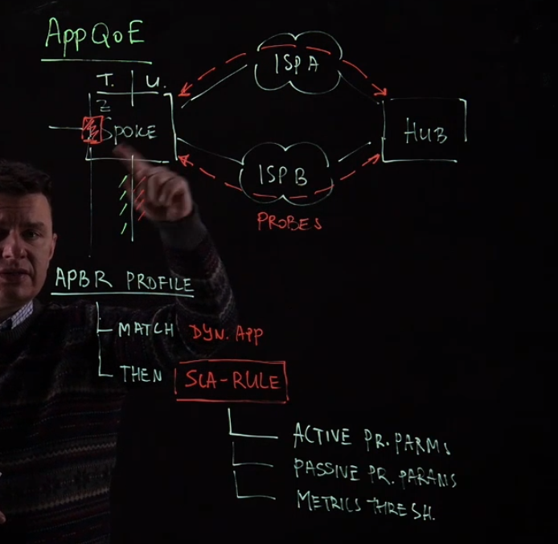
The configuration is done as continuity for the APBR in the THEN option where you configure active/passive probes parameters and metrics threshold

There are two probes (Active and Passive):
Active probes: These probes are custom packets sent between hub and spoke and used to measure RTT, latency, jitter, and packet-loss
Passive probes: Passive probing monitors links for SLA violations on live data traffic. The SRX takes the payload of the application and encapsulates it in an IP/UDP the probe header in the live traffic between the SRX Series book-ended points, and RTT, jitter and packet loss between the points of installation of the probes are measured to compute the service quality, this will make tunnel between the SRXs.

Configuration via CLI:
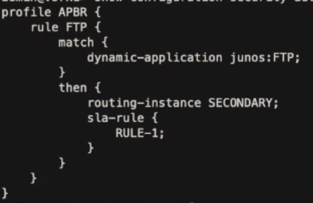
We added this SLA rule “RULE-1” which will monitor the link (ge-0/0/1.20) of routing-instance SECONDARY and if it fails then it will move the traffic to the link (ge-0/0/1.10) of routing-instance PRIMARY
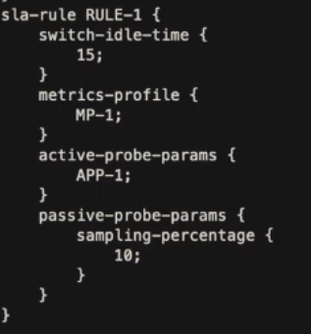
This SLA contains the four parameters:
- Switch-idle-time (hold time to move to another link)
- Metrics-profile
- Active-probe-parameters
- Passive-probe-parameters

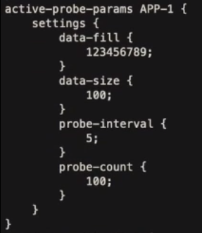
Active-probe-parameter contains the settings of traffic sent in the packet between hub and spoke.
This a packet with random data fill (123456789) to be exchanged between the hub and spoke for the purpose of measuring the RTT, latency, jitter, and packet-loss

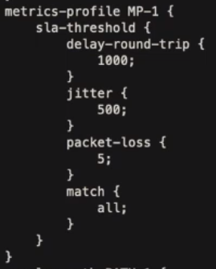
The metric-profiles has inside the SLA thresholds, if they are exceeded then the SLA will fail and it will trigger failover.

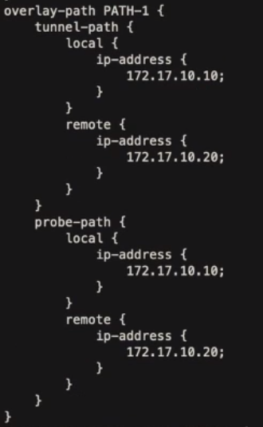

It contains the IP addresses of the local SRX with its gateway for the PRIMARY routing-instance since we will use it send our probes

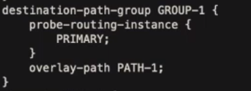
We here specify the PRIMARY routing-instance to send probes and measure results. And we specify the which overlay path to use which contains the source and destination IPs to use to send traffic

