Contents
1- Wi-Fi Fundamentals 1
2- Mist Architecture and Deployment 20
3- Mist Architecture and Deployment 24
4- General WLAN Concept Part 1 30
5- General WLAN Concept Part 2 42
6- MIST Network Operations Part-1 44
7- MIST Network Operations Part-2 58
8- Mist Location-based Services (LBS) 59
9- Mist Automation 63

1- Wi-Fi Fundamentals

Data Link layer is divided into two sub-layers (LLC and MAC):

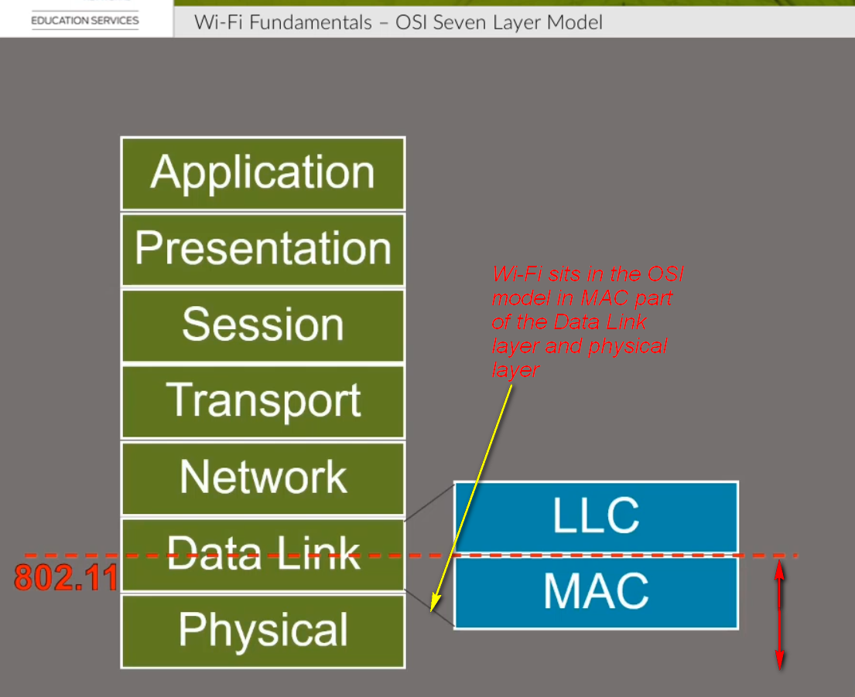
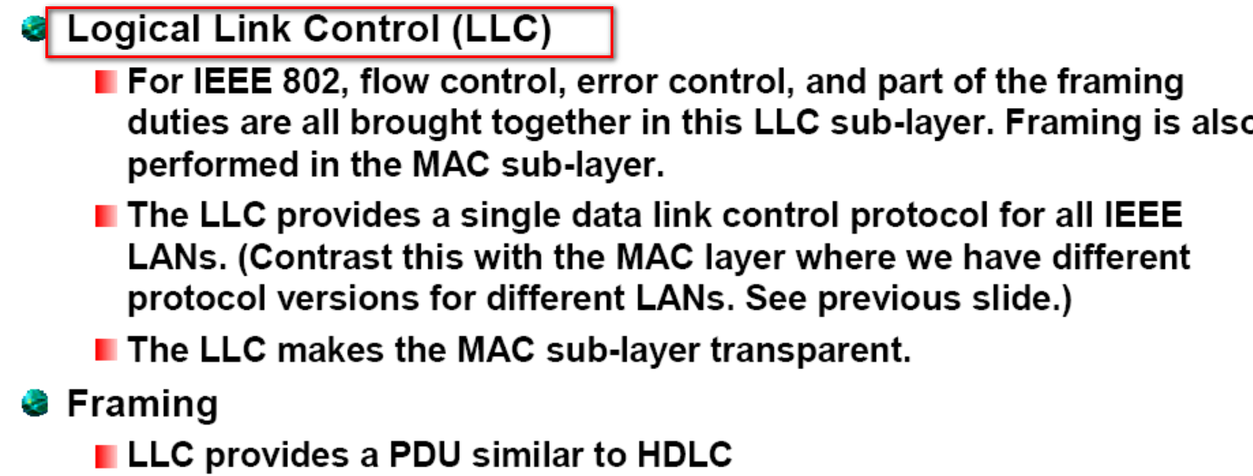
LLC is implemented in software, and its implementation is independent of the hardware. The driver software of computer NIC and be considered as LLC. The driver is a software program and instruction that interacts directly with the computer NIC and other hardware. Driver software also enables the communication between the network device, computer, and operating system as well as with other network computers and network devices.
Multiplexing/De-Multiplexing
As I mentioned earlier that LLC communicates with the uppers i.e network layer. When the data link layer received a frame from the physical layer, the LLC is looking at the Layer 3 Protocol type and handing over the datagram to the correct Layer 3 protocol. It is called the de-multiplexing process.
When Layer 3 sends a packet, LLC takes it from different Layer 3 protocols like IP, IPX, ARP etc., and forward it over to the MAC layer after adding the Layer 3 protocol type in the LLC header portion of the frame multiplexing. This process is called the multiplexing process.

The function of MAC sublayer
MAC is the lower sublayer of the data link layer. It is listed in the IEEE 802.3 standards. The figure above lists common IEEE Ethernet standards. It also shows how the data link layer divided into the LLC and MAC sublayer. The LLC sublayer communicates with the network layer while the MAC sublayer allows various network access technologies.
For instance, the MAC sublayer communicates with Ethernet LAN technology to send and receive frames over copper or fiber-optic cable. The MAC sublayer also communicates with wireless technologies such as Wi-Fi and Bluetooth to send and receive frames wirelessly.
As we know that the Media Access Control (MAC) layer is between the LLC sublayer and physical layers, The MAC sublayer has the following key tasks:
Data encapsulation
Media access control

802.11 IEEE Physical Layer (Amendments):

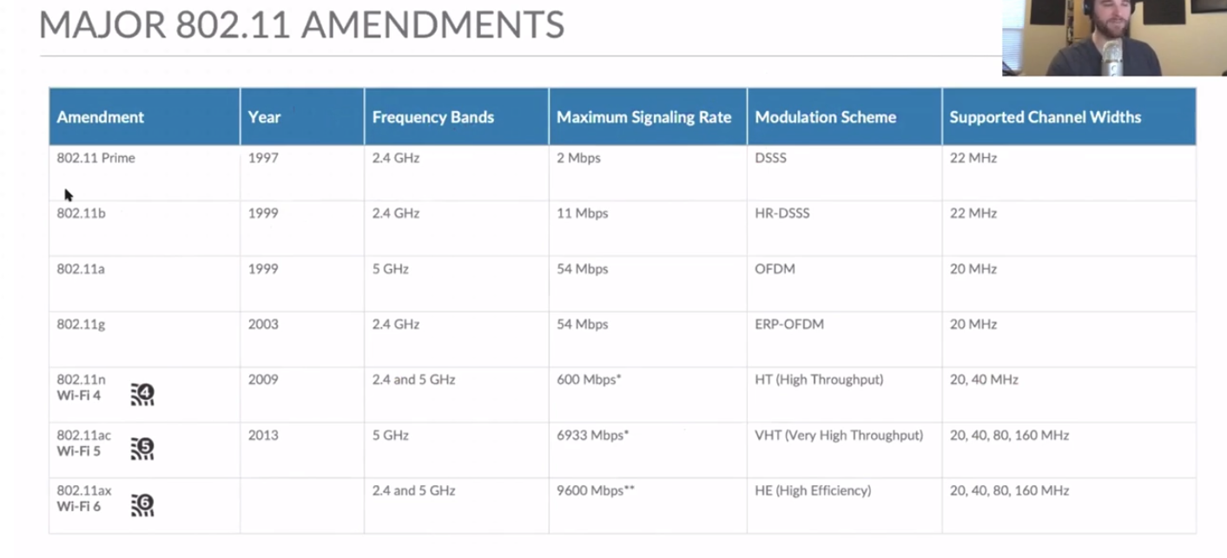
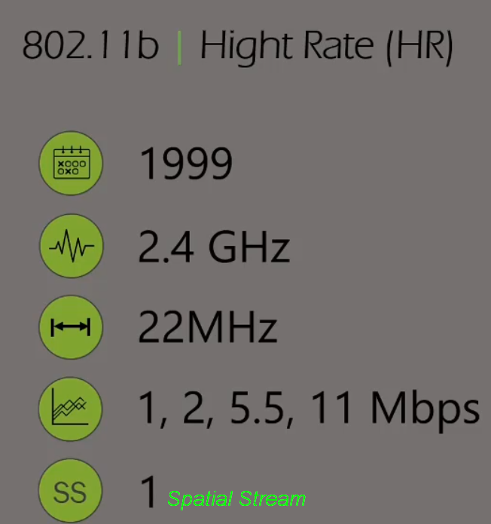

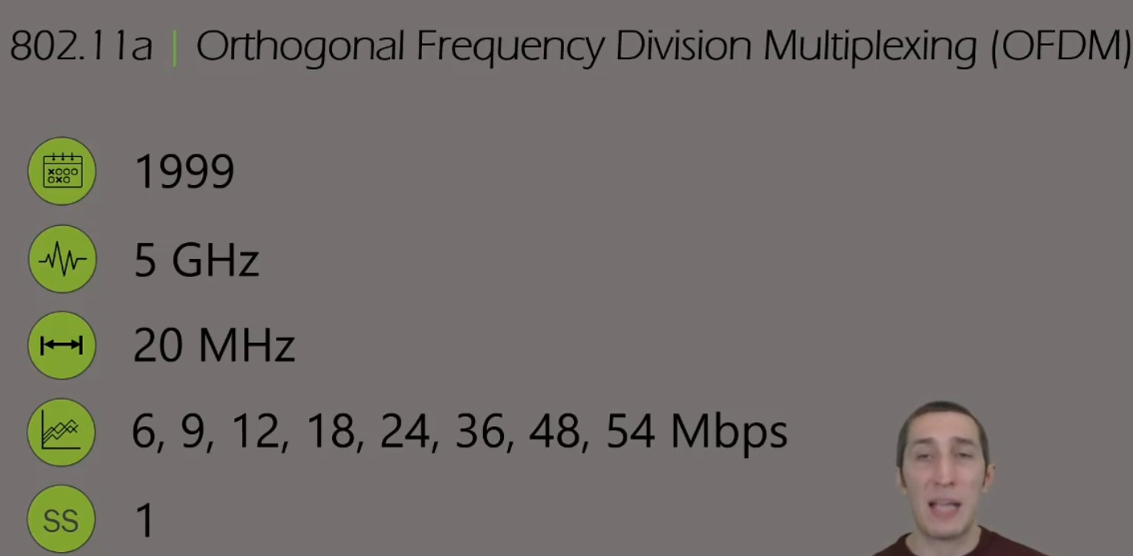

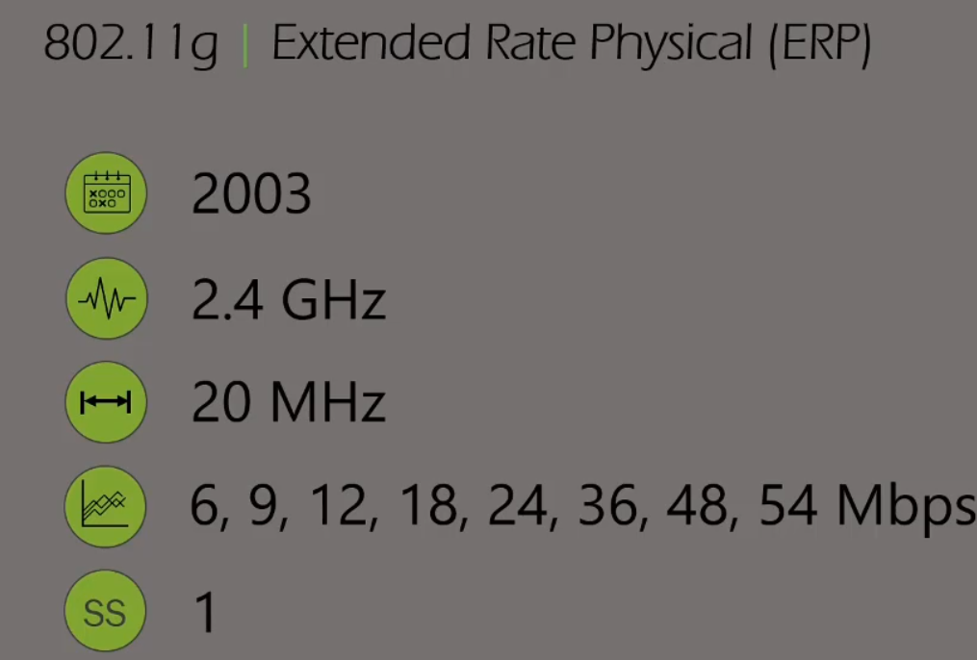
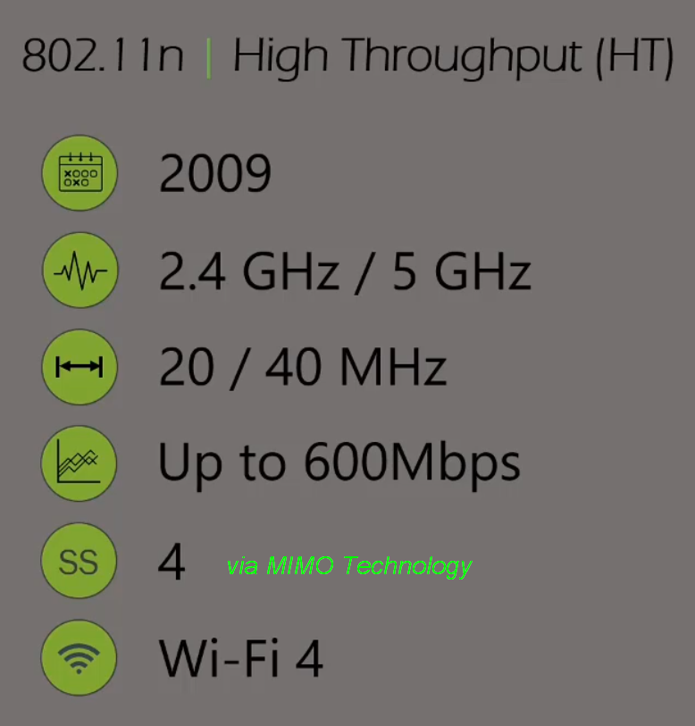
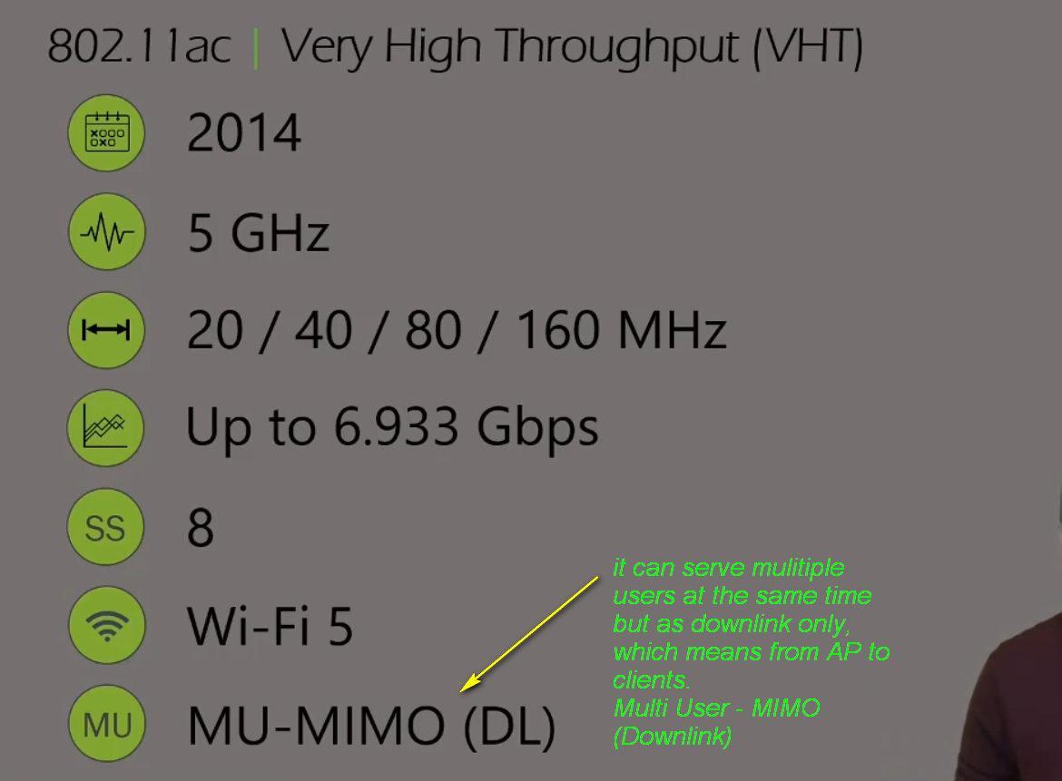

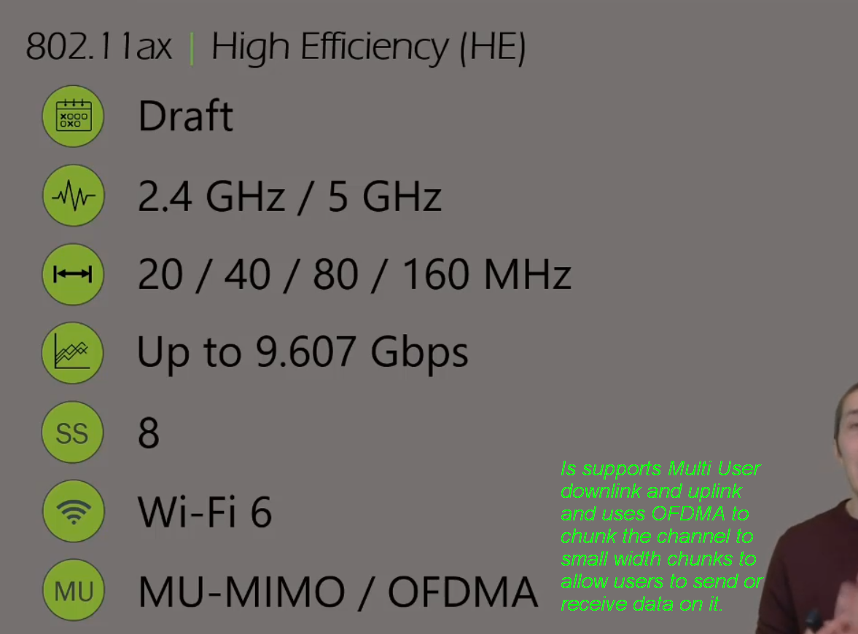

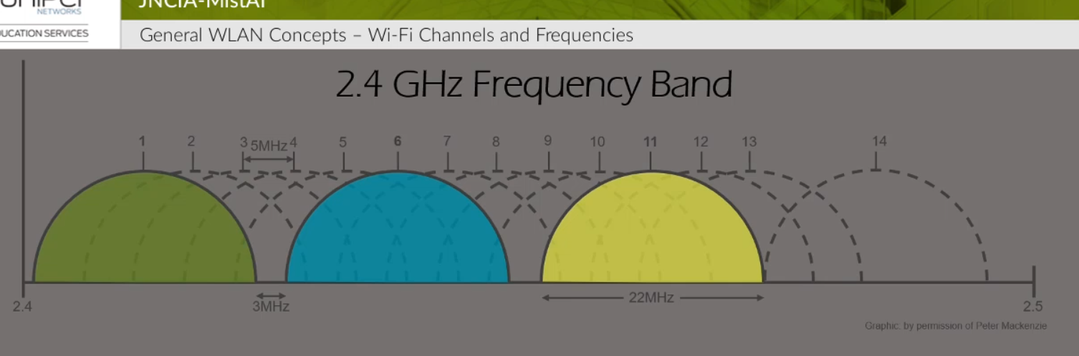
License free spectrum for 2.4 GHz is the above and varies according to each region:
1- US has a License free spectrum from Channel 1 till 11 and that’s why the optimum channels to use for non-overlapping are 1, 6 and 11
2- Europe has 1 13 and that’s the reason they have more options for the usage of channels. Even though customer in Europe can operate on 1, 7 and 13 channels without overlapping but the vendors always use the 1, 6 and 11 as default ones.
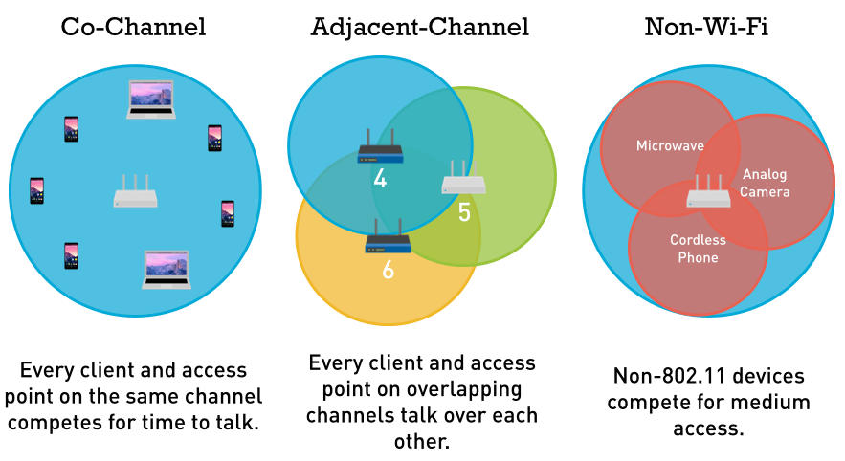
3- In Japan they have 1 14 channels and therefore they can use 1, 6, 11 and 14 with almost no overlapping

4, 5, 6 overlap in the spectrum

Co-Channel Interference: CCI
Adjacent Channel Interference: ACI
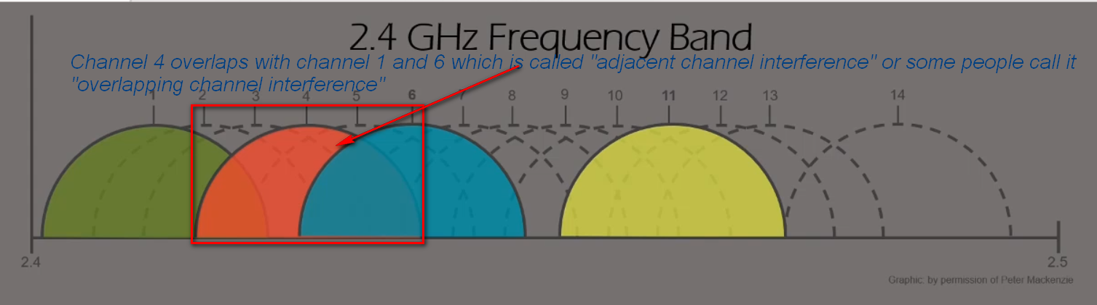
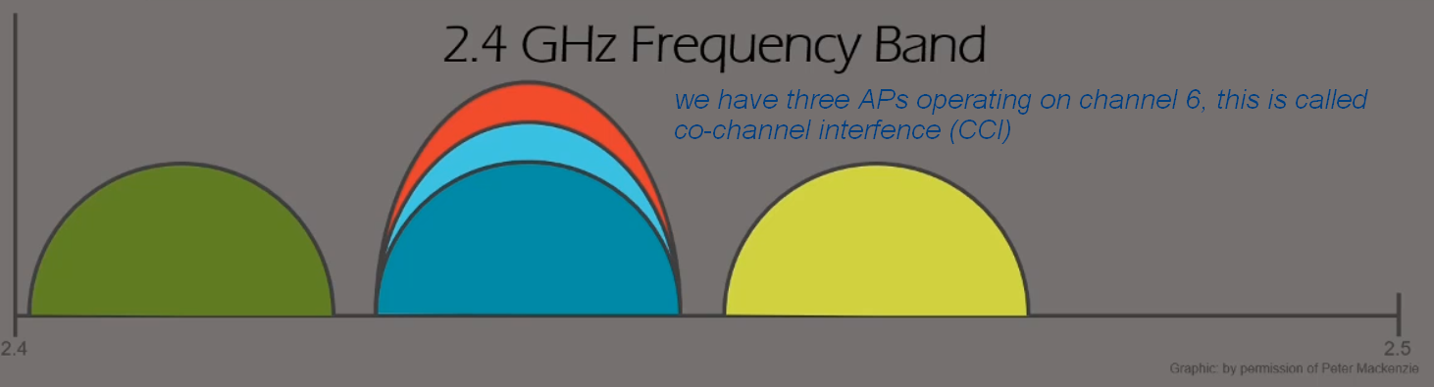

Number of channels available for 22MHz wide channels vs 20MHz wide channels.
802.11b uses 22MHz and if we disable it then we are only left with the amendments that support 20MHz.

For US, if we use 20 or 22MHz channels then they will still have only three channels to use in 2.4GHz since they only support 1 11.
However, for Europe where they support from 1 13, they can technically use 4 non-overlapping channels (1, 5, 9 and 13) as shown below.
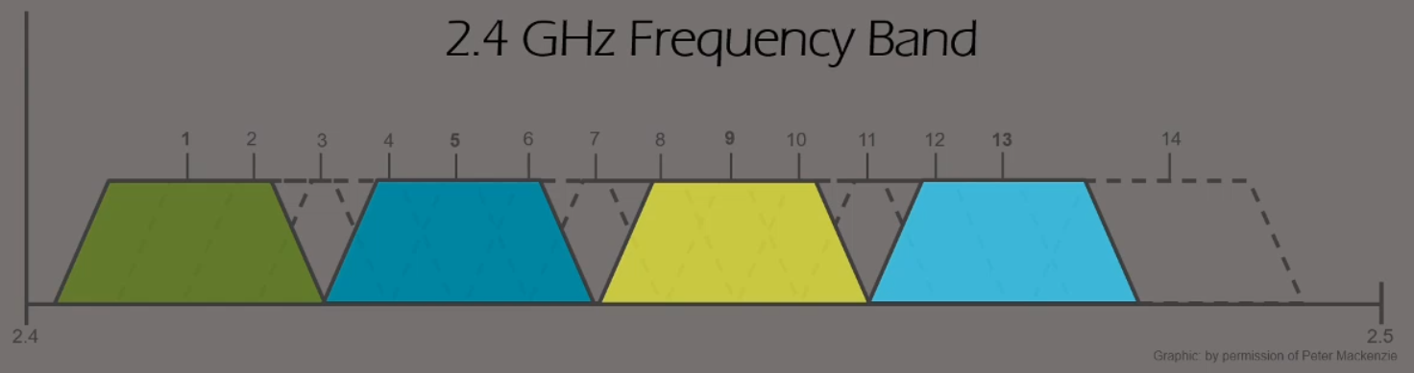

The reason we do not see clients using this widely is to avoid interference with neighbor APs, if there is any neighbors using the normal channels (1, 6 or 11) they will interfere badly with 4 used channels (1, 5, 9 and 13).
The only used case for using the four channels is if we have for example a warehouse in a fare place with nothing next to it and we sure all other channels are 100% clear then we can benefit from the four overlapping channels and of course we have to disable 802.11b data rates to prohibit the use of 22MHz channels.

5GHz:
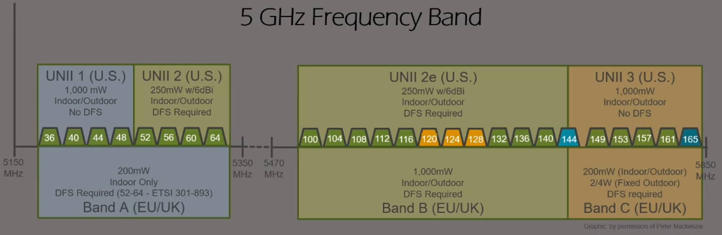

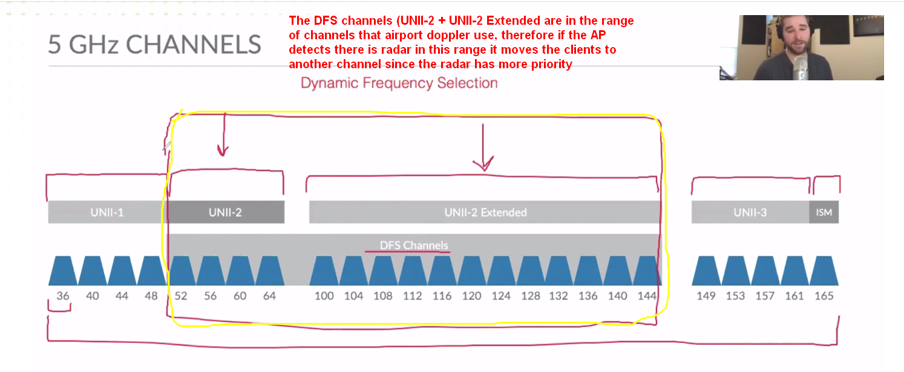
US calls the ranges in UNII while Europe calls them in Band (A,B,C)

Merging channels for more bandwidth:
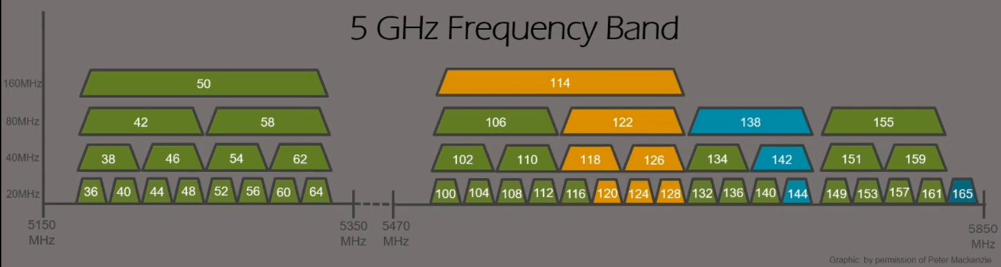

RF Signal:
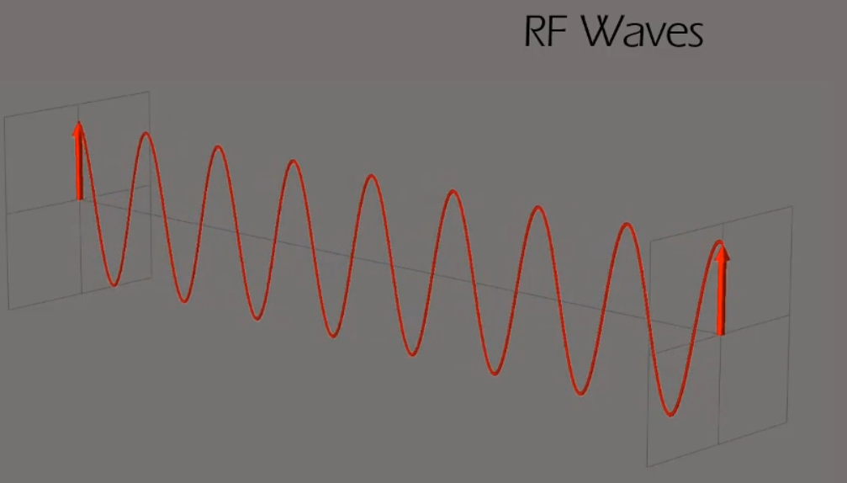
The frequency is how many time the signal repeats itself in one second and measured in Hz.
The wavelength is the distance the signal crossed in one second.

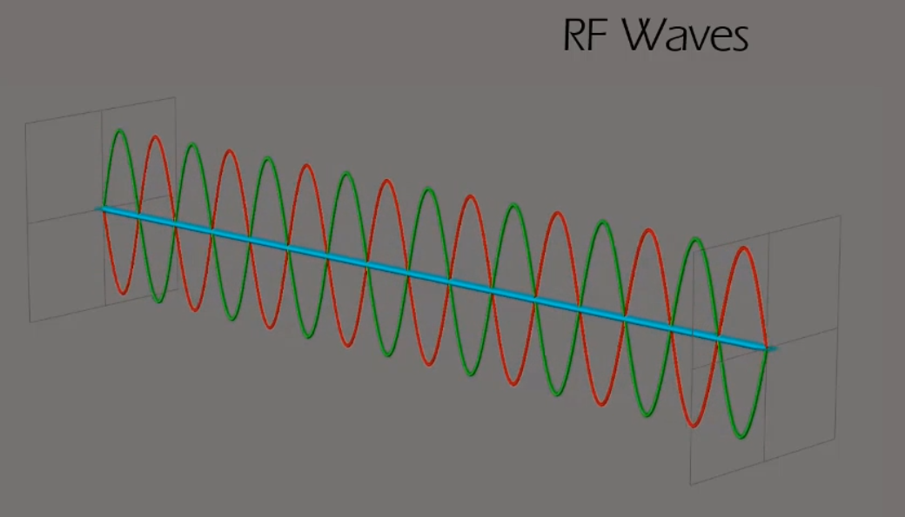
If you add two same signals (Same Amplitude/power) shifted by 180’ (red and green), their sum will be zero (blue line).
RF Power:
When we measure transmitted power by an AP we use mW (Milliwatts)
When we measure received power by an AP we use dBm
Indoor AP will transmit power between 1mW and 100mW

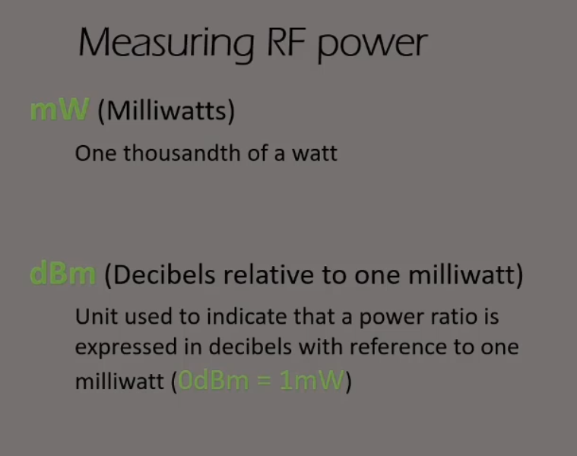
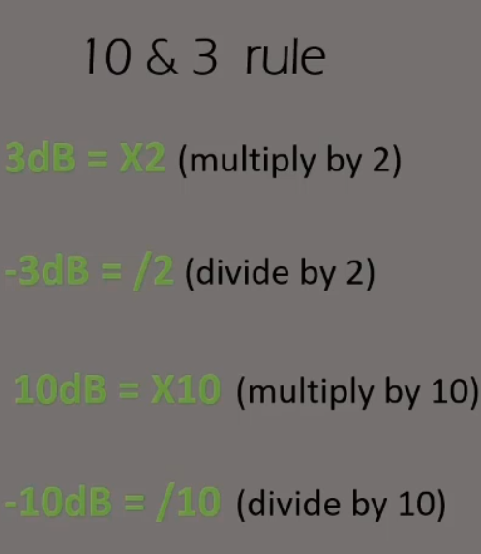
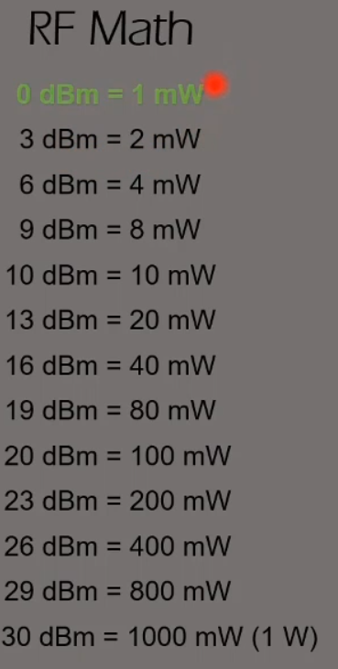

Signal Strength:
The rate of power loss for signal is calculated using the inverse square law:
1/r² or 1/d² (range or distance), it means if the range doubles from the source the distance is shattered four times more. Every time the distance doubles then we lose 4 times the power which equals to 6dB.

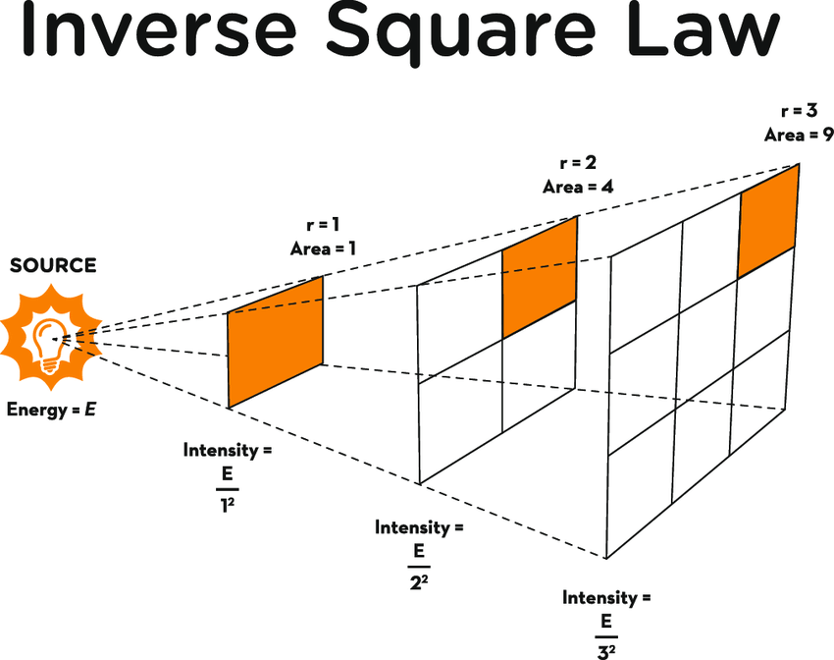

Because the wavelength of a 2.4GHz signal (12 cm) is longer that the one of a 5GHz signal (6 cm), the size of the antenna is bigger. This means that the 2.4GHz receiver will have a larger receive aperture and will be able to better “hear” the incoming signal.
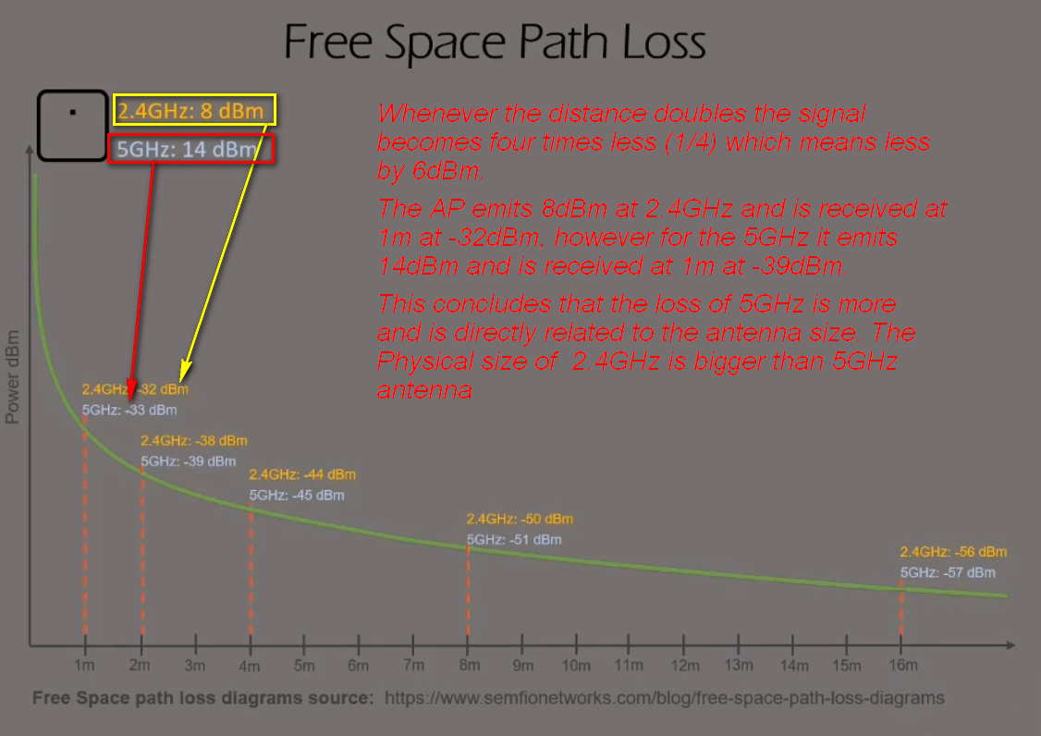
Most of the signal loss is in the first 1meter, as you can see the AP was emitting 14dBm and after 1m it became -33dBm with a loss of 47dB

RF Modulation:
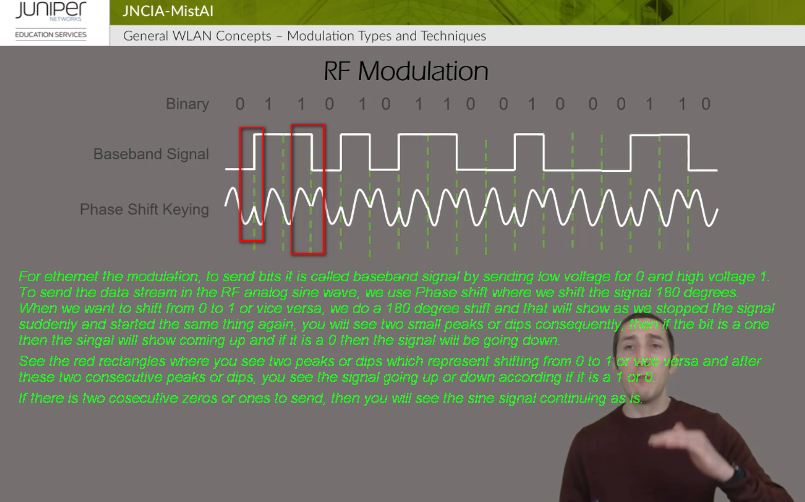

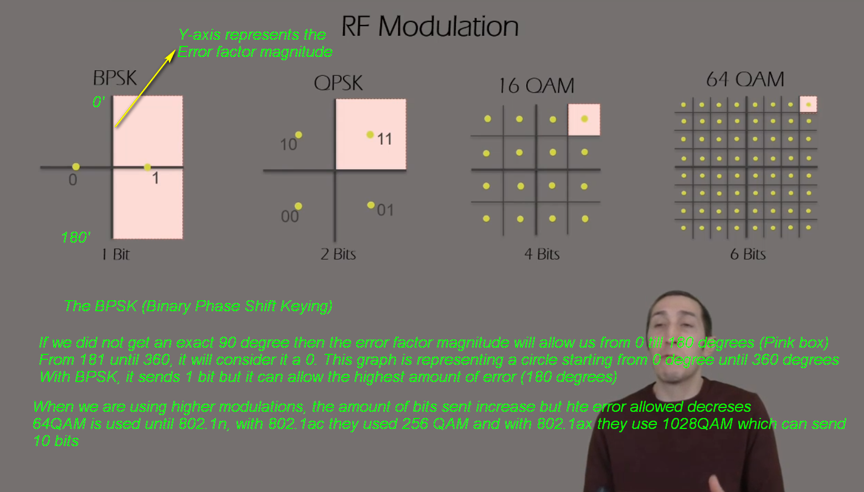

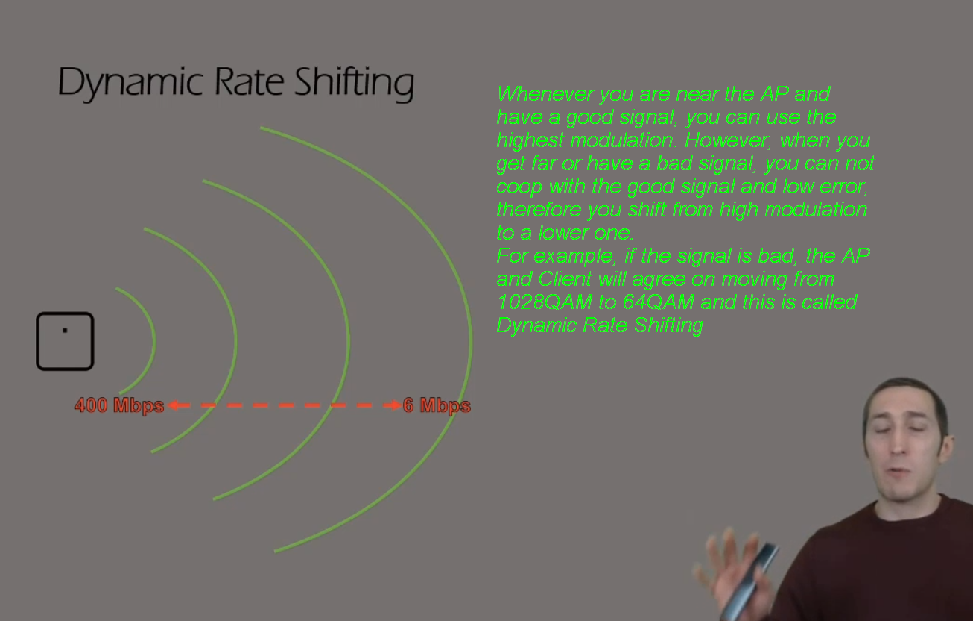

Client Connection:
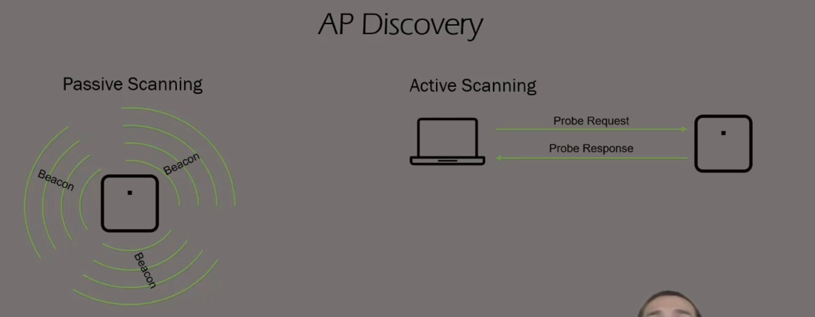
Clients discover APs to connect to it via two ways: Passive and Active Scanning:
Passive Scanning: AP sends every 100ms a beacon frame that contain the WLANs and the AP capability, clients listen to these beacon frames to know what APs are there to exist.
If the client only will use passive scanning then it will have to wait 100ms to each channel to send the beacon which will take considerable time to see all the 2.4 and 5GHz channels available.

Active Scanning: the client here takes the lead and send a probe request frame, that says is there any APs available that I am interested in. We mean by interested in, for example if I have an SSID already saved and configured on my laptop, then the laptop will send on all the channels a probe request to see if there is any AP advertising this exact SSID, the APs will send a probe response frame. Which will save a lot of time instead of waiting 100ms for every channel.
Another type of probe request is the broadcast probe request which send all APs if there is any SSID on any channel, this is when we see on our laptop the full list of SSIDs available to connect to.

Client Association:

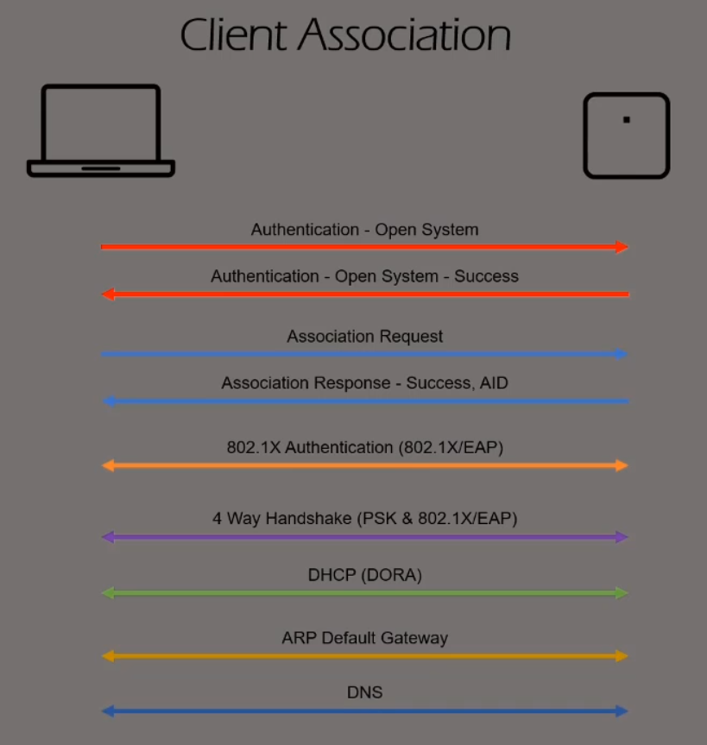
1- Open system Authentication is the first step on connecting, Open system Authentication is basically NO authentication and it allows all clients to connect, this is simply the client identifying its MAC to the AP. Before this step included another sub-step, which WEP shared key negotiation, which is now removed since it is breakable and the PSK was moved to later steps after they are associated.
2- Association is the second step where the client is associated to the AP and AP gives the client and AID (Association ID). Association can fail if the AP reached the max number of supported clients it can handle or if the client can not support any data rates that AP is working on.
3- 802.1X Authentication is the NAC protocol used to authenticate with the radius server, this step happens if the WLAN is using 802.1x authentication method.
4- Four Way Handshake included the PSK and the encryption that will be used to encrypt the data exchange.
5- For the three last steps it is normal network communication request, DHCP IP request, ARP the gateway and DNS.

Contention/Interference:
WiFi is a half-duplex shared medium and it needs rules to control who can send and when, these rules are names DFC (Distributed Coordination Function)

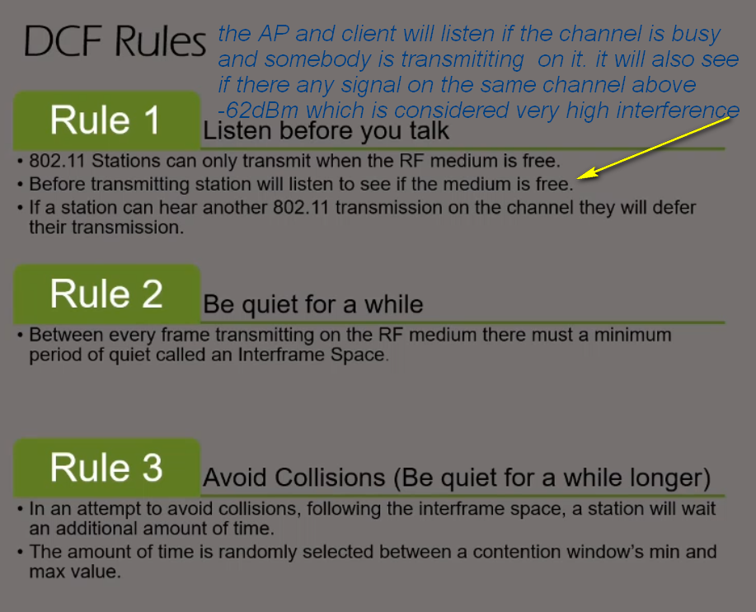

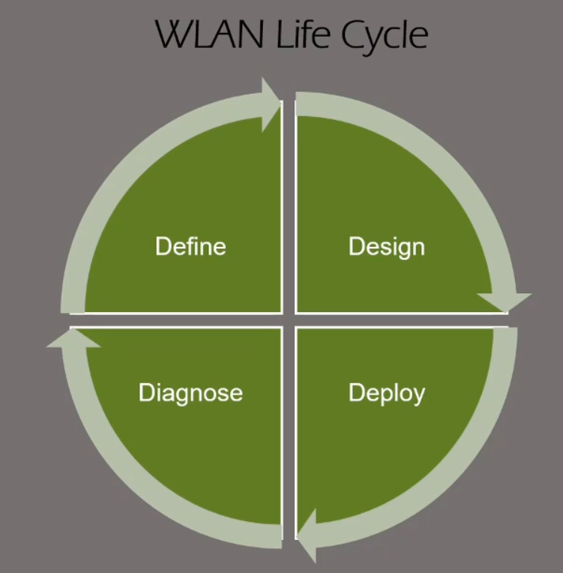

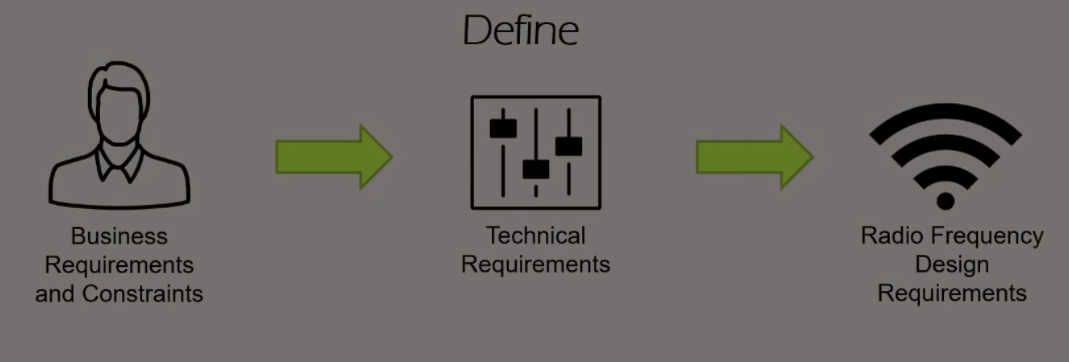
Primary coverage is the AP that has the strongest signal in that area and secondary is the neighbor AP that has the second strongest signal in that specific area. Secondary coverage needed simply as a method of providing RF roaming and redundancy. If one AP fails the secondary coverage coming from the neighbor, AP can support the clients in that area. For sure, the neighbor AP that is providing secondary coverage must be operating in a different channel to not interfere with the primary AP.
Therefore, in 2.4GHz we avoid designing for secondary coverage since we only have three non-overlapping channels whereas in 5GHz we have a lot more which gives us flexibility in designing secondary coverage and channel without causing interference.

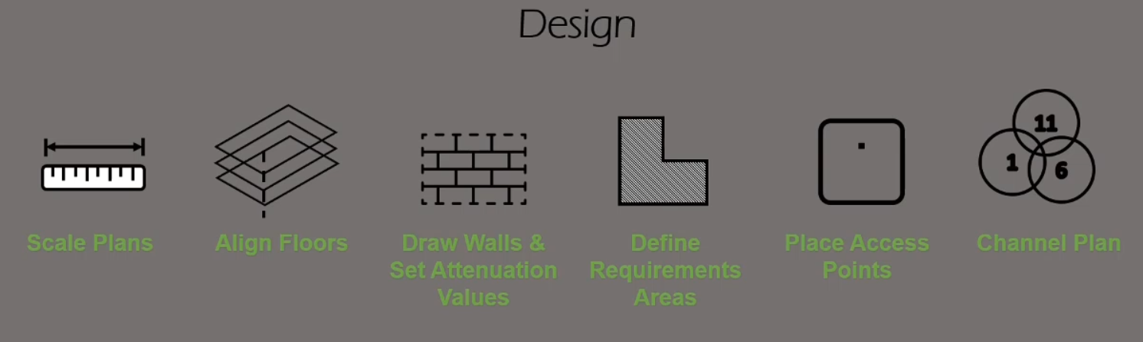

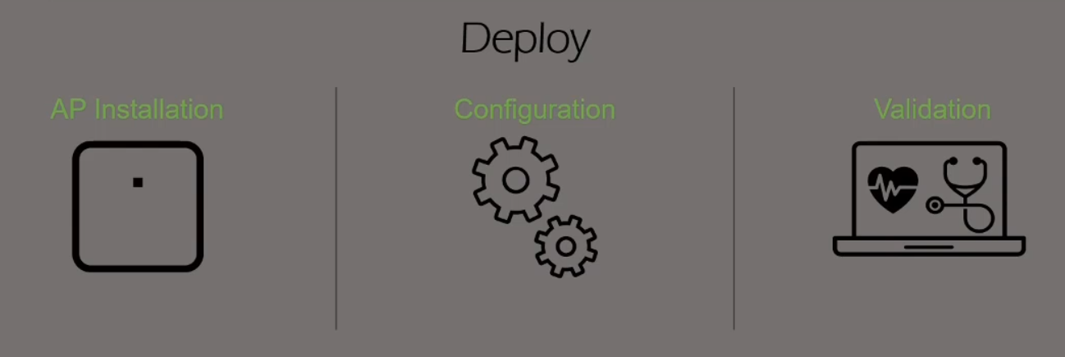

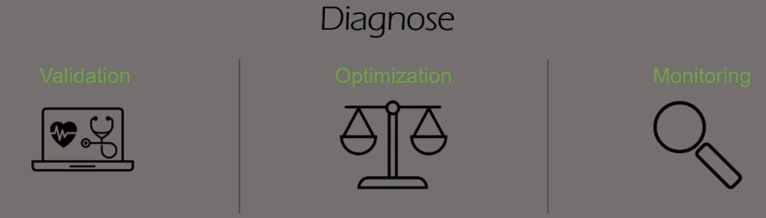

2- Mist Architecture and Deployment

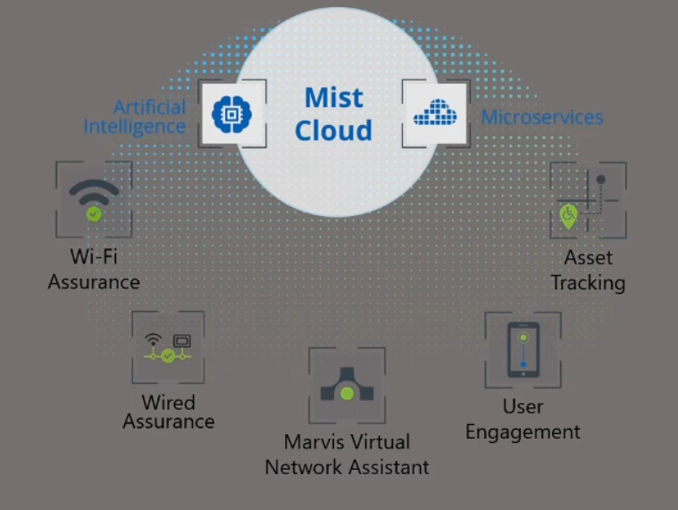
User Engagement license is required for every BLE radio (AP) that will transmit BLE advertisement packets
Asset Tracking license is required for every BLE radio (AP) to enable its receive and monitor capability

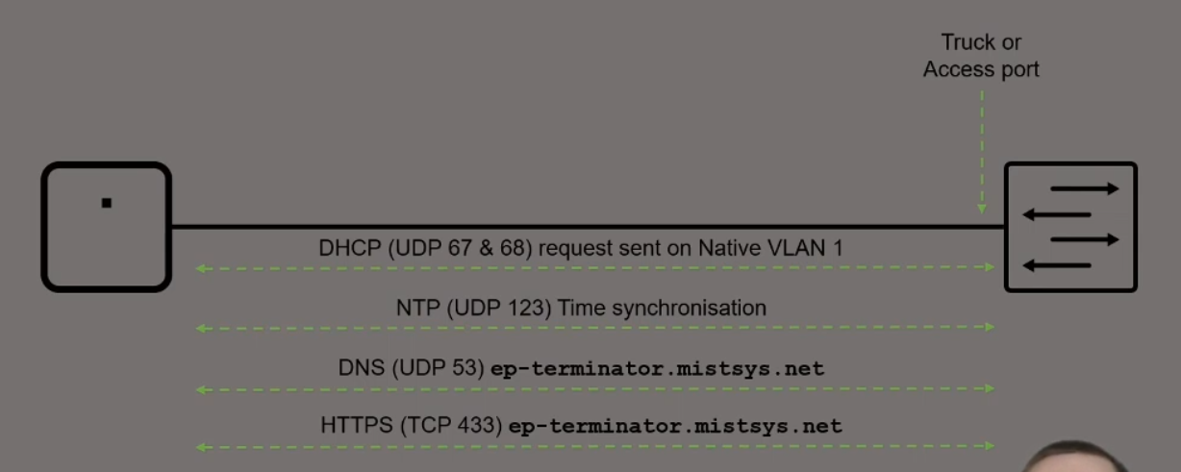

Once the AP powered up and has Ethernet connected, it will do the following step:
1- Request for DHCP on the untagged VLAN (never minds if the port is access or trunk)
2- Synchs the time with the NTP server
3- Requests the DNS entry of the ep-terminator.mistsys.net which is the DNS name of mist cloud
4- Last step to create an SSH connection to mist cloud

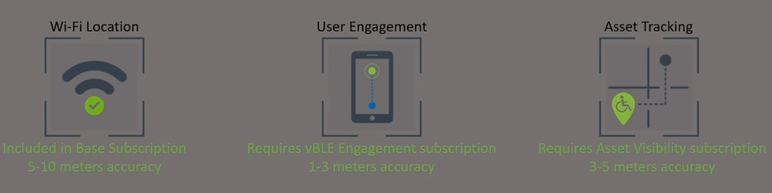

1- WiFi assurance can locate connected and non-connected devices with accuracy of 5-10m
2- User Engagement enables the BLE to send advertisement packet to users that run MIST SDK APP and provides the highest accuracy of 1-3m. The drawback of this license is locations services is available only for devices running MIST SDK APP
3- Asset Tracking enables the MIST BLE radio to listen to third party BLE antennas such as a BLE asset tag on boxes and estimates the location.
User Engagement allows transmit of advertisement packets from MIST BLE radio to MIST SDK Application. However, Asset Tracking allows Mist BLE radio to listen to third party advertisements coming from assets and then estimates their location.
User Engagement Mist BLE sends advertisement capability
Asset Tracking Mist BLE receives advertisement capability
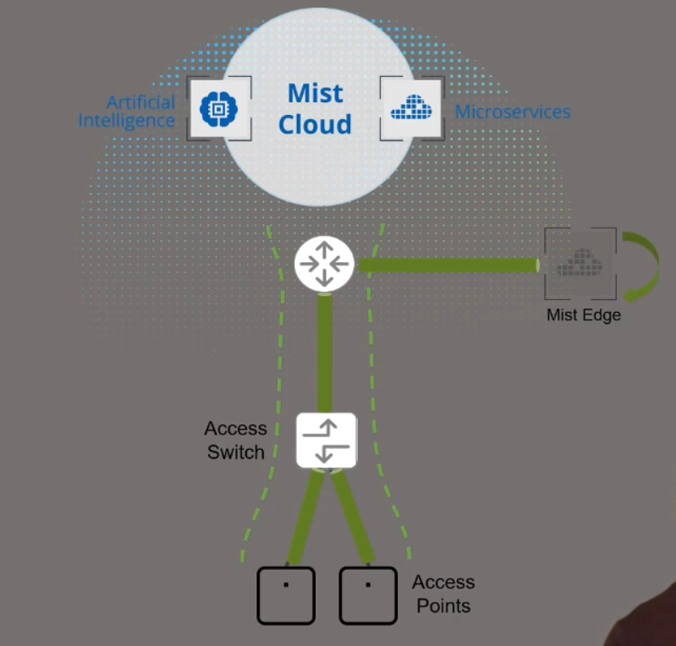
The AP bridge data directly on the switch and therefore all VLANs must be trunked to the AP.
In scenarios where you can’t trunk all VLANs to the AP or you need some SSID to be tunneled to a specific security zone, for example if you want to tunnel guest traffic to DMZ. In this case, you can introduce Mist Edge which purpose is to tunnel traffic from AP to it.
Mist Configuration:
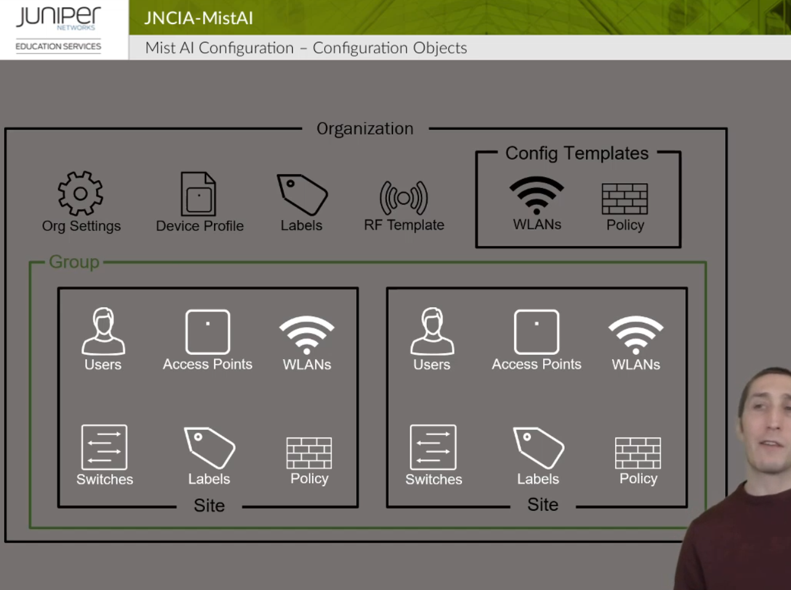

Organization configs will be applied to all sites and site groups and you can to that by clicking on the Organization Tab below. In Config templates under organization you can specify if you want to apply to specific sites instead of all of them.
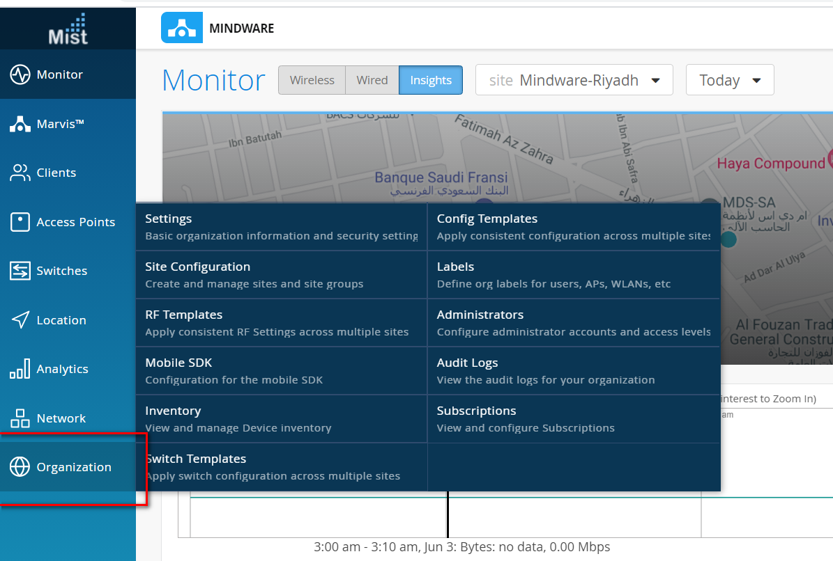

Configuration for sites done under Network and you can specify which site you want to apply to.
Sites can be grouped under a site group.
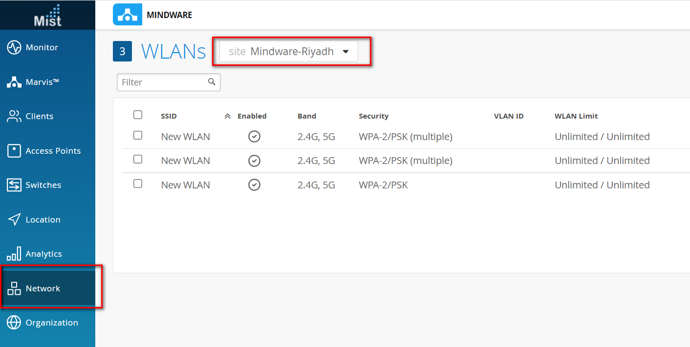

You can configure labels under Organization and Sites. Configs for Organization can only use organization labels and same thing for sites.

3- Mist Architecture and Deployment

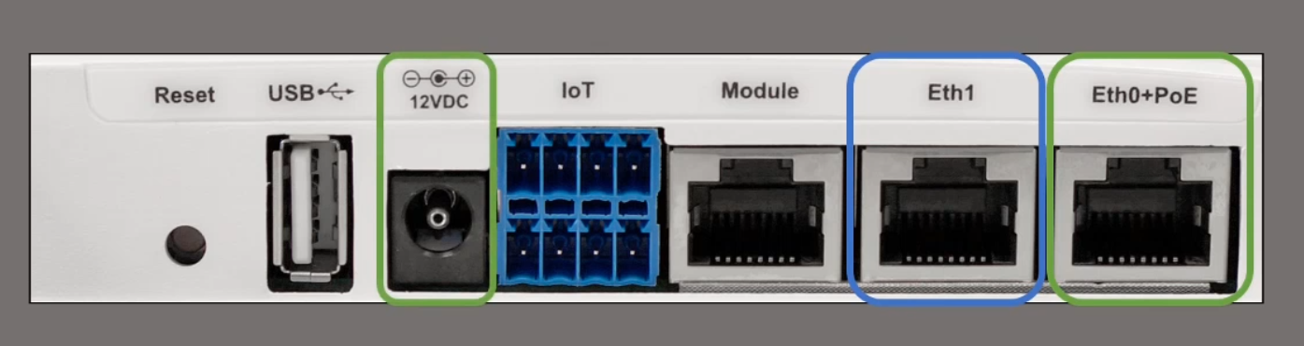
Some switches do not provide more than 15W (802.3af) unless negotiated via LLDP, it is important to enable LLDP on the switch port.
Eth1 is for PoE pass through to power daisy chain BT11 APs.
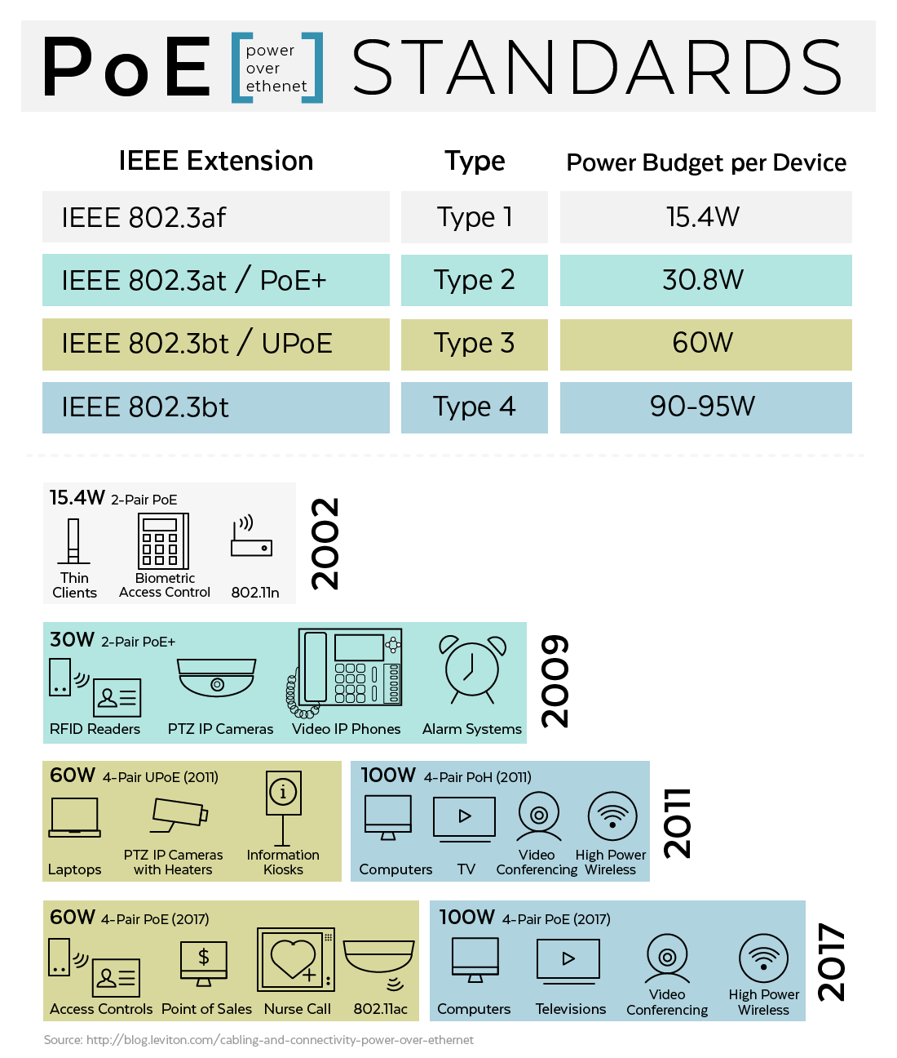

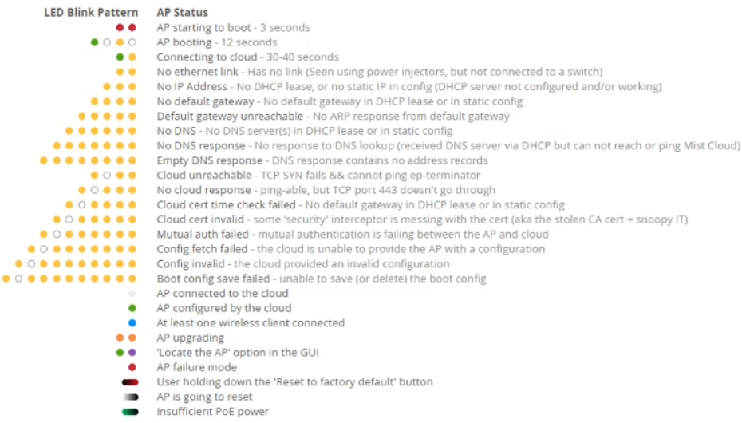

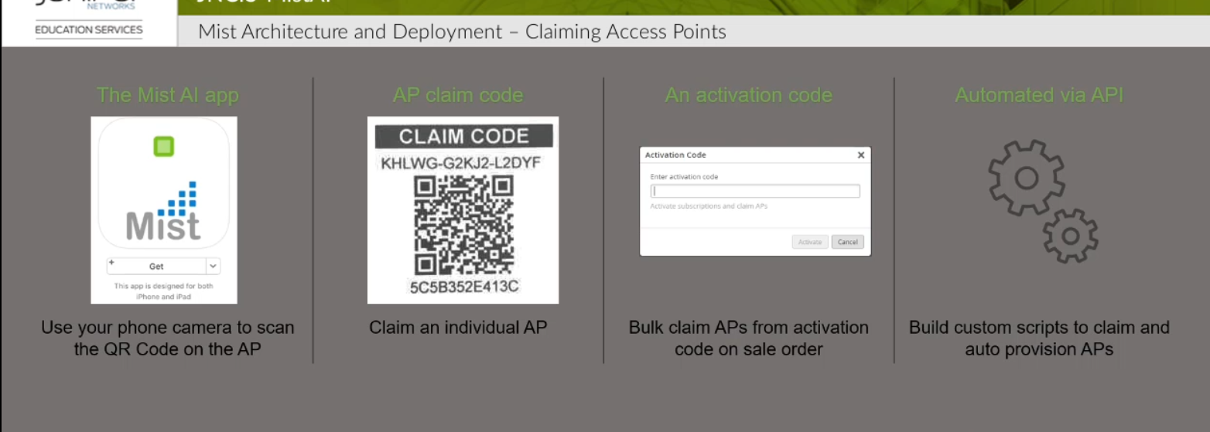

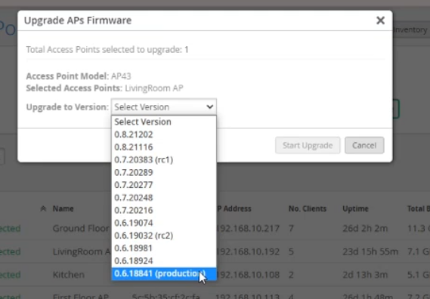

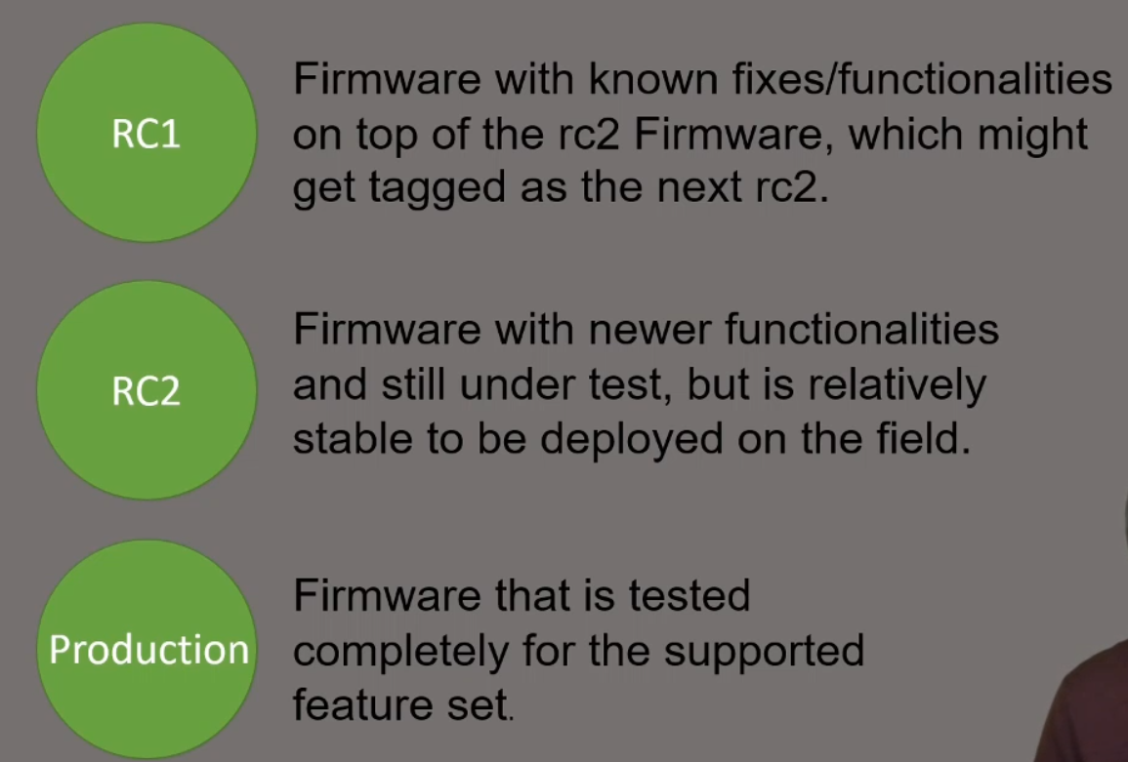

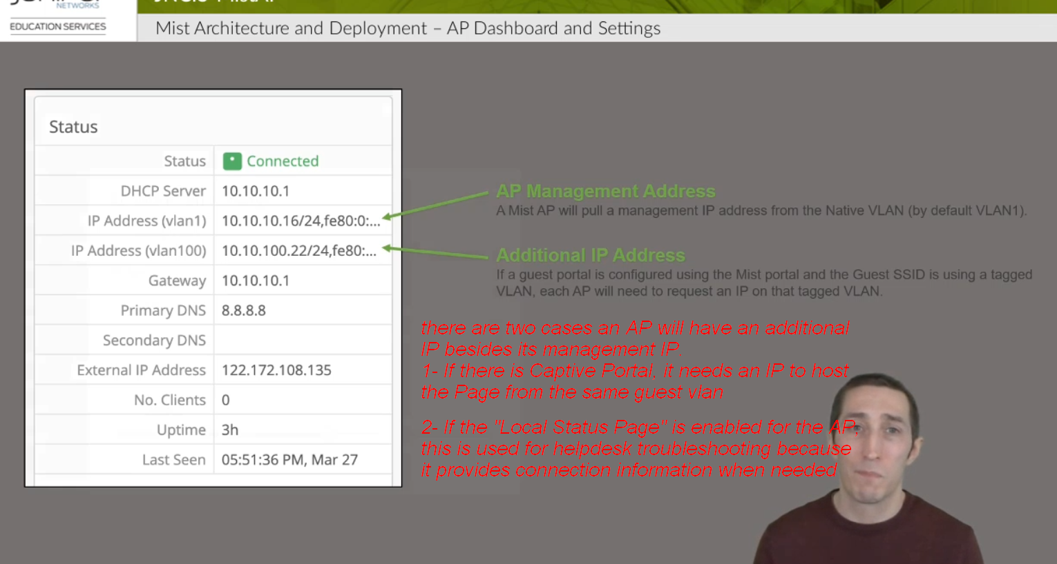

Local Status Page is enabled under site settings. You need to enable it then provide a hostname or DNS entry (in this example we entered ap.info)
Whenever the client types in his browser here ap.infro then it will give him information regarding the connection that is provided by the AP. This information can be shared with helpdesk to provide any kind of help if the user is experiencing any issues.
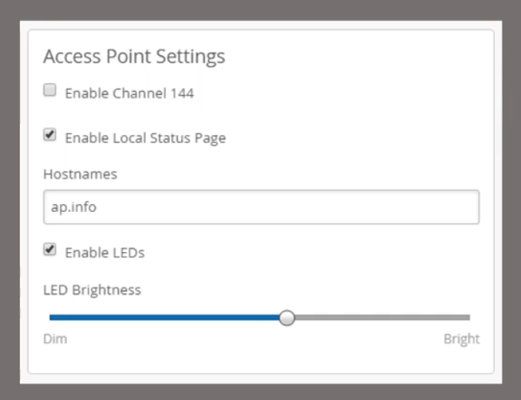
Sample of the Local Status Page
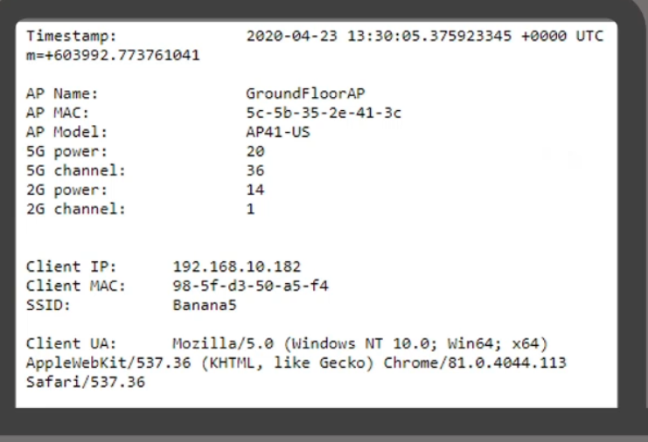

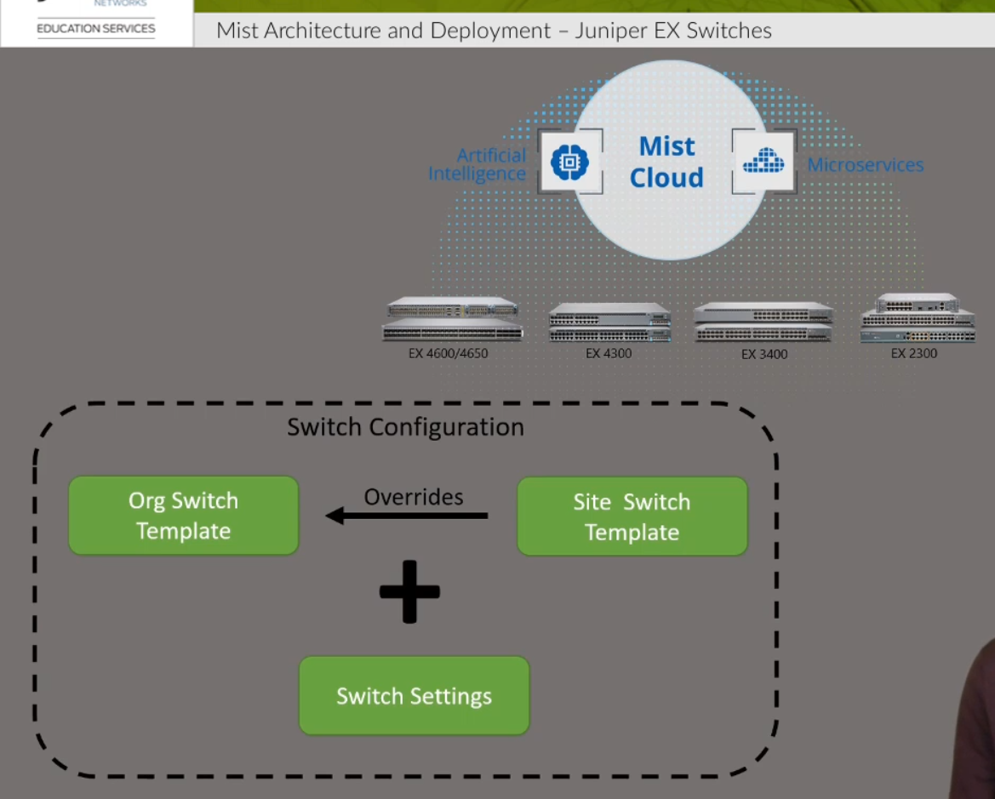

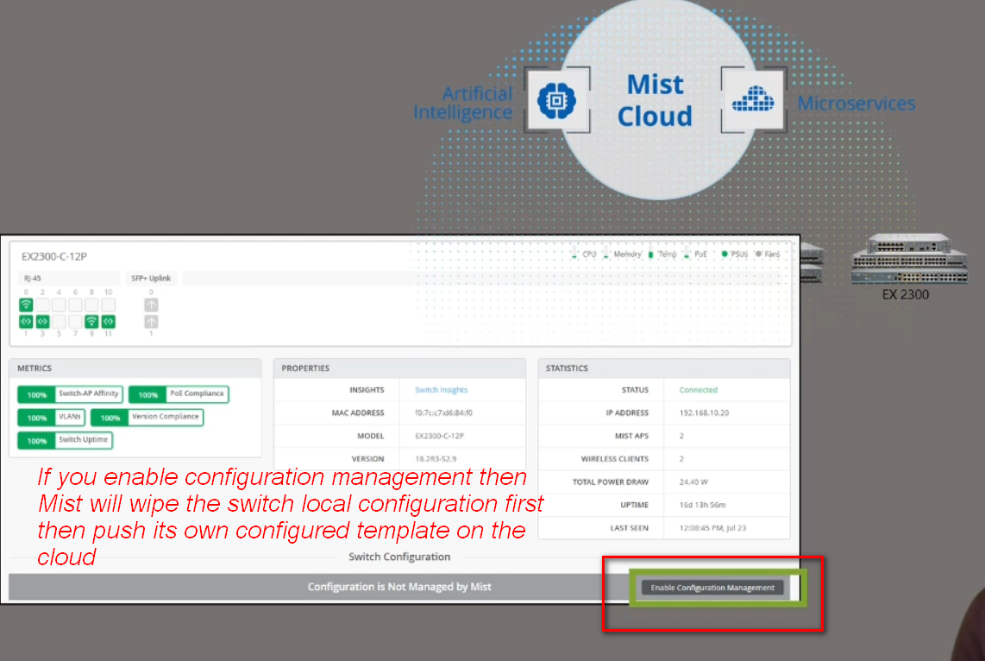

4- General WLAN Concept Part 1

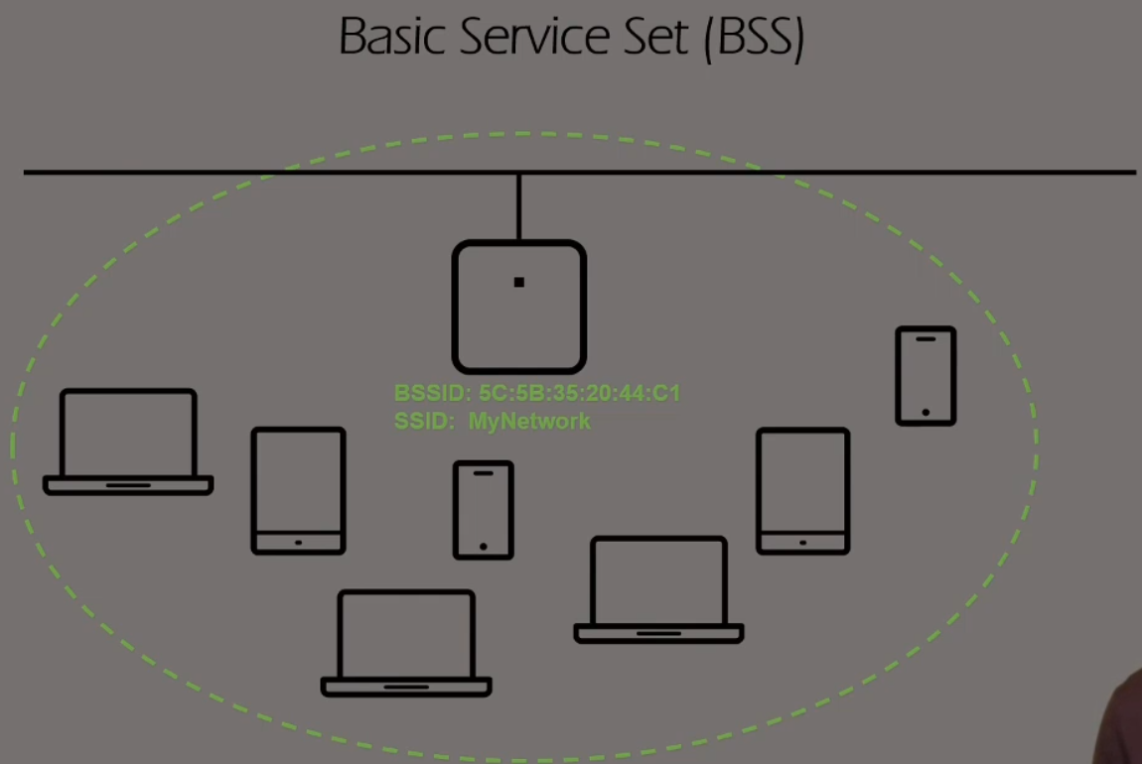

A BSS is the AP with its associated clients for a given SSID.
Each BSS has a unique Identifier called BSSID. The BSSID is the MAC address of the AP radio.
Mist AP has 16 different MAC addresses for each radio and every time you create an additional SSID, it is given one of these 16 MACs available.
Every time you add another SSID on the AP, you create another BSS.

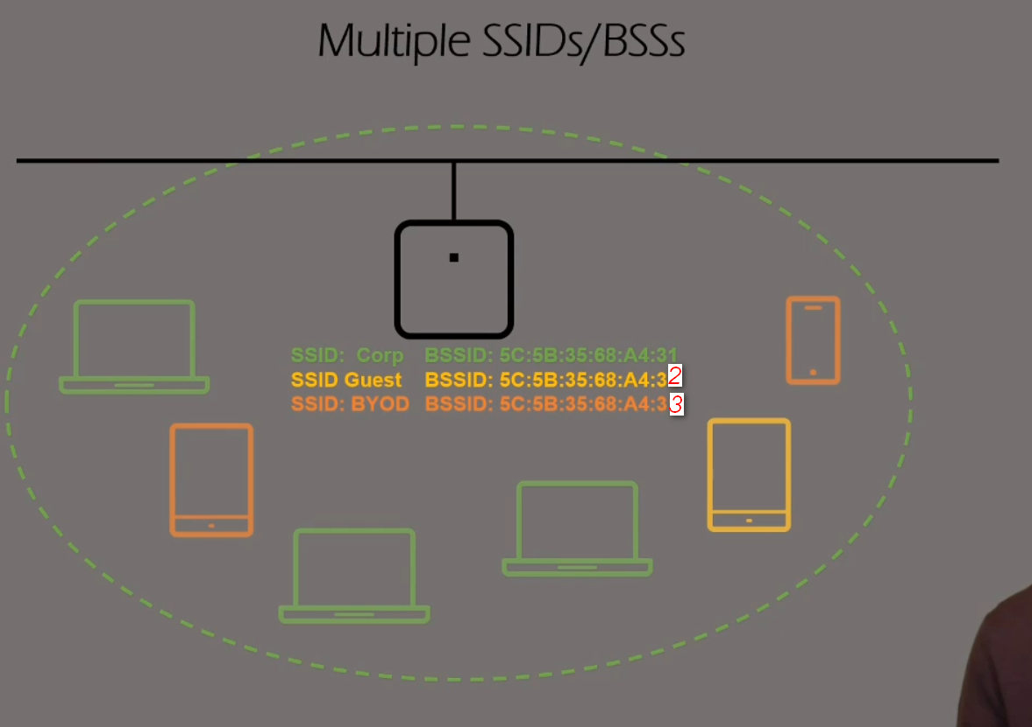

For each SSID you configure it will send an advertisement beacon every 100ms. If you have 3 SSIDs, this means it will send 3 beacons every 100ms and you are consuming the radio bandwidth and airtime with more with beacons. Beacons are between 300-400 bytes in size and they are sent at the lowest data rate supported, therefore it is recommended to disable the lower data rates so we force the beacons to be sent at high data rates and does not affect the overall efficiency of the radio.

We can configure a maximum of 15 WLANs per radio. Our APs have 2 Wi-Fi radios, so a total of 30 WLANs can be created per AP.

Maximum Number of Devices

AP43/41/33/32/12 and AP61/63
The maximum theoretical number of client associations on each should be around 500. Each radio on the AP supports up to 256 connected clients.

AP21
The maximum theoretical number of client associations on each AP21 is around 256. Each radio on the AP supports up to 128 connected clients.
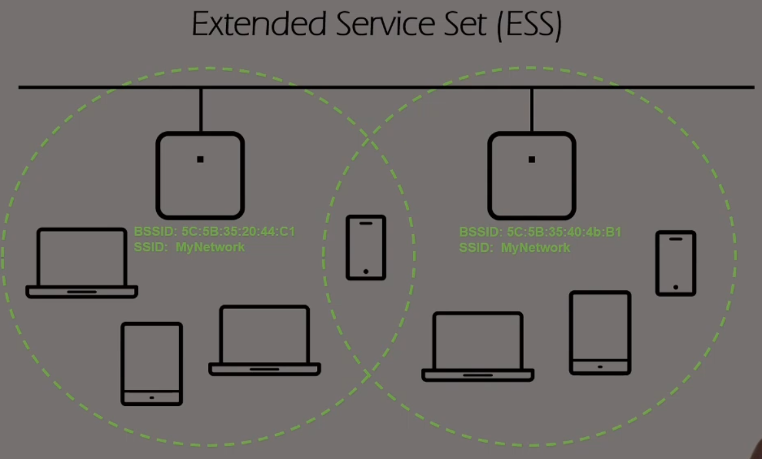

ESS is the setup of two or more APs advertising the same SSID through a common infrastructure. In others words it is formed from more than one BSS advertising the same SSID via a common infrastructure.

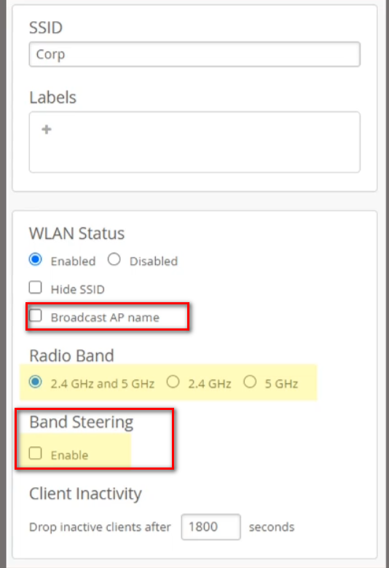
Once you hide SSID, it will not respond to probe requests and will not show in the list of available SSIDs on the devices. It is not consider a secure way to protect your SSID since anybody with a protocol analyzer can know the SSID name.

If you enable Broadcast AP name, this will advertise the AP name in the SSID and this will only be seen by WiFi tools, this is usually used for site surveys where you want to know what AP is broadcasting the SSID.
If you choose “2.4GHz and 5 GHz” this will enable dual band SSID and will broadcast the same SSID on both bands. When you choose this option it is preferred to enable band steering which tries to steer client to use 5GHz instead of 2.4GHz, but is not successful always.

Configure the user vlan of WLAN:
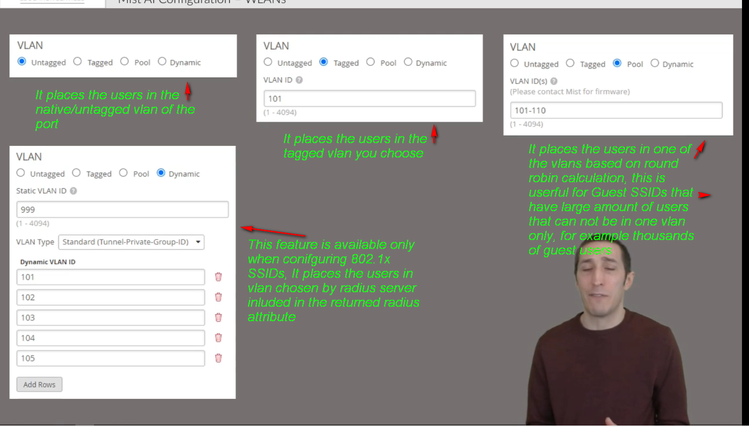

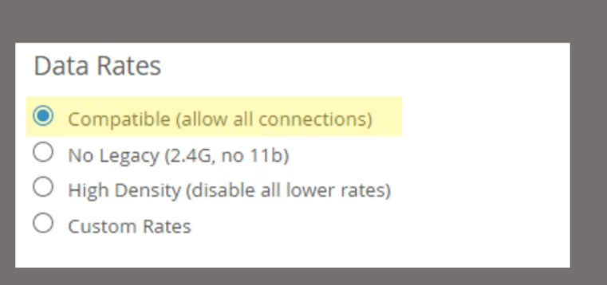
1- Compatible: it allows all types of data rates and insures that all legacy devices are supported, but at a cost that enabling slow rates affect the performance. For example, 802.11b has 22 MHz channels that overlap with the 20MHz channels of the rest of 802.11 amendments.
2- No Legacy disables the 802.11b data rates (1, 2, 5.5 and 11 mpbs)
3- High Density: it disables all data rates lower than 18 Mbps; this encourages clients to roam in high density of deployed APs.
4- Custom rates: allows you to enable or disable certain chosen rates shown below:
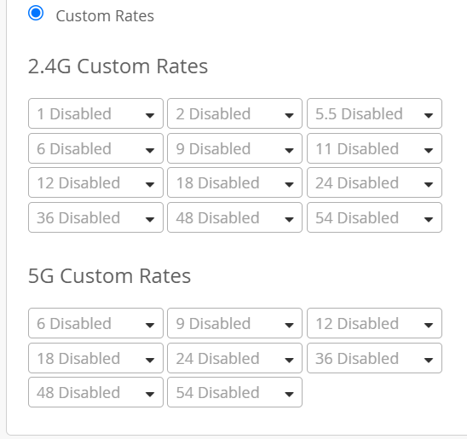

Mist Security:
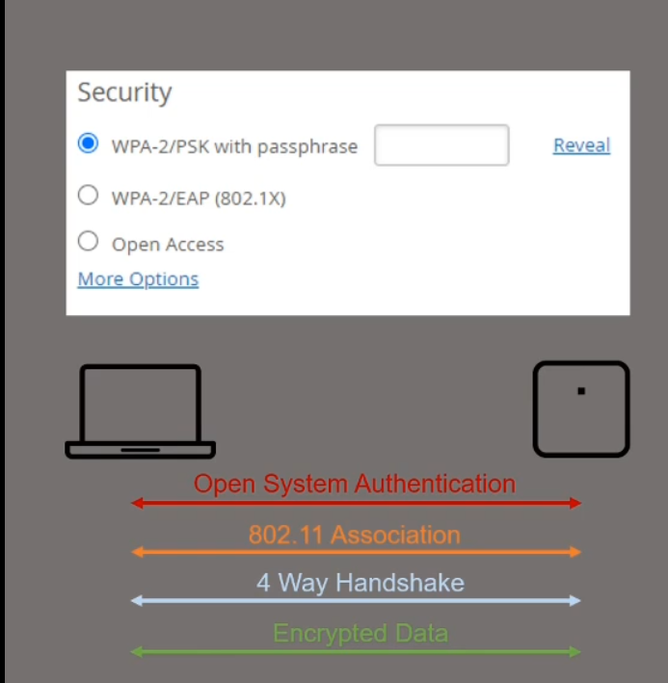

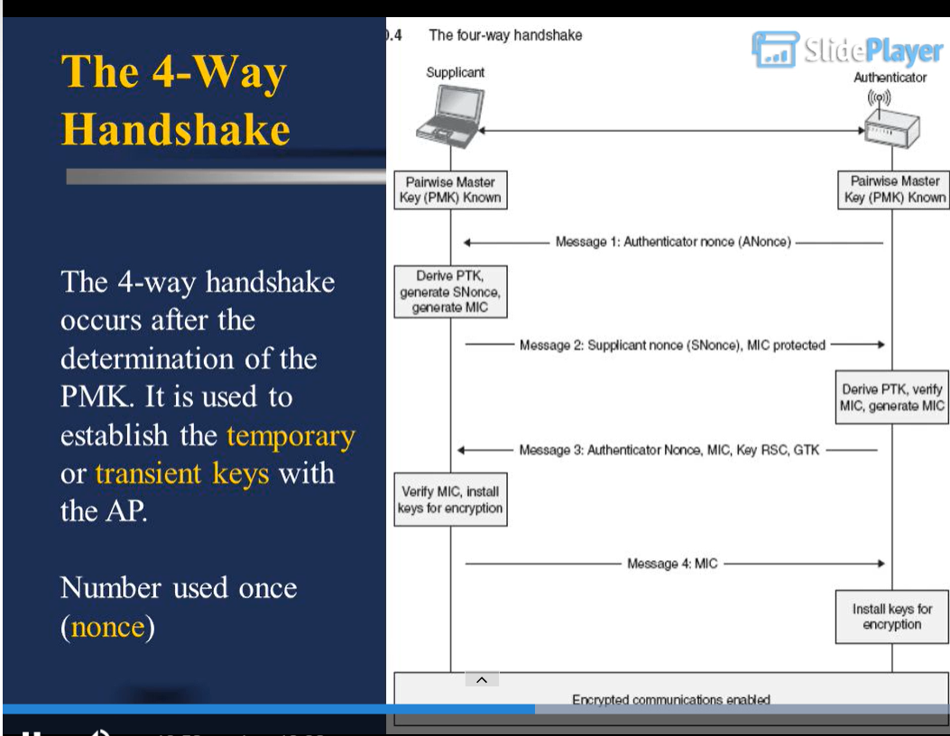
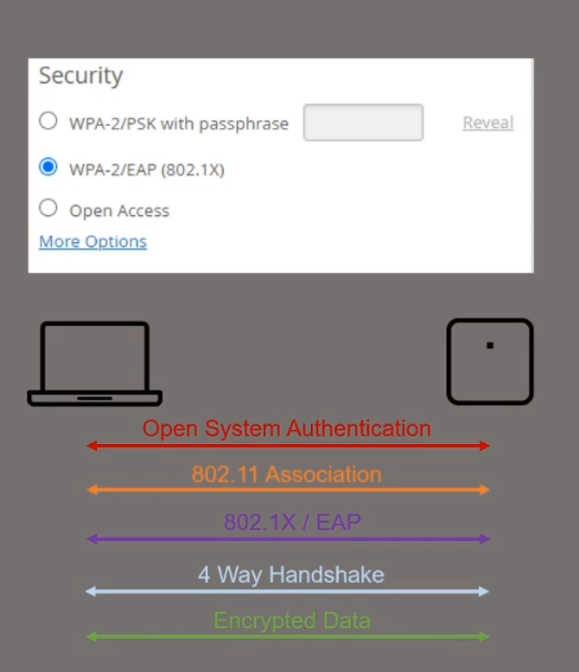

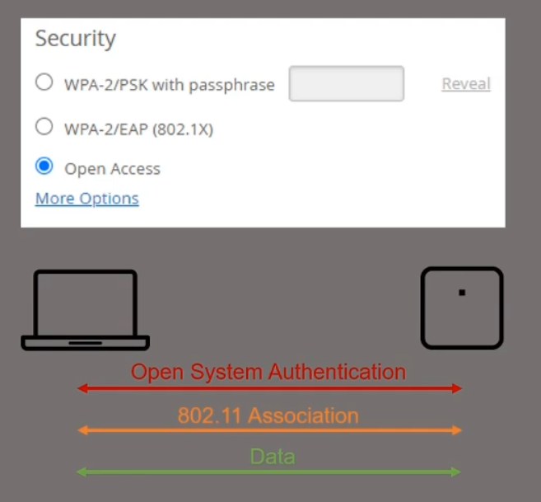

You can use multiple passwords for the same SSID and assign each password to one or group of users.
It is very useful for IoT devices that don’t support 802.11x since we configure the password and link it to a specific MAC address
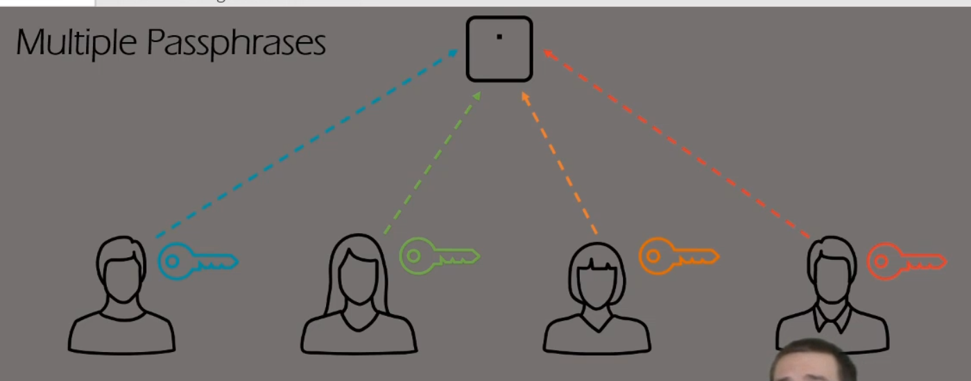

If we enable Personal WLANs (this feature is available only if enable multiple passphrases) then all the devices sharing the same PSK will be able to communicate together, however they are prohibited to communicate with other users having a different PSK.
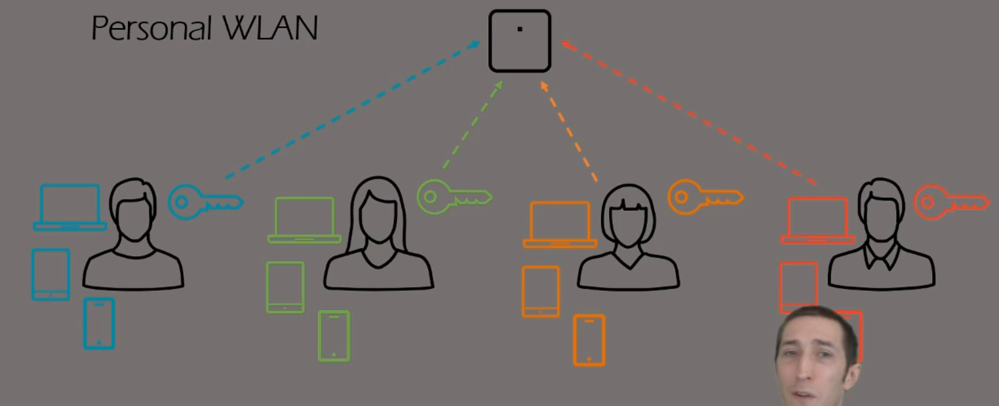

Guest Captive Portal:
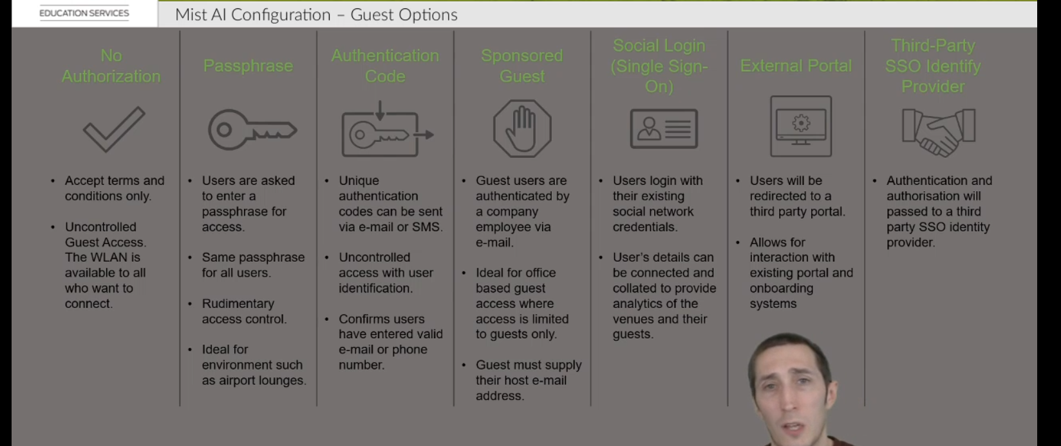

WxLAN Policies:
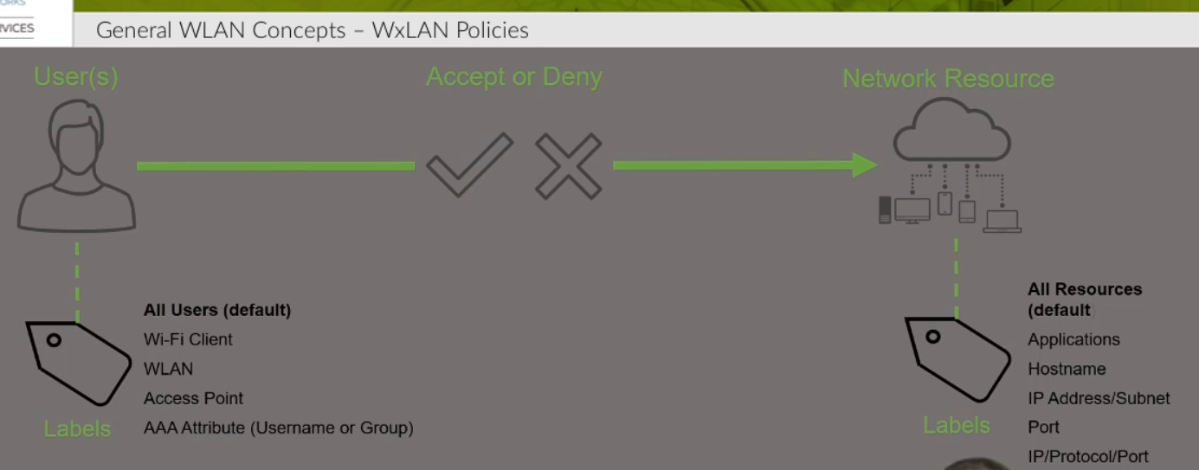
We use labels to refer to users and network resources in our policies, the type of labels supported are shown above.

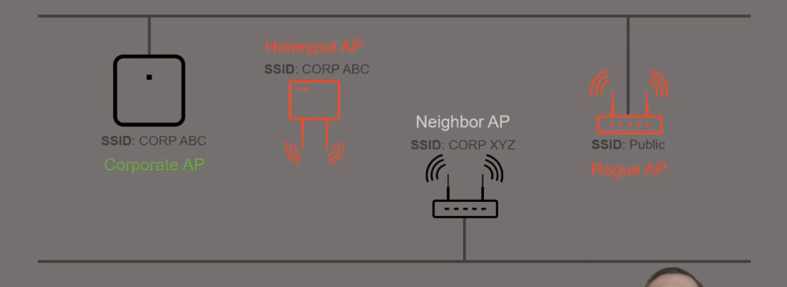
Cooperate AP and neighbor AP or genuine AP belonging to your company. The threats come from Honeypot and Rogue.
Rogue, Neighbor and Honeypot APs
In addition to the 2.4 GHz and 5 GHz radios, our Mist APs also contain a third radio dedicated to scanning. This radio is used for detecting Rogue, Neighbor, and Honeypot APs on both 2.4 GHz and 5 GHz radio bands. This means that regardless of which radios you have enabled on your AP (2.4 GHz or 5 GHz), it will still be able to detect unauthorized APs at any frequency using the scanning radio.
Honeypot APs are unauthorized APs advertising your SSID. A bad guy might be trying to spoof your login screen to capture your password. This is an obvious security risk that should be detected and monitored. Detection of Honeypot APs can prevent such threats to your network and is enabled by default under Site Settings.
Mist AP’s also scan for unknown APs who are classified as a Neighbor AP. You can set an RSSI threshold as a criteria for detecting these Neighbor APs in proximity of your network.
Rogue APs are defined as any AP not claimed onto your Organization, but detected as connected on the same wired network. Rogue APs share the same Local area network, but are unknown to your Organization.
The Rogue AP detection is disabled by default. Please go to Organization -> Site Configuration to enable it. Here you can enter an RSSI threshold value at which APs will be detected as neighbor/rogue. The default RSSI is -80dBm – you may set the RSSI Threshold for Rogue AP detection between -40dBm to -100dBm. Also, set a Time threshold for Neighbor AP detection to prevent getting flooded with “neighbor” APs which only appear momentarily.
To prevent sanctioned APs from being identified as Rogue or Honeypot, allowlist the specific SSID and BSSIDs of known access points in the Security Configuration box.
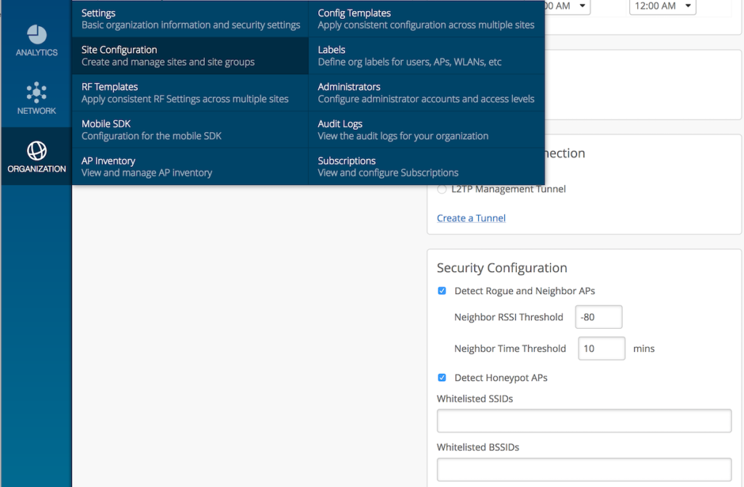
Expand image

To view the list of Neighbor, Rogue, and Honeypot APs, navigate to Network -> Security. Rogue and Honeypot APs are under the Threats tab and Neighbor APs has its own tab. You can switch between the tabs to view the desired APs.
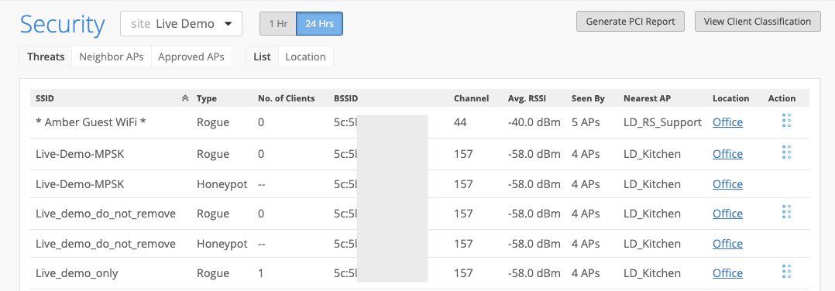
Expand image

Expand image
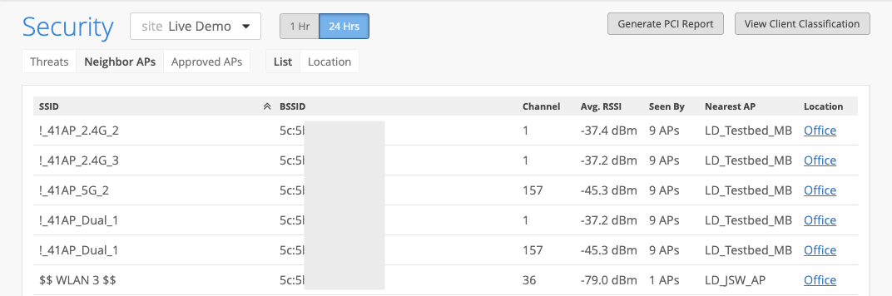

The Rogue AP detection is disabled by default. Please go to Organization -> Site Configuration to enable it. Here you can enter an RSSI threshold value at which APs will be detected as neighbor/rogue. The default RSSI is -80dBm – you may set the RSSI Threshold for Rogue AP detection between -40dBm to -100dBm. Also, set a Time threshold for Neighbor AP detection to prevent getting flooded with “neighbor” APs which only appear momentarily.
Expand image
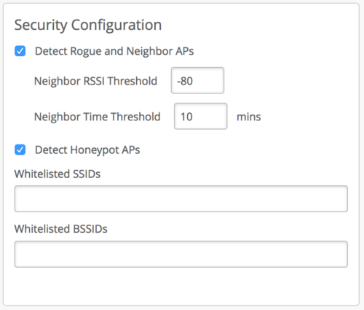
To prevent sanctioned APs from being identified as Rogue or Honeypot, allow list the specific SSID and BSSIDs of known access points in the Security Configuration box.
To view the list of Neighbor, Rogue, and Honeypot APs, navigate to Network -> Security. Rogue and Honeypot APs are under the Threats tab, and Neighbor APs has its own tab. You can switch between the tabs to view the desired APs.

5- General WLAN Concept Part 2

WxPolicy:
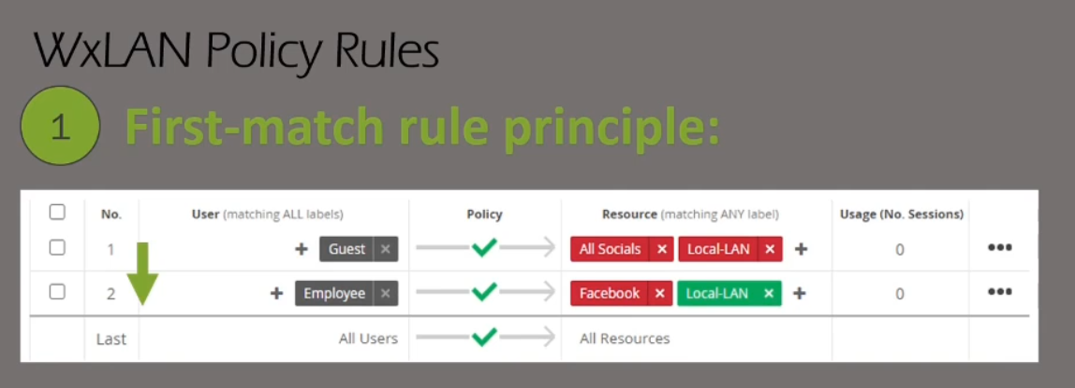
In this rule, if the user belongs to the “Guest” Label then it will apply only this policy, it will not continue to check if there is any policy that has “Guest” user. This is First-match rule.

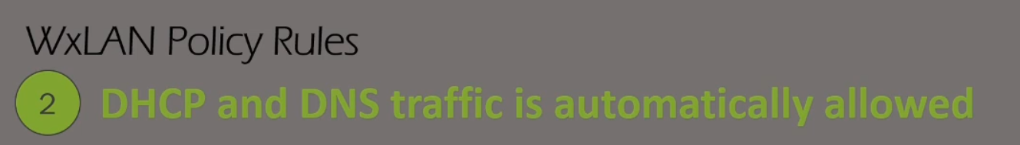
You can not block DHCP and DNS traffic at all.

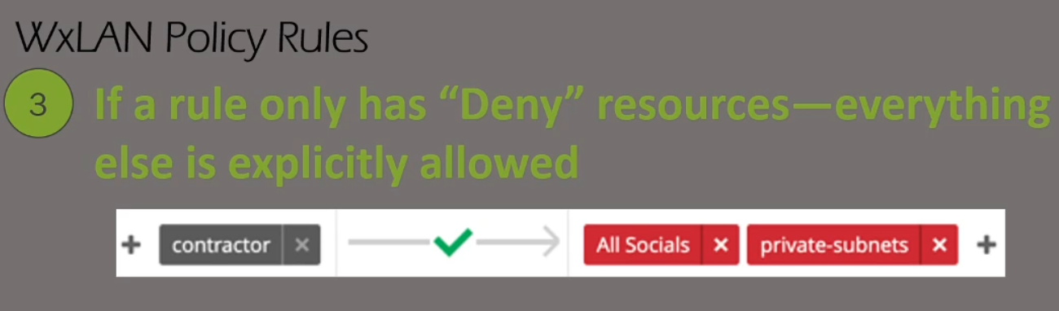
If the policy is only blocking resources then everything else is allowed.

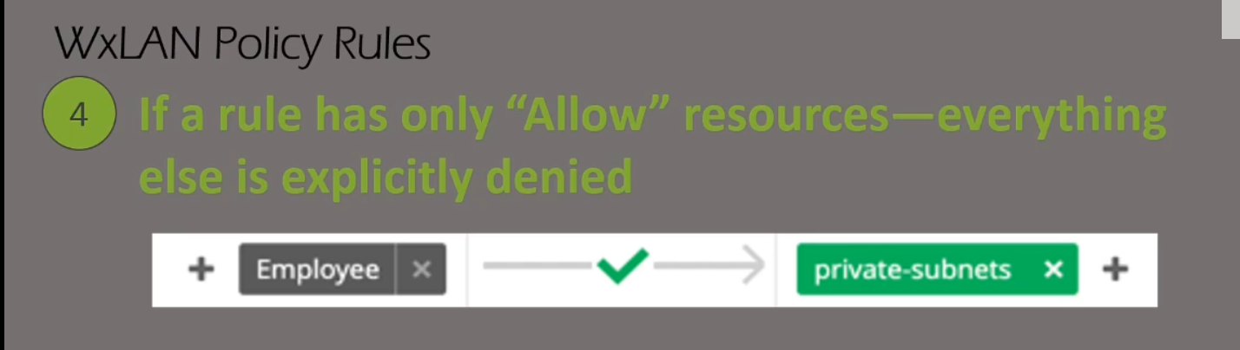
If the policy is only allowing resources then everything else is blocked.

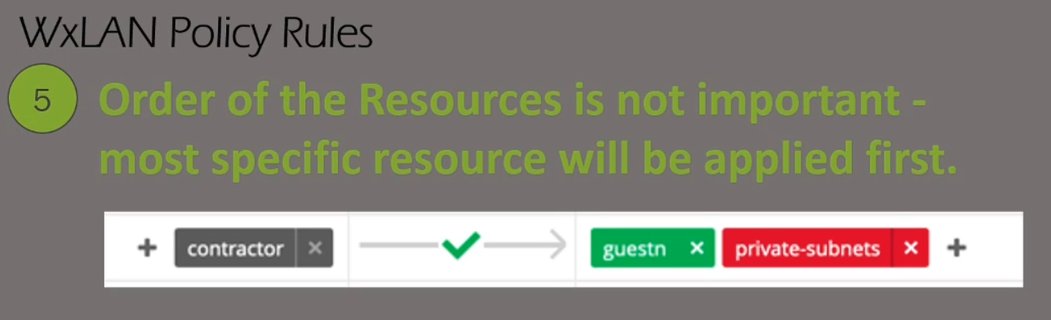
If the single policy is blocking some resources and blocking others then order does not matter if the green or red resource comes first in the policy. (“guestn” can be on the left or right of “private-subnets” in the policy above)

6- MIST Network Operations Part-1

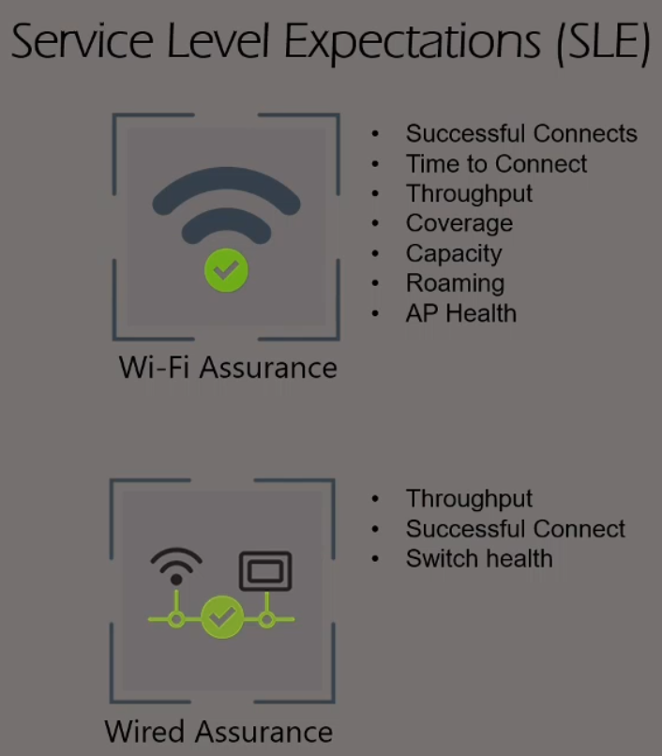

SLE Classifiers:

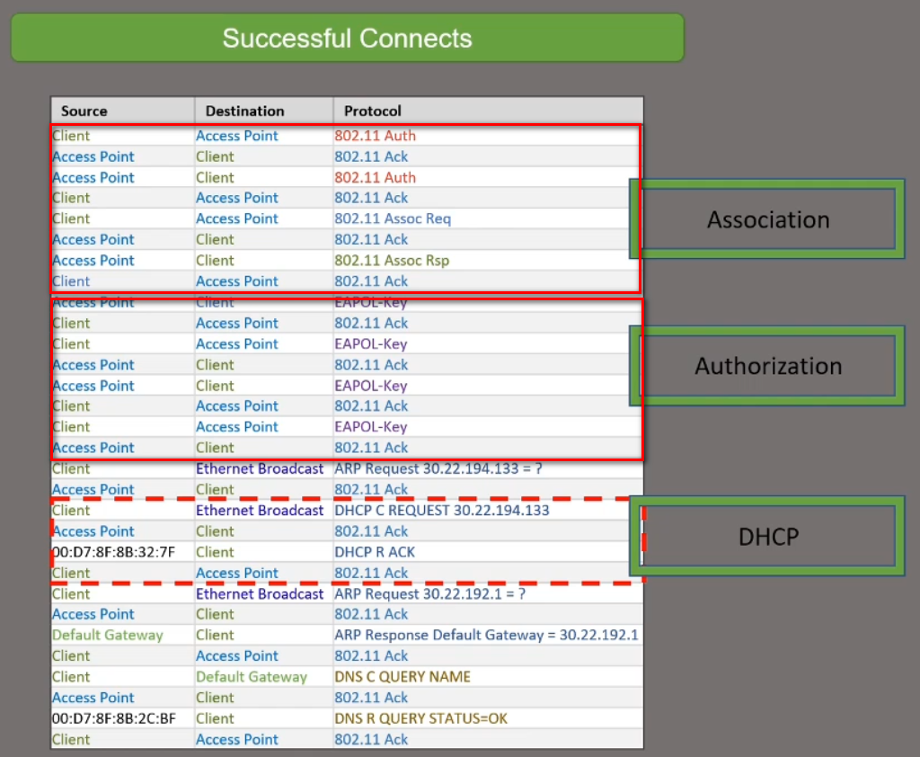
DHCP classifier check if the client received an IP
Authorization classifier checks if the client has gone through 802.1x EAP or PSK Authentication
Association classifier checks if the client has gone through 802.11 Authentication and Association

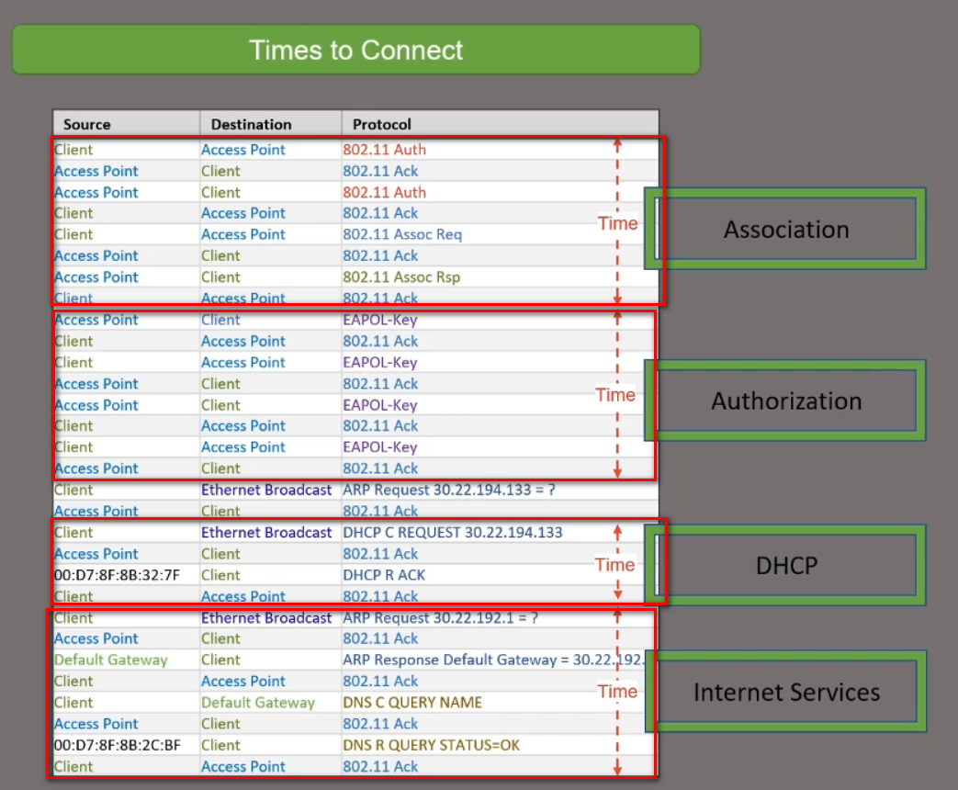
Association classifier checks the time it took the client to go through 802.11 Authentication and Association
DHCP classifier check the time it took the client to receive an IP
Authorization classifier checks the time it took the client to go through 802.1x EAP or PSK Authentication

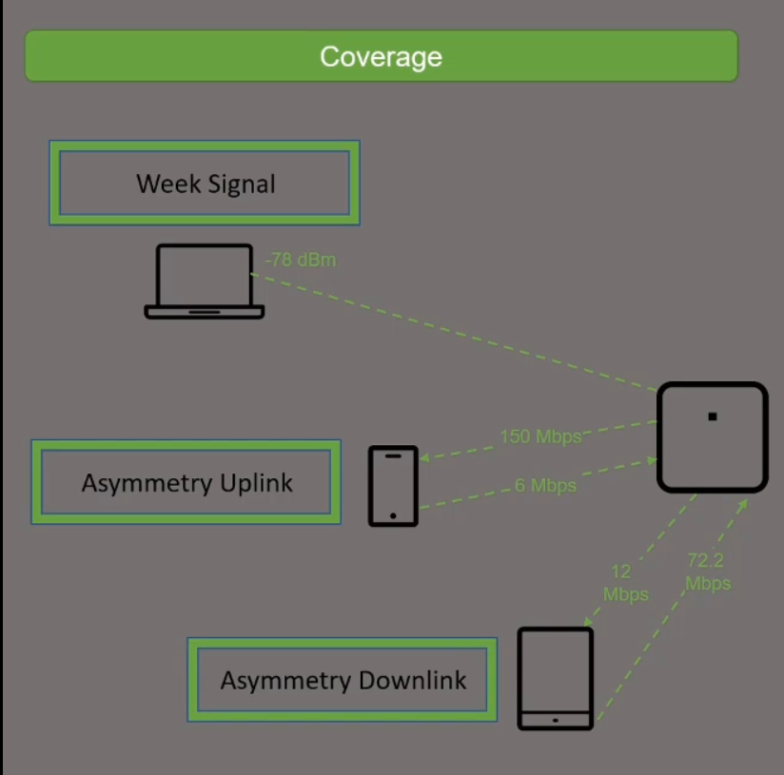
This SLE is to check if you have enough APs

Asymmetry indicates there is a power level mismatch between the client & AP. Since APs are capable of higher power levels than a client, if power levels are set too high, then there is a chance that the low powered client is not heard by the AP, resulting in an asymmetry uplink issue.

As the received signal strength gets lower it gets closer to the background noise level. This makes it more difficult for the radio in your device to differentiate between the desired signal and the noise. Eventually data errors occur and the data bits need to be resent thus slowing down the data speed. Radios can also negotiate a slower speed with the wireless access point to improve the reliability of the data.

1- Better signal strength implies higher Signal to Noise Ratio (SNR) at the receiver, and thus less errors (more number of successful transmissions);
2- The maximum achievable data rate depends on SNR Shannon–Hartley theorem. So for a fixed error rate, the data rate can be increased as signal strength increases.
3- Increasing the SNR makes the transmitted symbols more robust against noise and produces a stronger RF link. This allows for more advanced modulation methods and increases the amount of data transmitted, i.e. better videos and less errors.
Different modulation schemes (Data Rates) are applied for different signal levels.
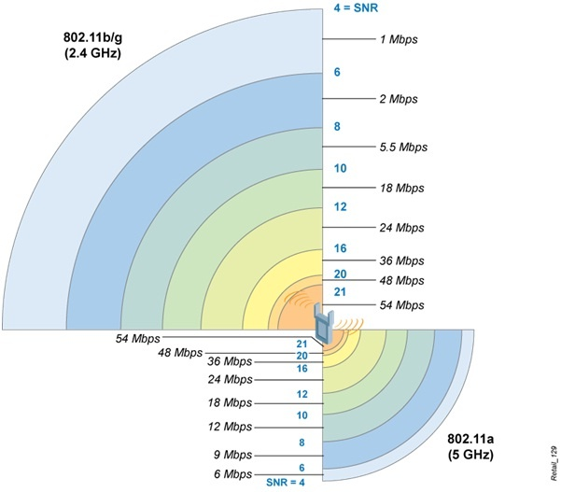

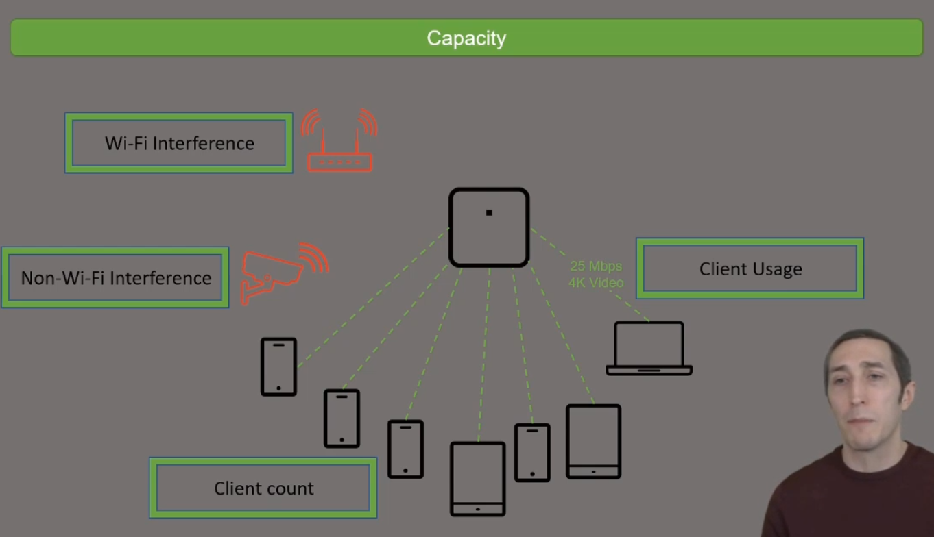
Capacity means is there enough RF left in the channel for more users.
Wireless capacity relates to the number of users who can use your wireless simultaneously in one place, and how (and at what rate) they are using bandwidth. ... In these locations it's important to maximize WiFi capacity to meet the needs of all users in the network, taking into account potential traffic at peak hours
If once user is consuming huge data then this will affect the RF availability for others.
This SLE measure the amount of time it takes a user successfully roam to another AP.
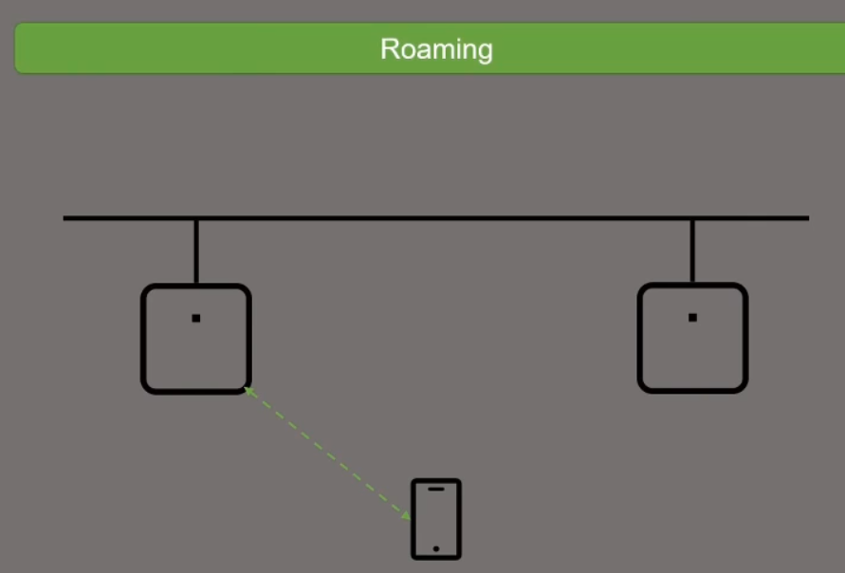

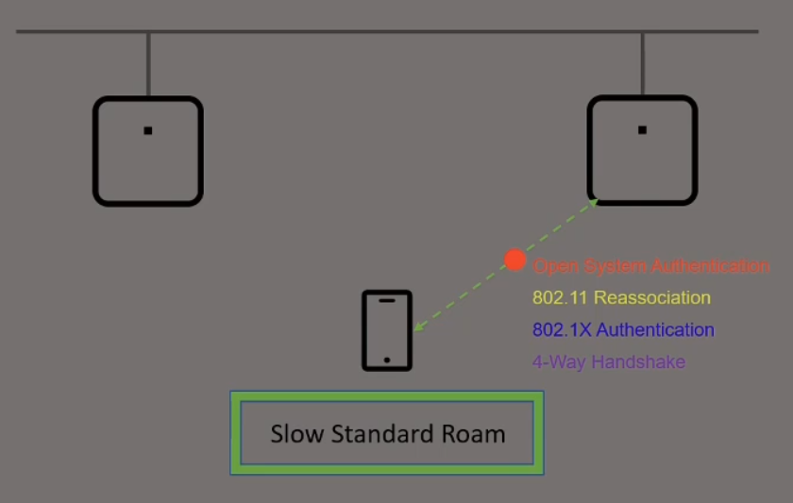
It measures the time for the client to perform a full standard roam including the four steps mentioned.

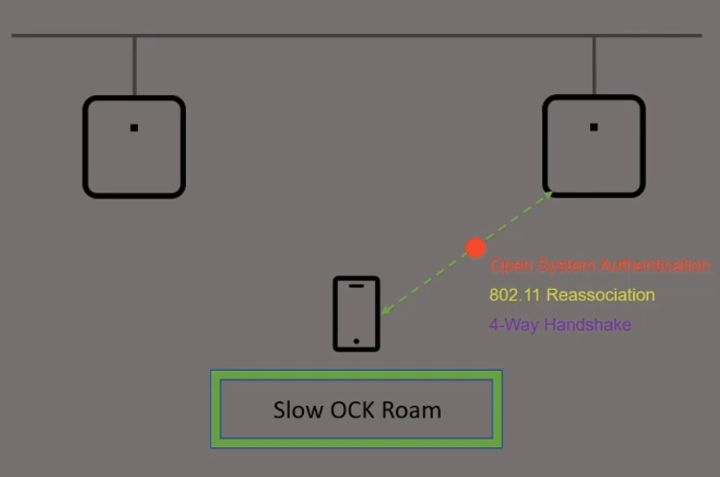
It measures the time for the client to perform OCK roam including the three steps mentioned. OCK skips the 802.1x authentication for faster roaming

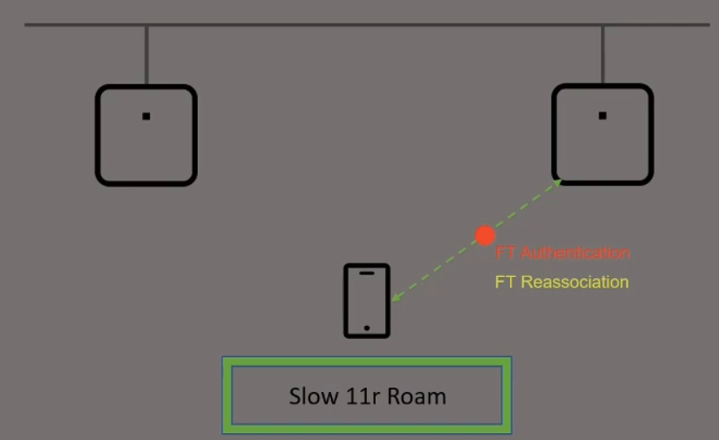
It measures the time for the client to perform OCK roam including the two steps mentioned. 802.11r skips the 802.1x authentication for faster roaming and merges the 4-way handshake in the frames on the two steps mentioned.

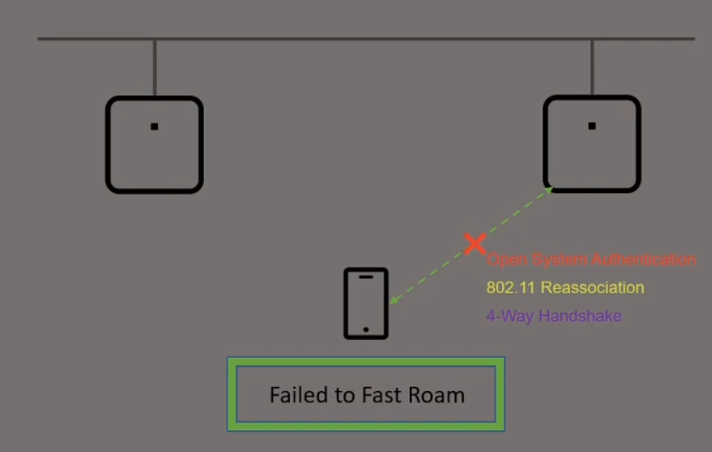
It looks for situations where the client tried to fast roam and fails

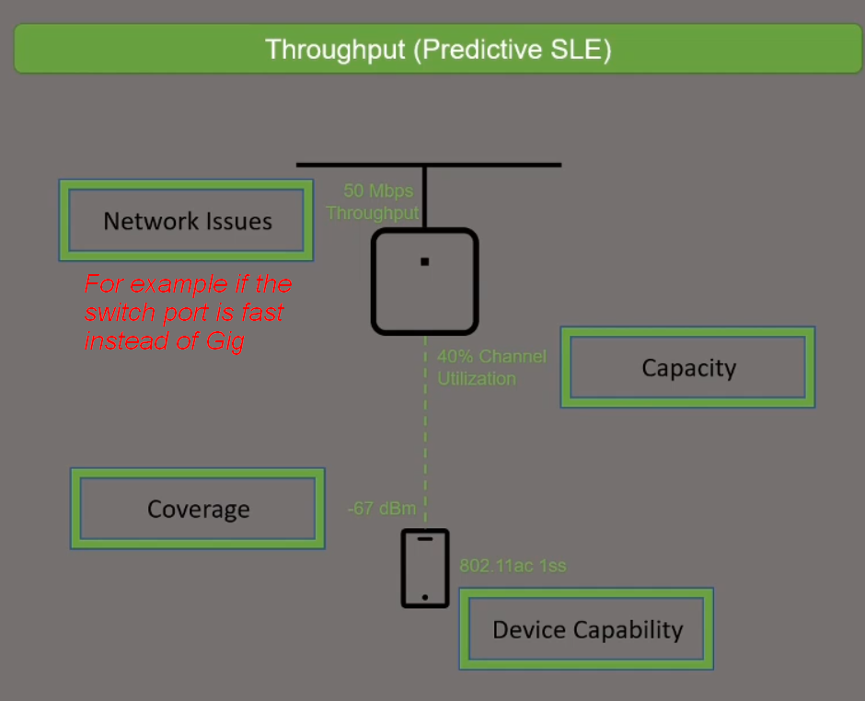

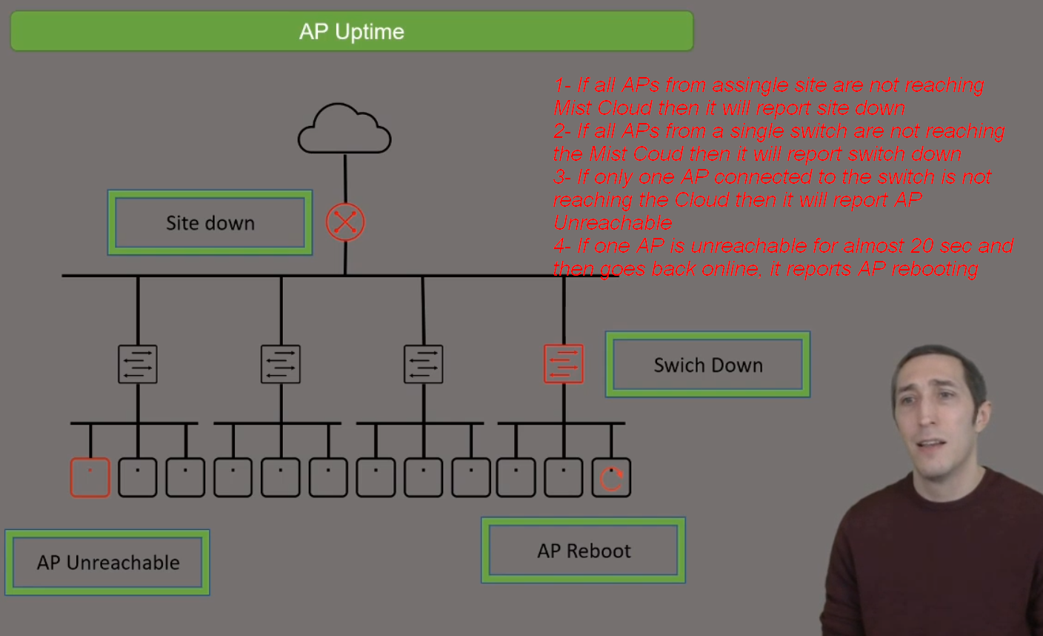

Wired Assurance:

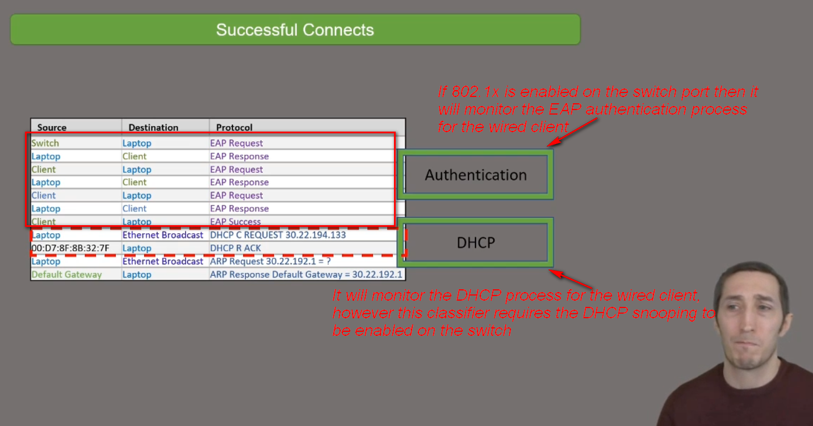

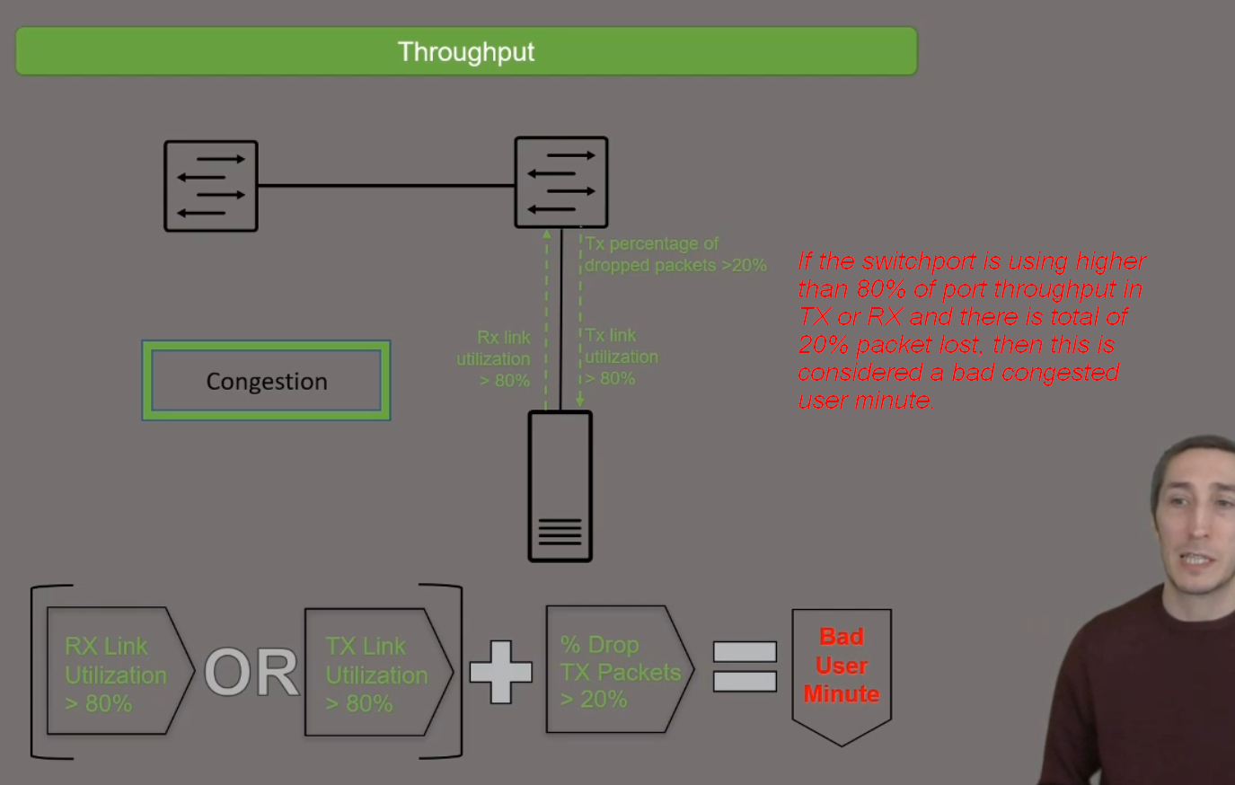

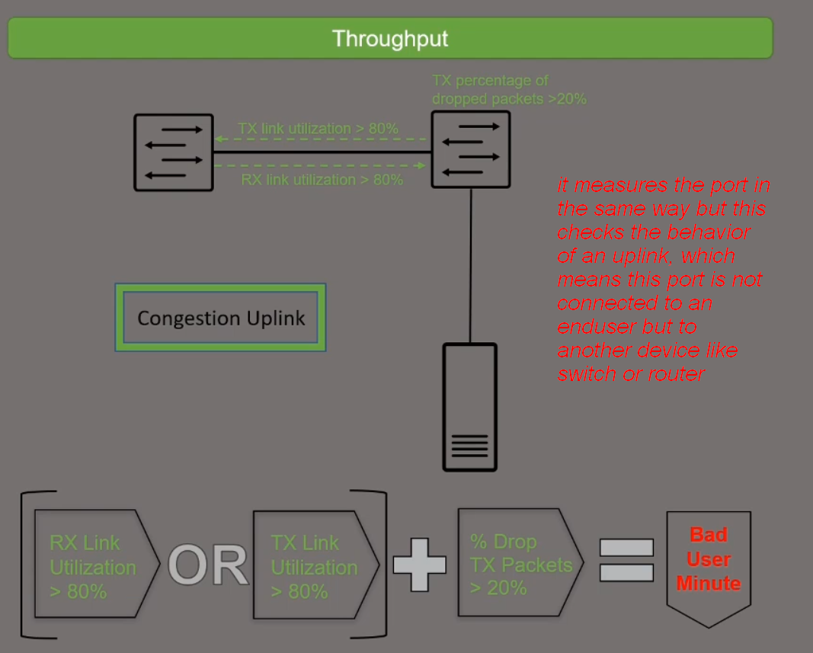

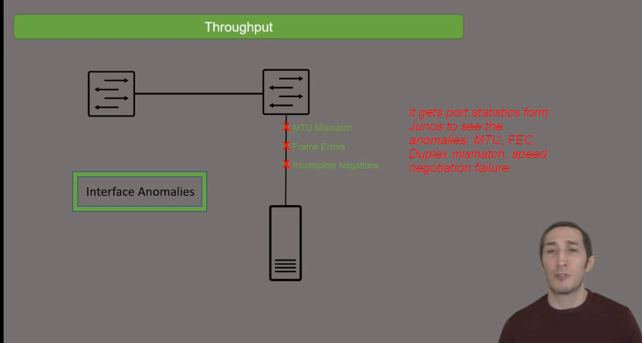
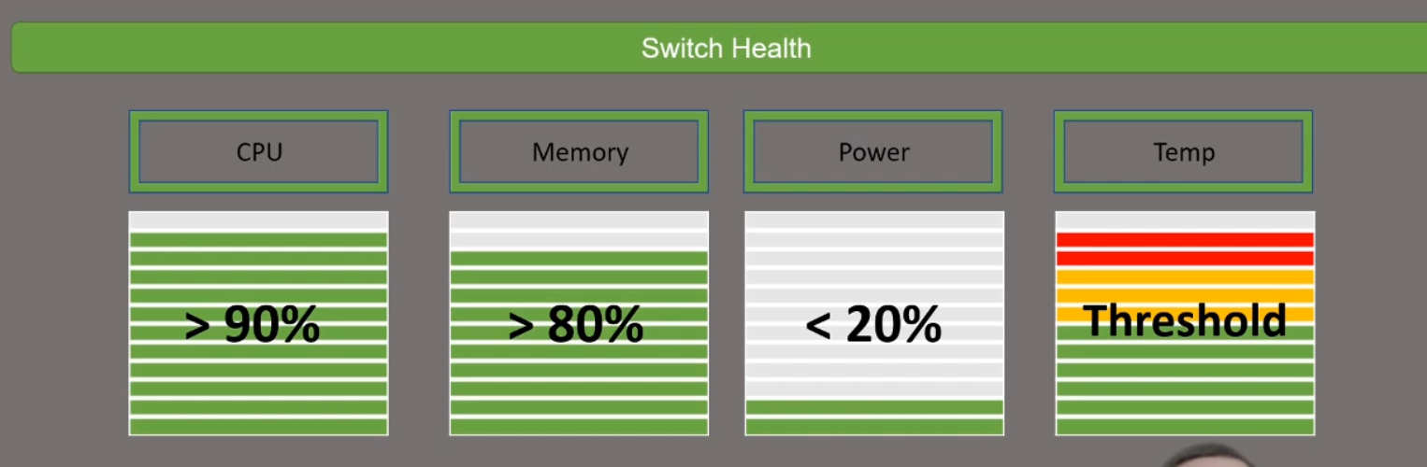
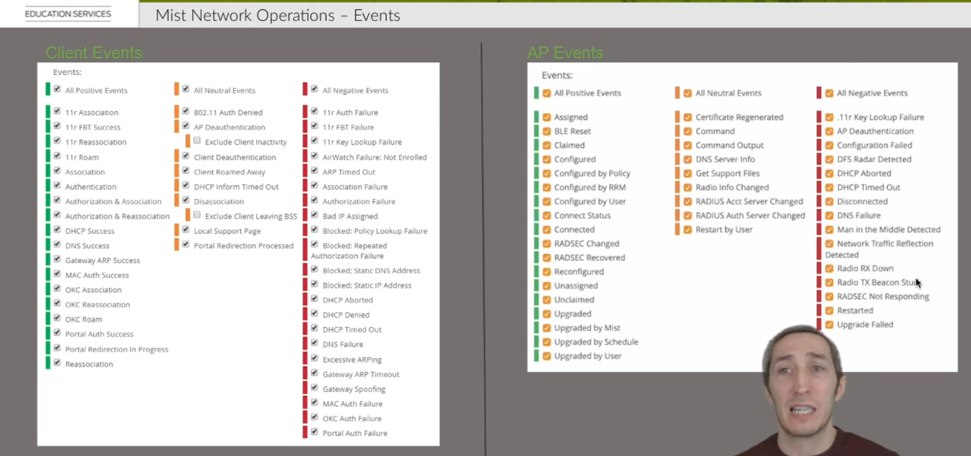
Events:

Site Events:
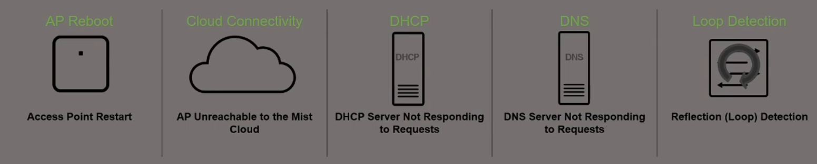
These events trigger an email sent if you enable this on your My Account Settings:
Pick and choose the specific sites you wish to get alerts for by navigating to 👤> My Account.
In order to receive an email for unresponsive DHCP or DNS, ten or more clients must have unresponsive requests in a window of 10 minutes to trigger an email to the site admin.

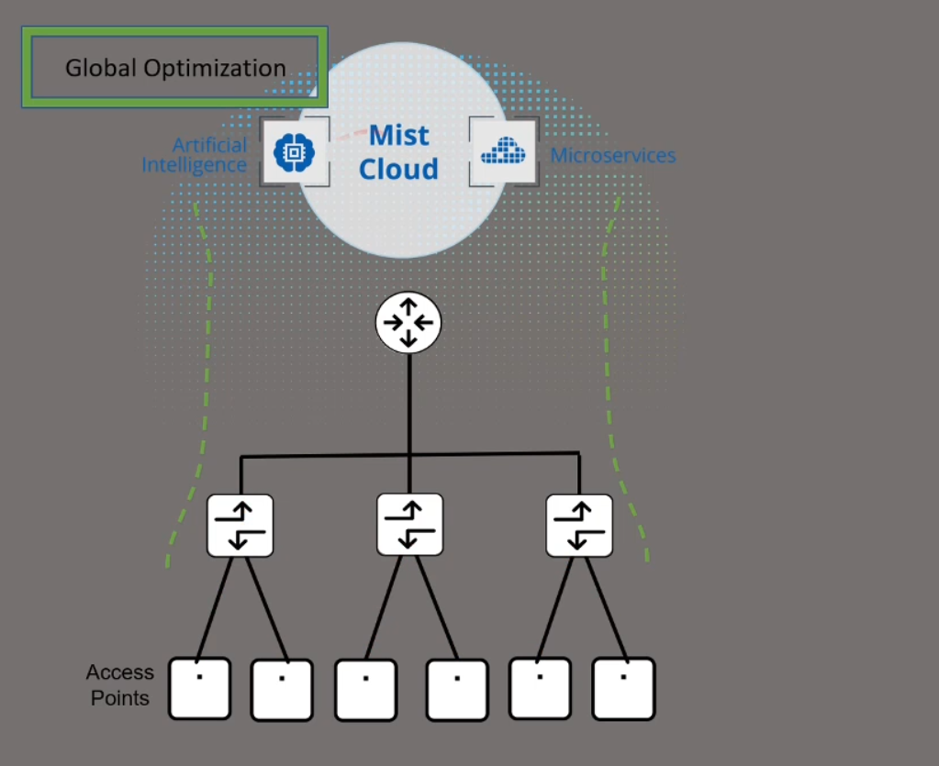
RRM:

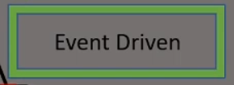

There are two types of RRM algorithms for optimization:
1- Global Optimization (Pushes the new radio settings if required between 2AM and 3AM)
2- Event Driven

Global Optimization algorithm sits in the Mist Cloud and takes optimization decisions based on the long-term events and baseline. These new optimized settings are pushes automatically once a day between 2AM and 3AM in your local time.
Event Driven algorithm runs on each AP and takes optimization actions based on environmental changes similar to Wi-Fi and non-Wi-Fi interference and radar DFS events.

If you click on optimize now this will optimize the radio instantly instead of waiting for the global optimization at 2AM to push the optimization settings.
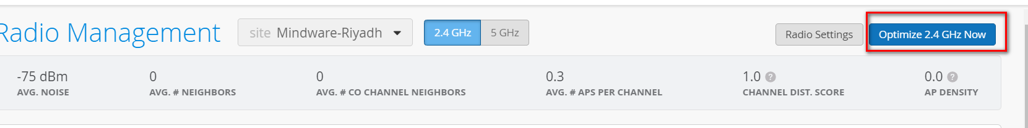

Radio Management: Event Types
In Radio Management, there are several event types in the Radio Events section of the page:
Expand image
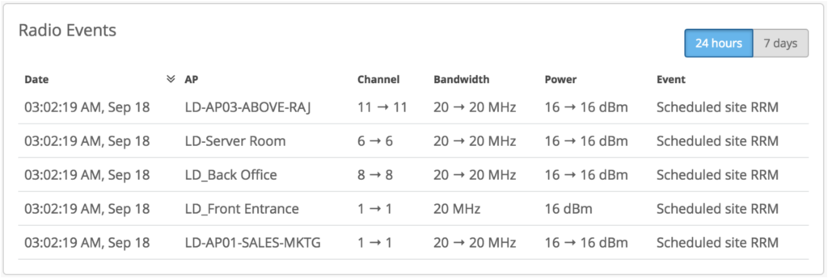
The AP shouldn’t automatically re-optimize unless necessary (ie: interference). So either you have to click “Optimize Now” to apply it immediately, or you can wait until ~2:00AM local time for our backend to optimize for you
Scheduled site RRM event occurs every day at around 3am. Here, RRM automatically checks how the interference is between radios (and other noise sources) at a site and adjusts the channels to prevent such interferences for the following day.
Triggered site RRM event will occur when you hit Optimize Now or make changes in the radio characteristics of an AP and save them.
Auto channel selection event will occur when an AP reboots or when you add a new AP on your site – the new AP is getting the radio parameters automatically from the site.
Auto Triggered ACS mainly happens 1 hour after auto channel selection. In Auto Triggered ACS, RRM checks the AP channel and scan data to decide whether a better channel is available.
Interference AP co-channel
Co-channel interference occurs when 2 or more AP’s are using the same channel. It causes unnecessary contention as all AP’s and clients will be forced to defer transmissions until the medium is clear. So when AP detects this on Site AP changes the channel with a event of Interference AP co-channel
Interference AP non wifi
Non-wifi interference are non 802.11 devices. These devices include microwave ovens, cordless phones, Bluetooth devices, wireless video cameras, outdoor microwave links, wireless game controllers, Zigbee devices, fluorescent lights, WiMAX, wireless bulbs and so on. Even bad electrical connections can cause broad RF spectrum emissions create interference. So when AP detects this on Site AP changes the channel with a event of Interference AP non wifi
Radar detected : When AP’s use DFS channels, they are required to backoff when radar is detected. Which shown as Radar detected event in UI.

7- MIST Network Operations Part-2

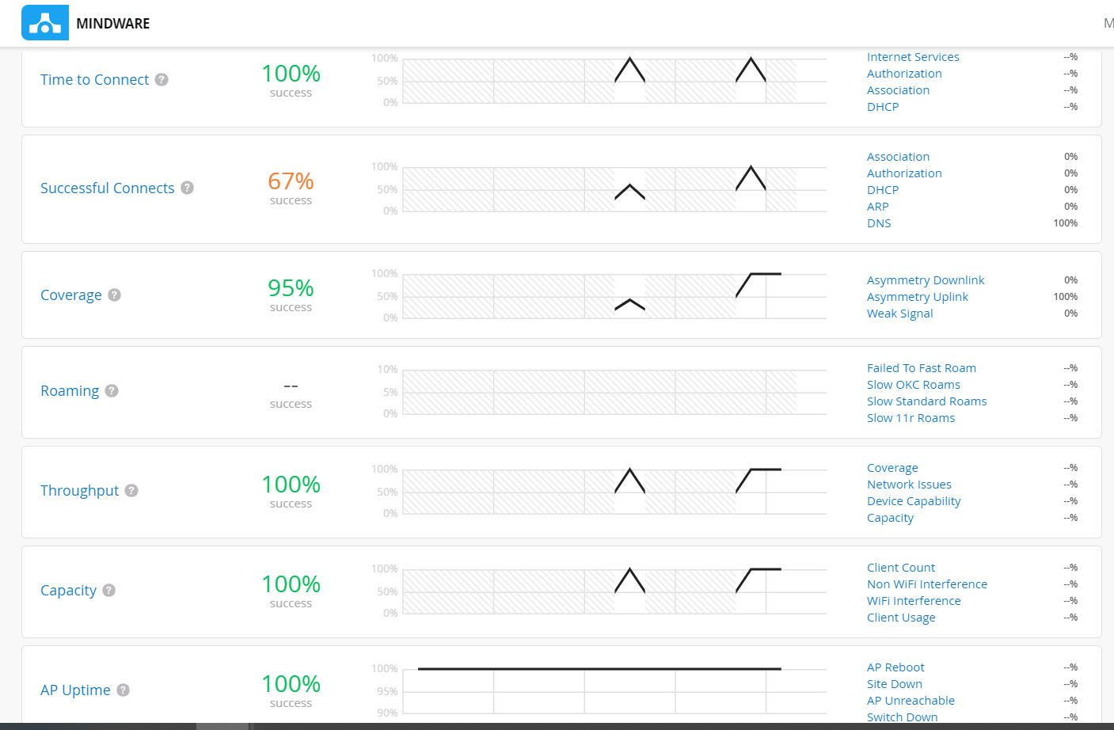
The percentage meaning in the SLEs differ from each other.
- For the “Time to Connect” the percentage is referring to the number of connections that happen in a timely matter.
- For the “Successful Connects” the percentage is referring to the number of successful connections
- For the “Roaming” the percentage is referring to the number of successful roamings that meet the configured threshold time
- For the “Capacity”, “Coverage” and “Throughput” the percentage is referring to the successful user minutes. If we have 10 users that are connected for 1 hour then we have 600 user minutes and we see the SLE for this amount of minutes that meets our thresholds

8- Mist Location-based Services (LBS)

1- WiFi assurance can locate connected and non-connected devices with accuracy of 5-10m
2- User Engagement enables the BLE to send advertisement packet to users that run MIST SDK APP and provides the highest accuracy of 1-3m. The drawback of this license is locations services is available only for devices running MIST SDK APP
3- Asset Tracking enables the MIST BLE radio to listen to third party BLE antennas such as a BLE asset tag on boxes and estimates the location.
User Engagement allows transmit of advertisement packets from MIST BLE radio to MIST SDK Application. However, Asset Tracking allows Mist BLE radio to listen to third party advertisements coming from assets and then estimates their location.
User Engagement Mist BLE sends advertisement capability
Asset Tracking Mist BLE receives advertisement capability
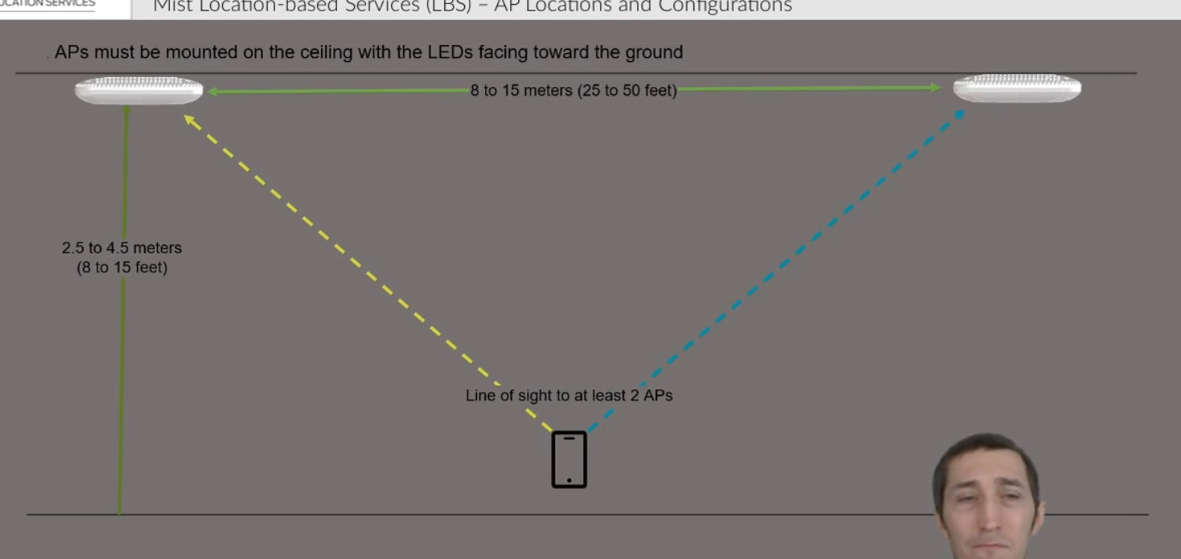

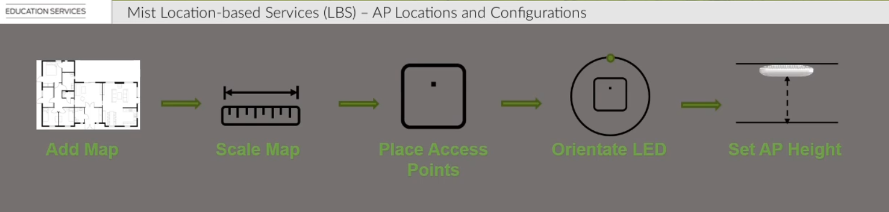

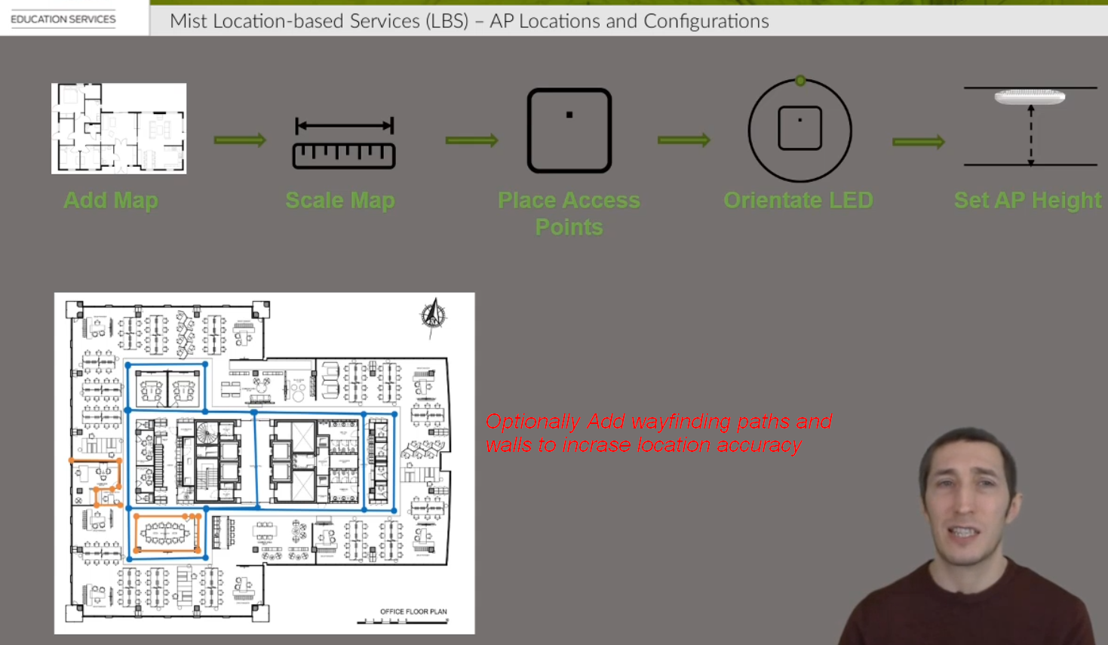

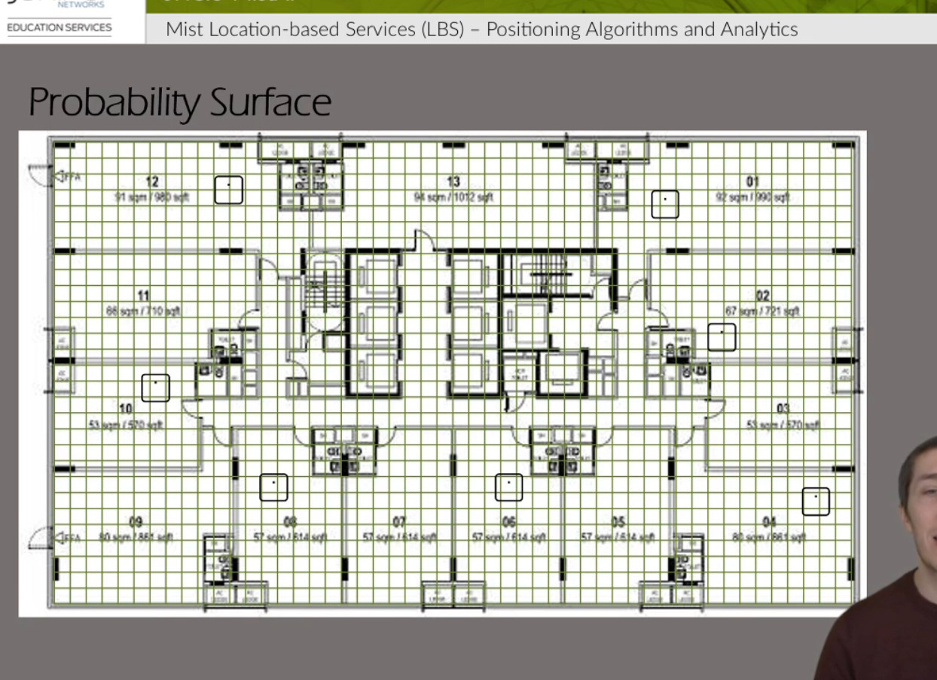

Mist divides the floor plan map to one by one meter squares and ahead of time estimate the RF finger prints for each device per square.

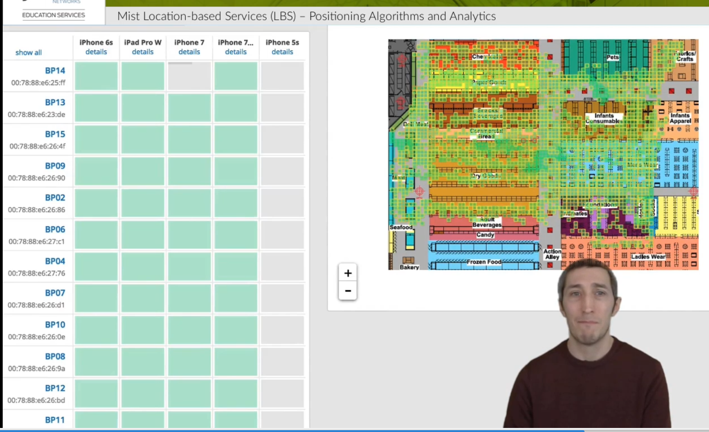
Through machine learning algorithms Mist will understand how each device hears the APs in each square and calculates the device location.

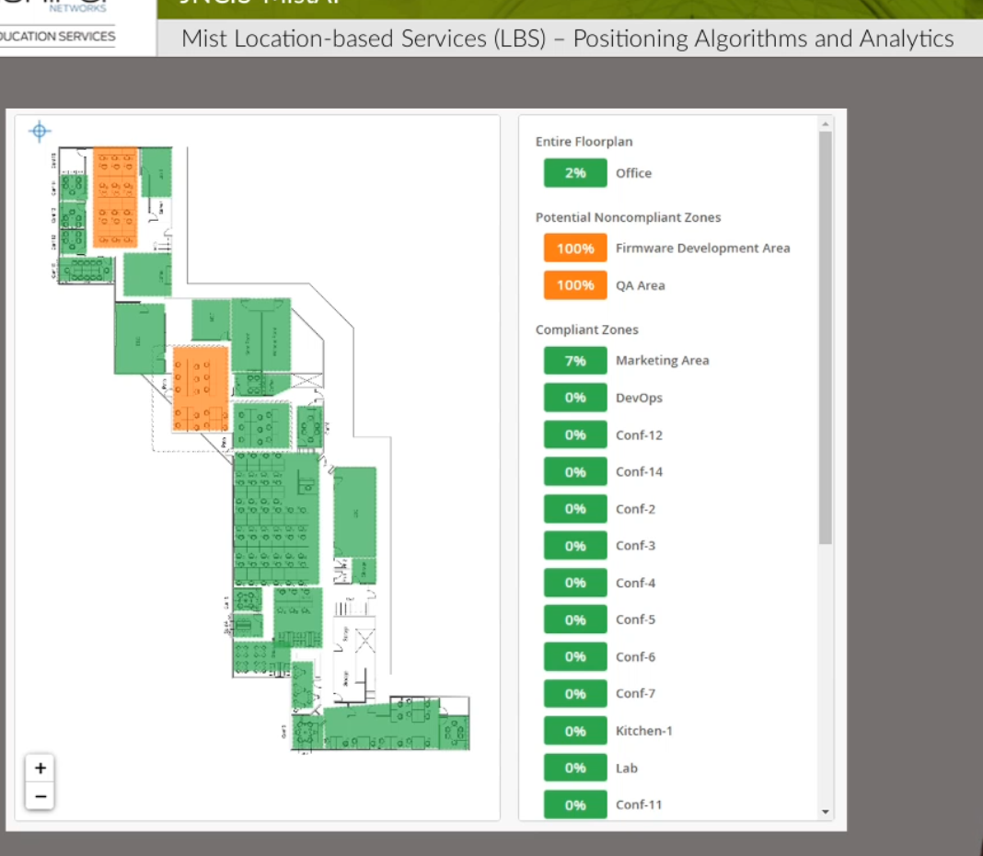

You can define zones on the floor map and occupancy limits can be added to zones to identify congestion.

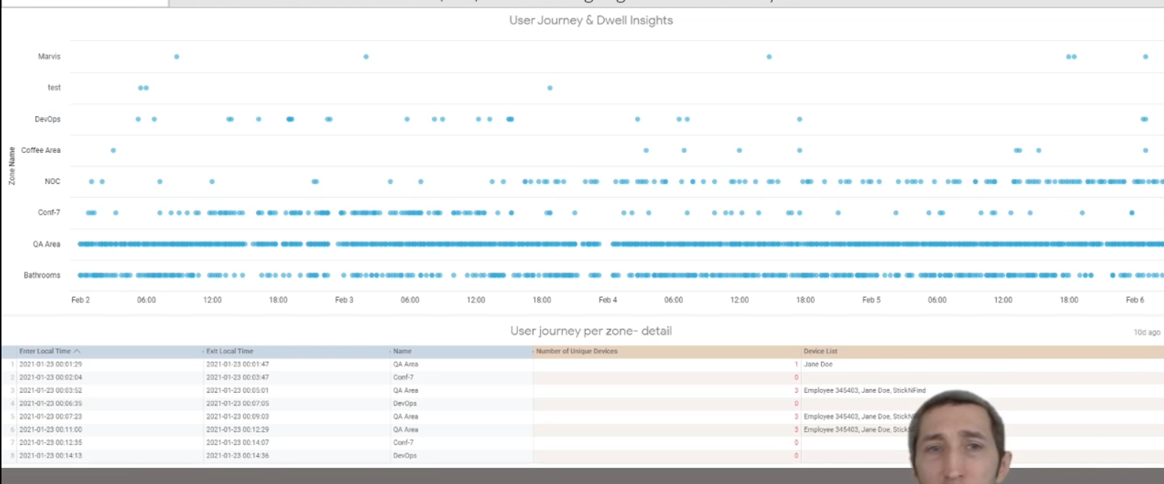
Premium Analytics subscription can provide proximity tracing and user journey and they have contact with and where.

9- Mist Automation

API Options to Communicate with MIST:
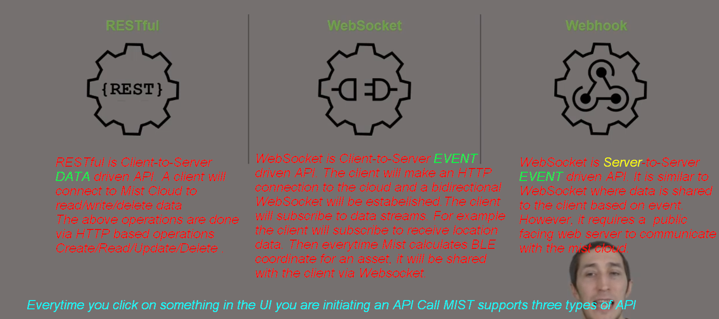

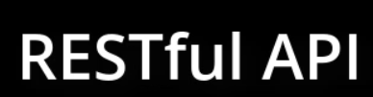

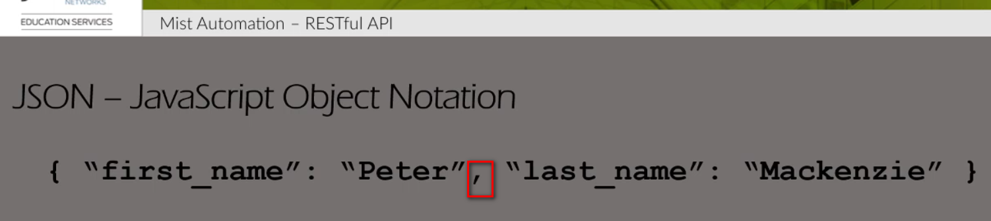

Mist API resources are written and read using JSON formatted data.
JSON is used to transmit and store key value pairs data types.
Above is an example writing the name Peter Meackenzie in a JSON key value pairs (in two parts)
The key value pairs (Peter and Meckenzie) and separated with a comma.
For each value pair we have an attribute of field name followed by the data value.
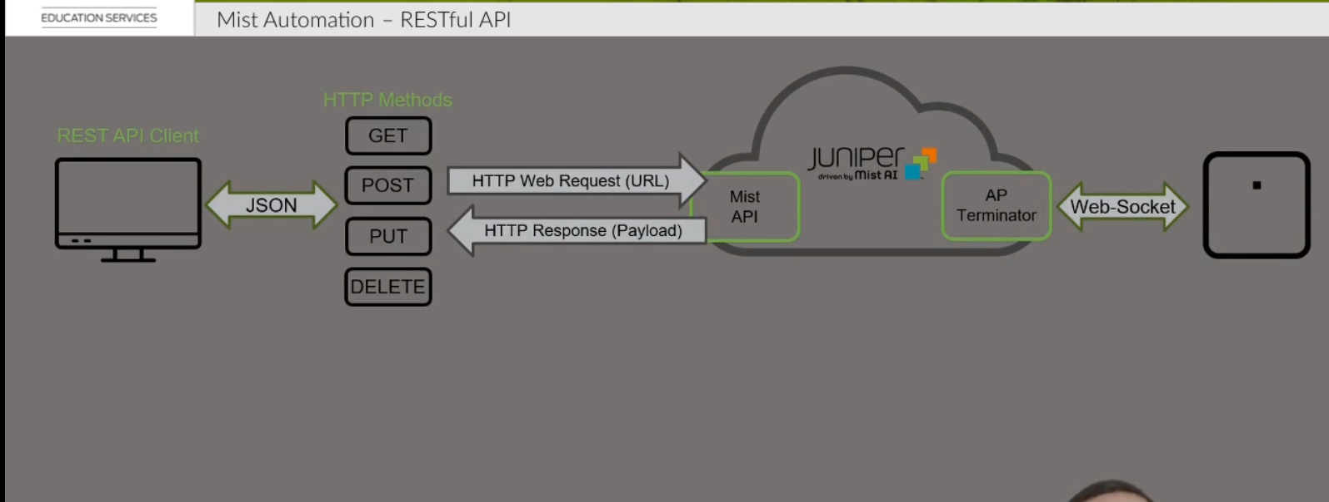

Clients using REST APIs use HTTP web requests to either read and write or delete data using one of four HTTP request messages (GET, POST, PUT and DELETE)

The GET requests are used to read data held in a resource
The HTTP GET will be directed to a unique URL called an API endpoint for the individual resource. Then a HTTP response will be returned including a status code which indicates if the request was successful or not.
If it was successful, the requested data will be returned in the payload of packet in JSON format.

To write data we use the POST and PUT methods. POST is used once we want to create a new resource; however, PUT is used to update a resource. Data being written included in the payload of the request will be in JSON format.

To delete a resource we use the DELETE HTTP request and we receive a status code in response indicating if the request was successful or not.

There are multiple status codes stating what happened to your request:
For a successful request, you will receive the 200 code:
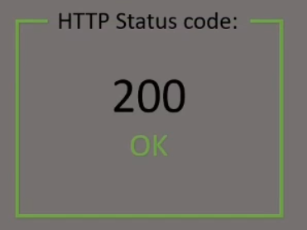

Codes in 400s indicate that they are not successful requests:

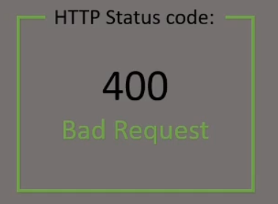
Bad request means the URL API endpoint exists but the syntax or payload is incorrect

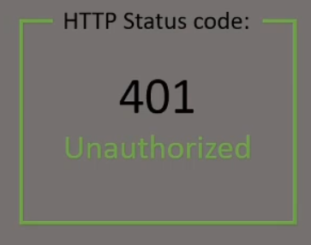
The request was rejected because it lacked valid authentication credentials

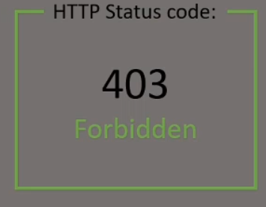
Forbidden means the permission was denied, the request was understood but it was refused

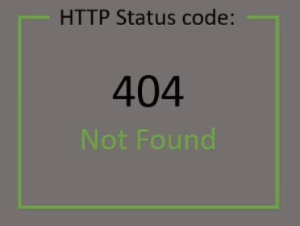
It means the URL API endpoint or the resource does not exist.

We need three things to make an API Restful Call as shown below:

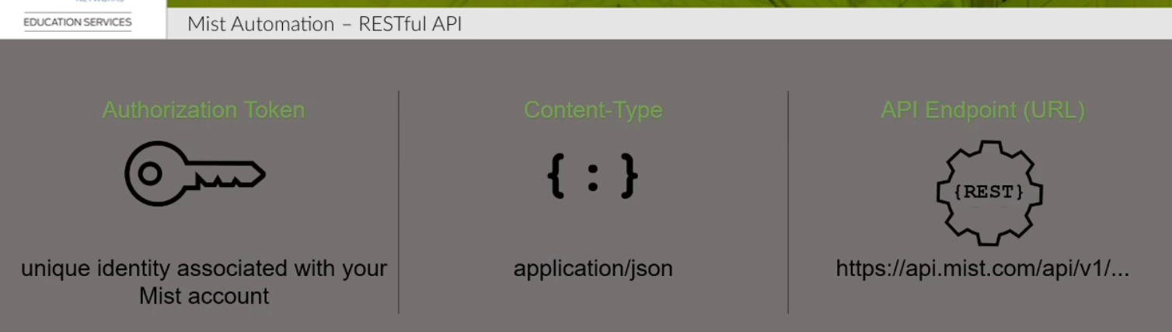
Authorization Token is a unique key that identifies you Mist Account, it is generated and you need to keep it secure.
Tokens can be generated by logging into your Mist account then access the below URL:

https://api.mist.com/api/v1/self/apitokens
and then follow the steps in the URL: https://api-class.mist.com/rest/create/api_tokens/

If a token is not used in 90 days then it will be deleted
Tokens needs to be added along with each HTTP request along with along with the Content-Type value set to application/json

The third piece to make an API call is the API Endpoint (URL), this is the address of the resource we want to read/write/delete
API URLs can found in Mist API documentation
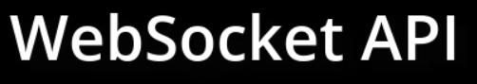
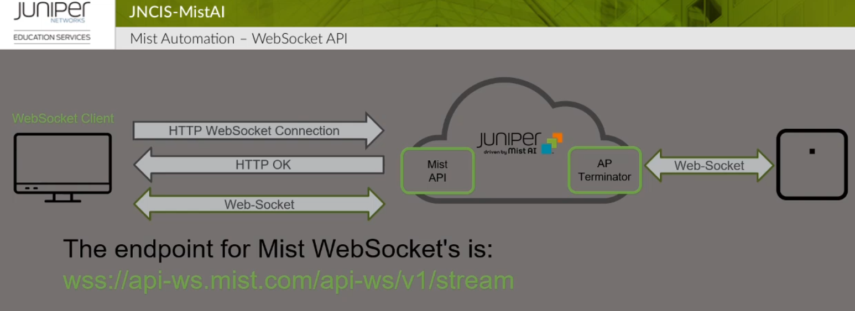

In the WebSocket API the WebSocekt client initiates HTTP request to the Mist cloud using the endpoint URL: wss://api-ws.mist.com/api-ws/v1/stream
This request is made to establish the Bi-Directional connection

The Flow of WebSocket connection is shown below:
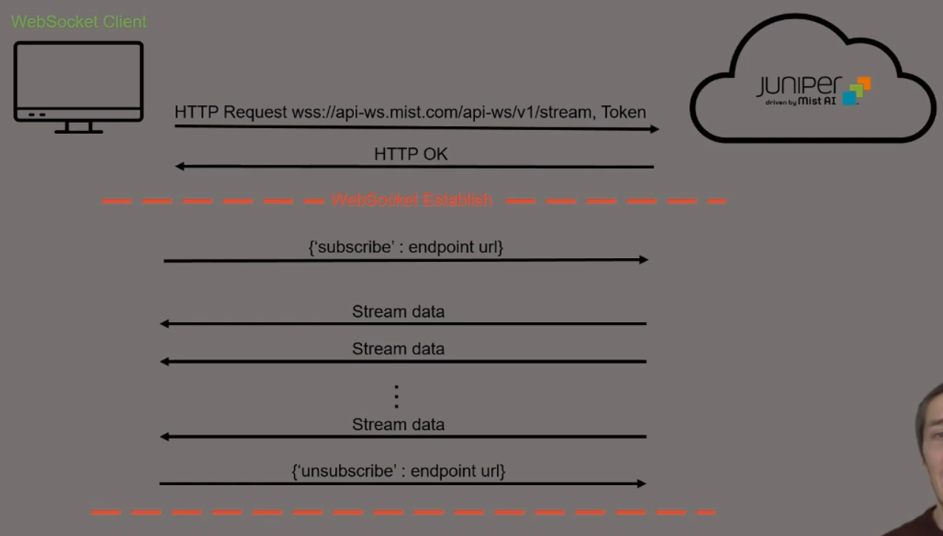
The client makes the initial connection providing the authorization token
If the request is successful, they should receive HTTP 200 ok code response and then the bi-directional communication will start.
Within the WebSocket connection the client can subscribe to various WebSocket endpoint topics and the mist cloud sends data relevant as events occur.
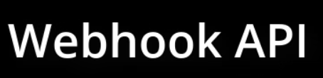
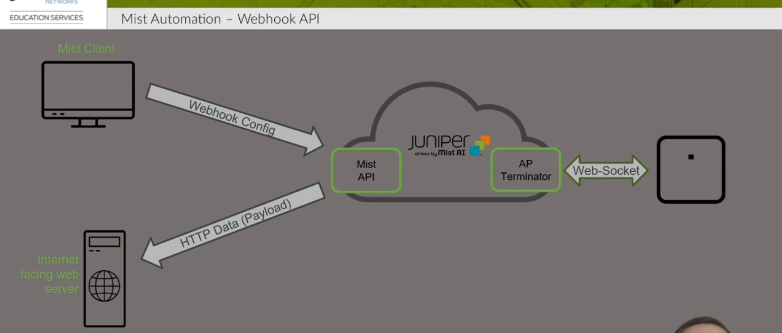

Webhook are event driven API where Mist cloud sends data directly to a public facing web server. The client must first configure the Webhook on the Mist platorm.
Webhook can be configured on both the organization or site level.
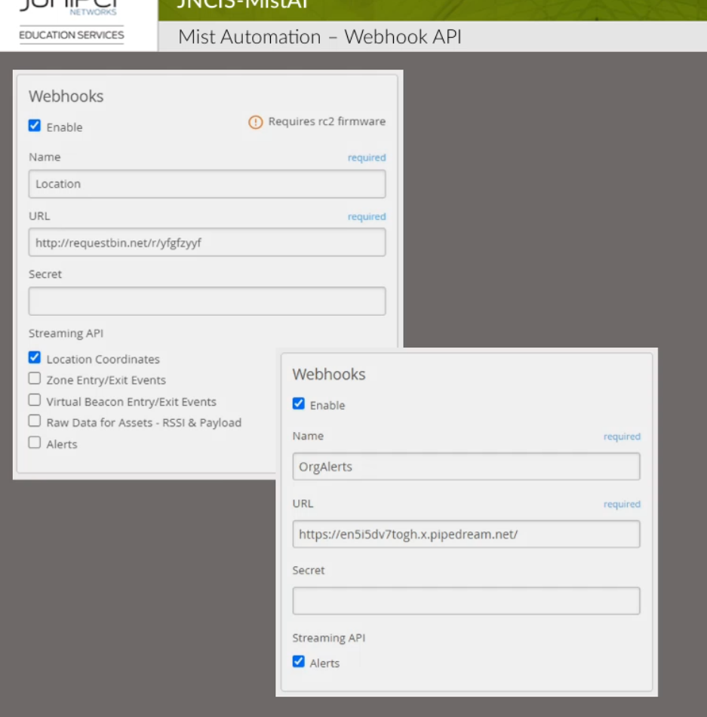
We specify the published URL of our webserver and then specify the API topics/streaming API that we want to push to our server

