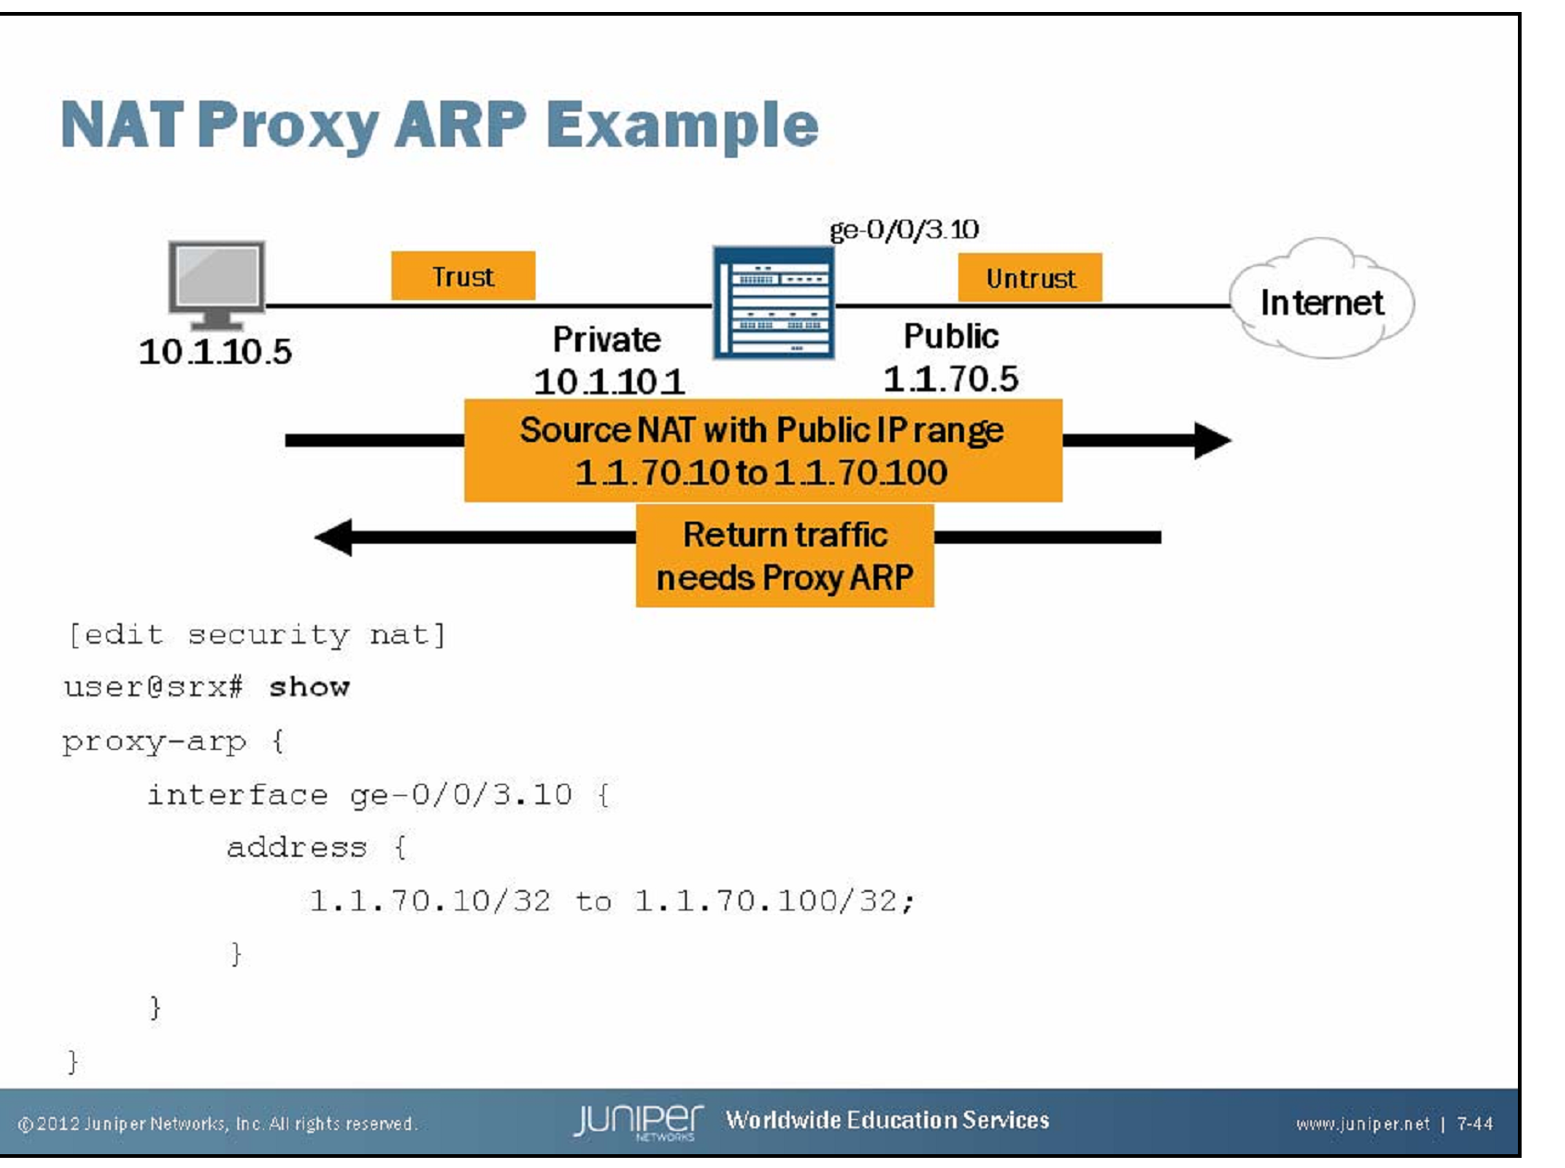

The slide illustrates a sample situation requiring proxy ARP In the example, the device performs source translation for traffic from the Trust Zone, translating the private source address to a public source address in the 1.1.70.10 to 1.1.70.100 address range. The NAT source pool belongs to the same subnet as the public interface. For return traffic to successfully reach the 10.1.10.5 host, the device must perform proxy ARP for the 1.1.70.10–1.1.70.100 address range.

The hierarchy should read [edit security nat source]

