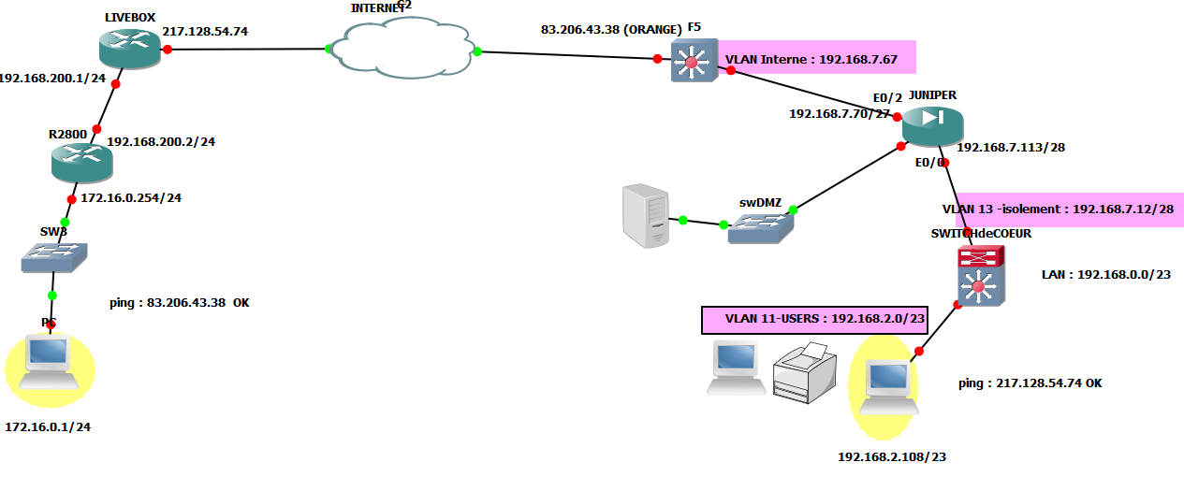

Cisco 2800 VPN related configuration

crypto isakmp policy 15
encryption 3des
hash md5
authentication pre-share
group 2
lifetime 28800
!
crypto isakmp key golfTDI130 address 83.206.43.38
!
crypto ipsec transform-set vpn esp-3des esp-md5-hmac
!
crypto map vpn 1 ipsec-isakmp
set peer 83.206.43.38
set transform-set vpn
set pfs group2
match address 101
!
interface Ethernet0
description Inside Interface
ip address 172.16.0.254 255.255.255.0
!
interface Ethernet1
description Outside Interface
ip address 192.168.200.2 255.255.255.0
crypto map vpn
!
ip route 0.0.0.0 0.0.0.0 192.168.200.1
!
access-list 101 permit ip 172.16.0.0 0.0.0.255 192.168.0.0 0.0.1.255
permit ip 192.168.1.0 0.0.0.255 192.168.55.0 0.0.0.255

