Contents
1- General WLAN Concepts 1
2- Wi-Fi Standards 11
3- WLAN LIFECYCLE 16
4- Mist AI Components 17
5- Mist AI Configuration 19
6- WLAN Monitoring 27
7- Wired Assurance 34

1- General WLAN Concepts
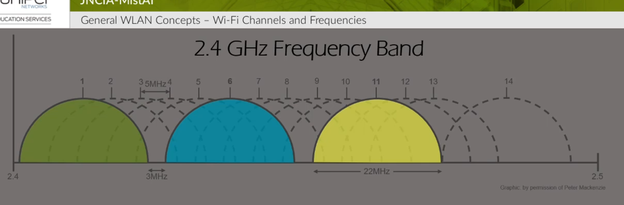
License free spectrum for 2.4 GHz is the above and varies according to each region:
1- US has a License free spectrum from Channel 1 till 11 and that’s why the optimum channels to use for non-overlapping are 1, 6 and 11
2- Europe has 1 13 and that’s the reason they have more options for the usage of channels. Even though customer in Europe can operate on 1, 7 and 13 channels without overlapping but the vendors always use the 1, 6 and 11 as default ones.
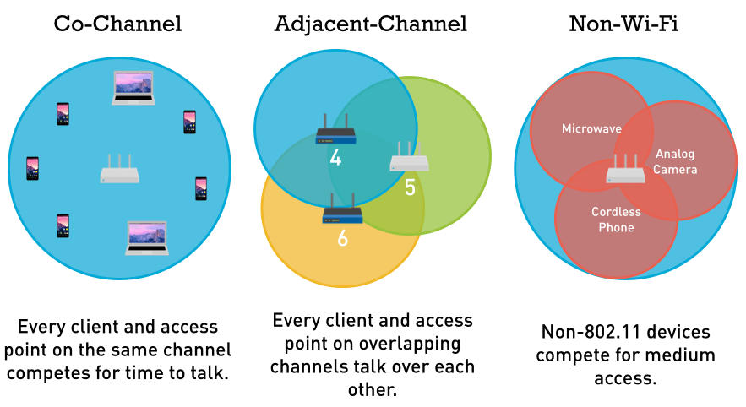
3- In Japan they have 1 14 channels and therefore they can use 1, 6, 11 and 14 with almost no overlapping

4, 5, 6 overlap in the spectrum

Co-Channel Interference: CCI
Adjacent Channel Interference: ACI
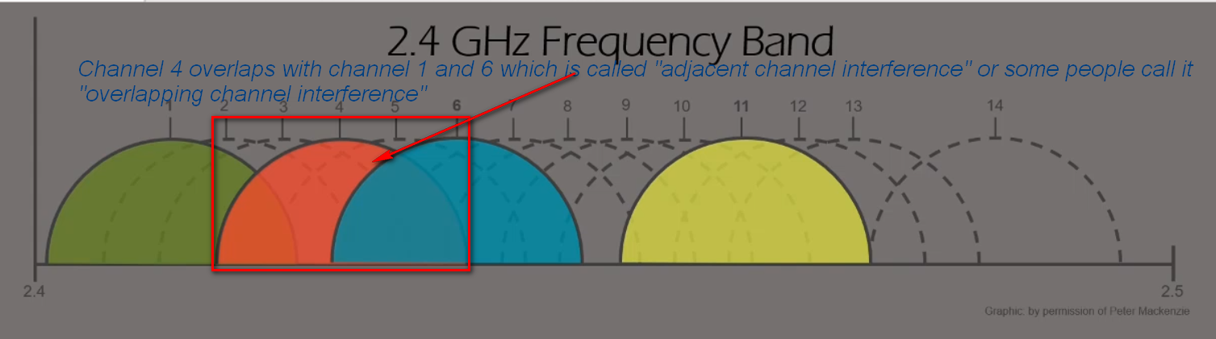
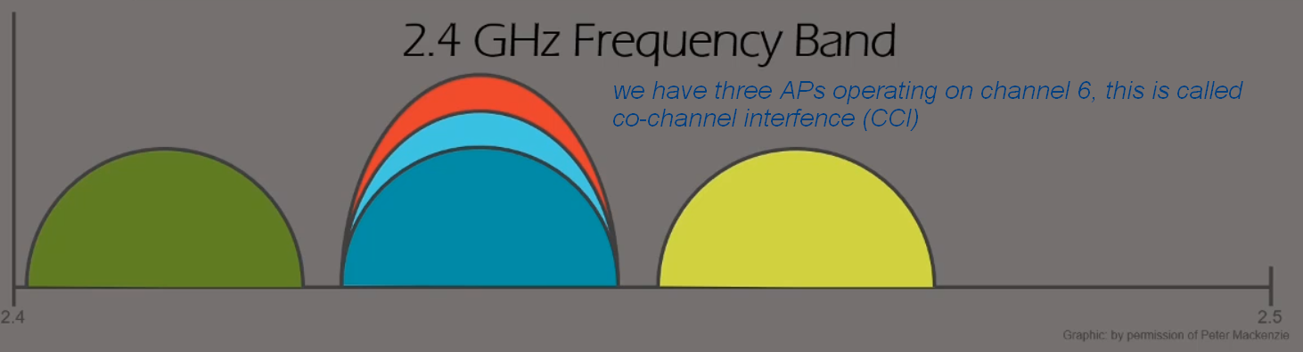

Number of channels available for 22MHz wide channels vs 20MHz wide channels.
802.11b uses 22MHz and if we disable it then we are only left with the amendments that support 20MHz.

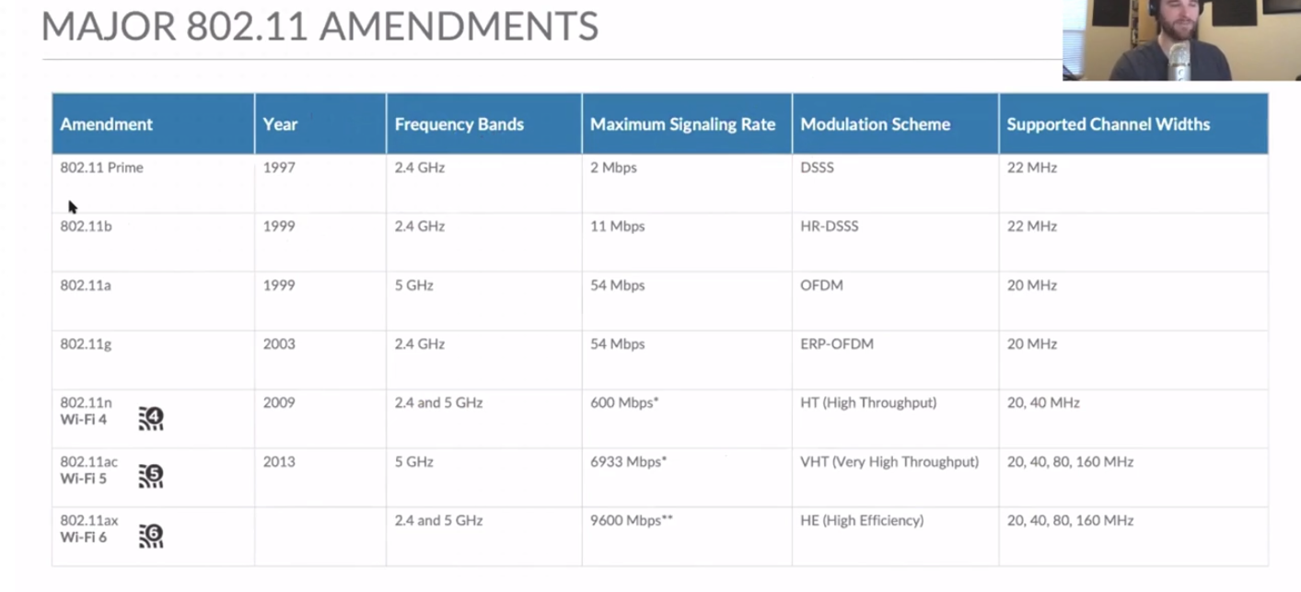
For US, if we use 20 or 22MHz channels then they will still have only three channels to use in 2.5GHz since they only support 1 11.
However, for Europe where they support from 1 13, they can technically use 4 non-overlapping channels (1, 5, 9 and 13) as shown below.
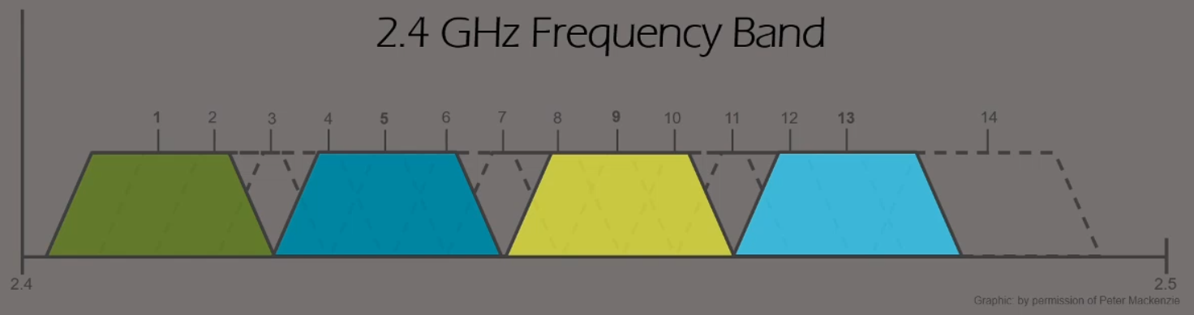

The reason we do not see clients using this widely is to avoid interference with neighbor APs, if there is any neighbors using the normal channels (1, 6 or 11) they will interfere badly with 4 used channels (1, 5, 9 and 13).
The only used case for using the four channels is if we have for example a warehouse in a fare place with nothing next to it and we sure all other channels are 100% clear then we can benefit from the four overlapping channels and of course we have to disable 802.11b data rates to prohibit the use of 22MHz channels.

5GHz:
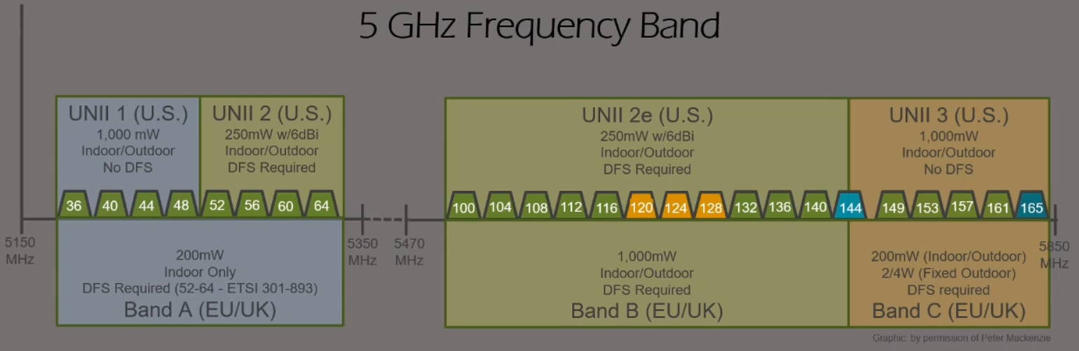

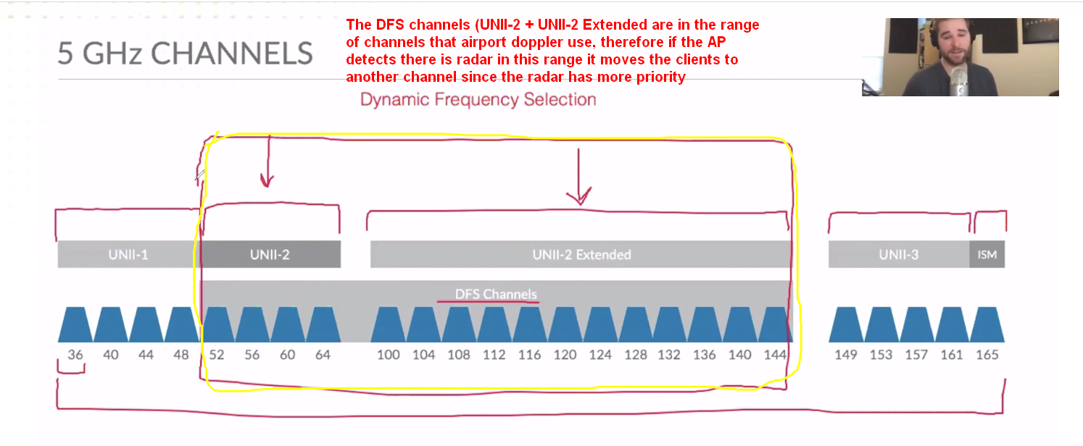
US calls the ranges in UNII while Europe calls them in Band (A,B,C)

Merging channels for more bandwidth:
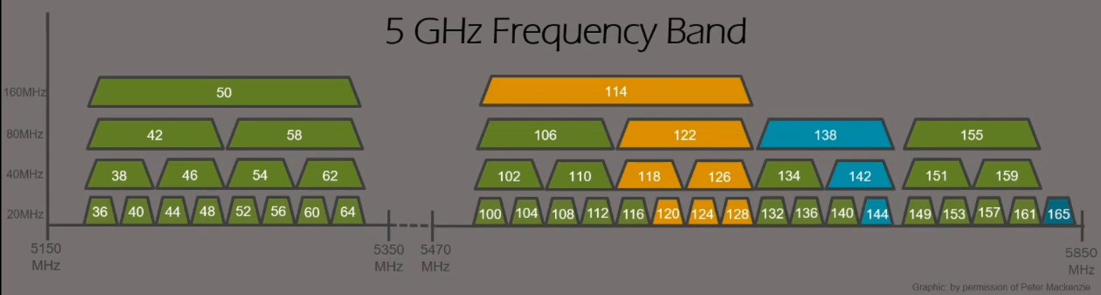

Channel Re-Use:
It is very important to know which AP can use the same channel that a neighbor AP is using without co-channel interference, it is related to the signal/distance of this specific channel.
If you have a dense area with many APs, the first AP is using channel 36 of 5GHz, there is another AP 10m far from it.
The question is, can it use the channel 36 without affecting the signal of both APs.
If we look at the signal propagating from the AP as shown below, we usually want the signal to be -67 dBm to be considered a good usable signal. Consider the x-axis the signal strength, when the SNR for the AP is less than 4dB then it is considered un-decodable and another AP can use the same channel in this area.

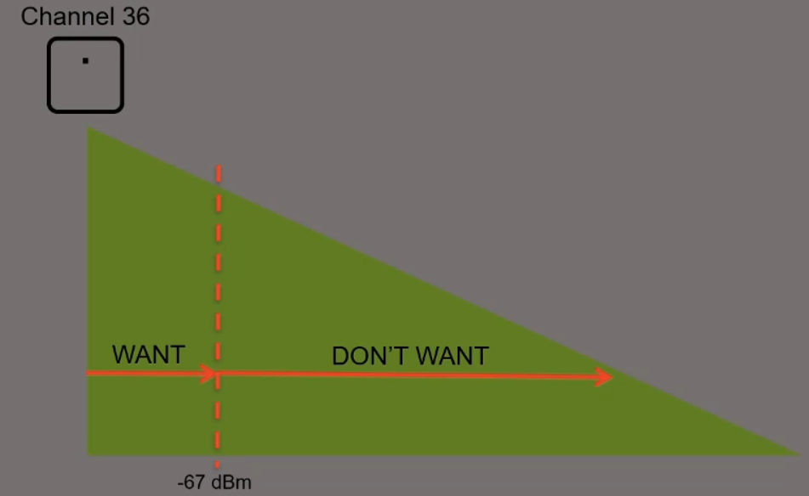

If a neighbor AP is using the same channel 36 and it reaching this area of AP1 (red square) then it is fine since the signal of channel 36 from the AP1 is low and the SNR is less than 4dB, this means the client can not decode the signal anyway coming from AP1.
When the SNR is higher or equal to 4dB then it is considered decodable, if it is less, then it is useless

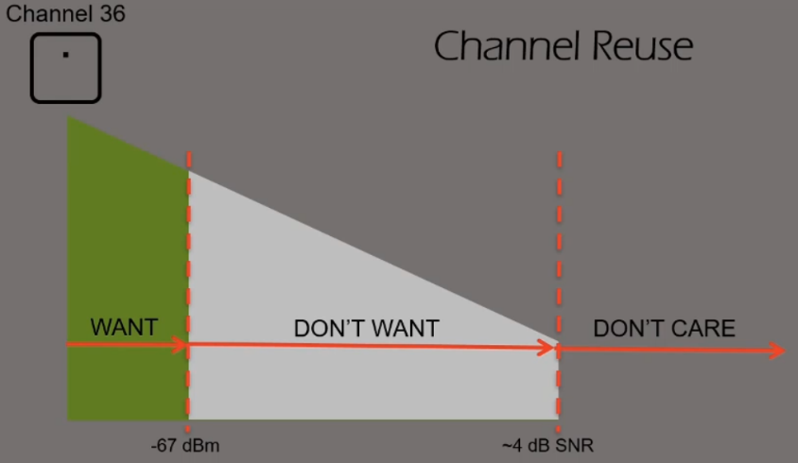

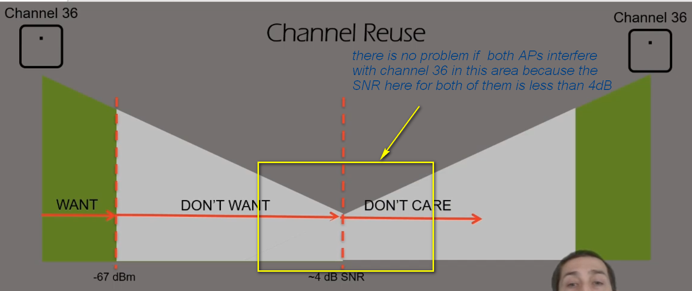

Signal Strength:
The rate of power loss for signal is calculated using the inverse square law:
1/r² or 1/d² (range or distance), it means if the range doubles from the source the distance is shattered four times more. Every time the distance doubles then we lose 4 times the power which equals to 6dB.

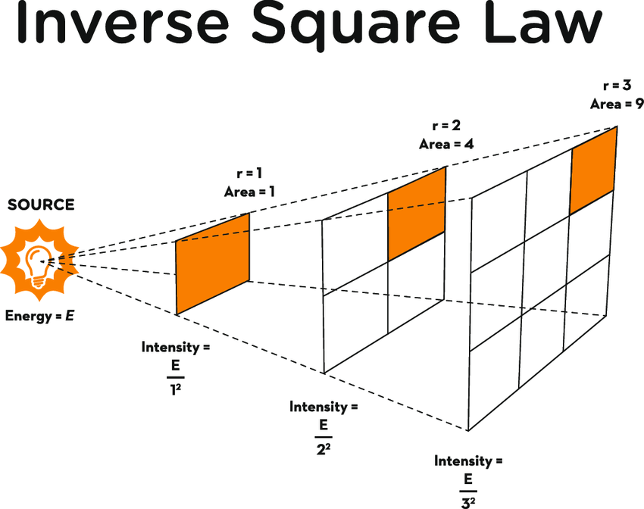

Most of the signal loss is in the first 1meter, as you can see the AP was emitting 14dBm and after 1m it became -33dBm with a loss of 47dB

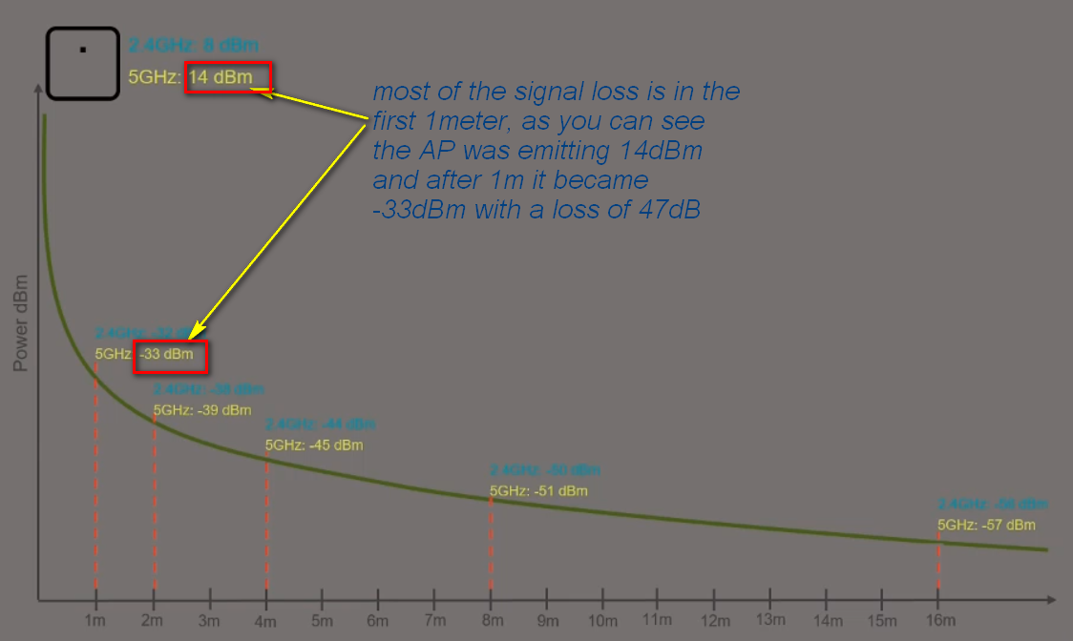

Contention/Interference:
WiFi is a half-duplex shared medium and it needs rules to control who can send and when, these rules are names DFC (Distributed Coordination Function)

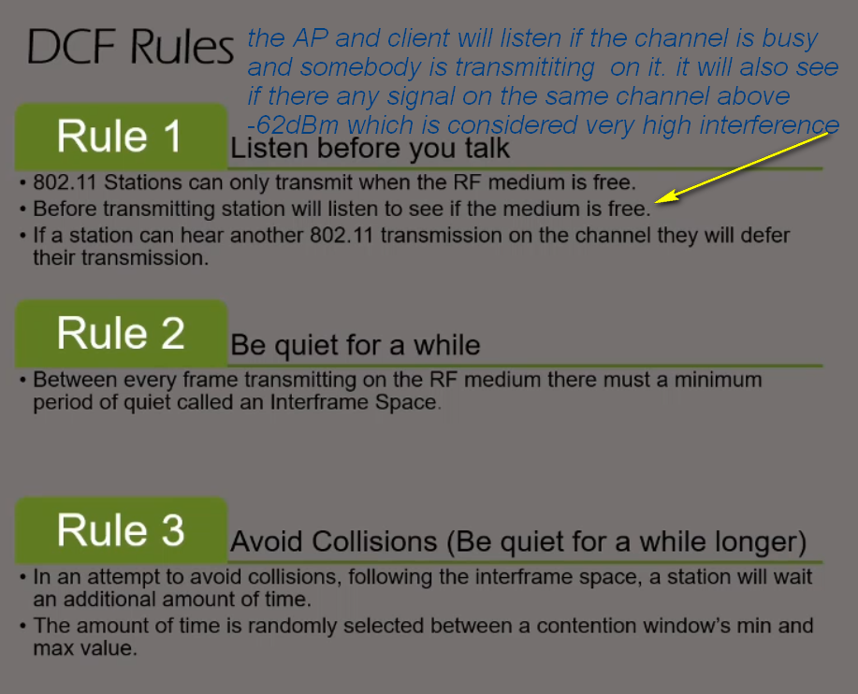

Client Capabilities:
In your design, you must check the supported capabilities of the clients.
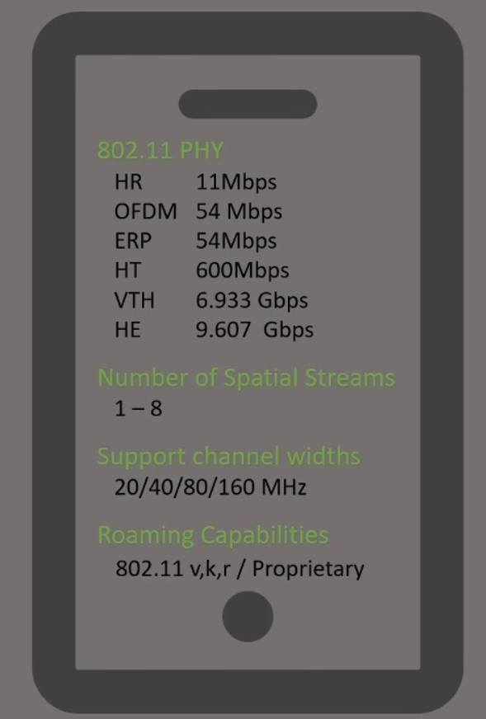

MIMO Concept:
The purpose of this is send different data streams at the same time on the same channel, this is referenced as special multiplexing. This is achieved by using the multiple antennas, each antenna will send different stream of data and this increases the data transfer.

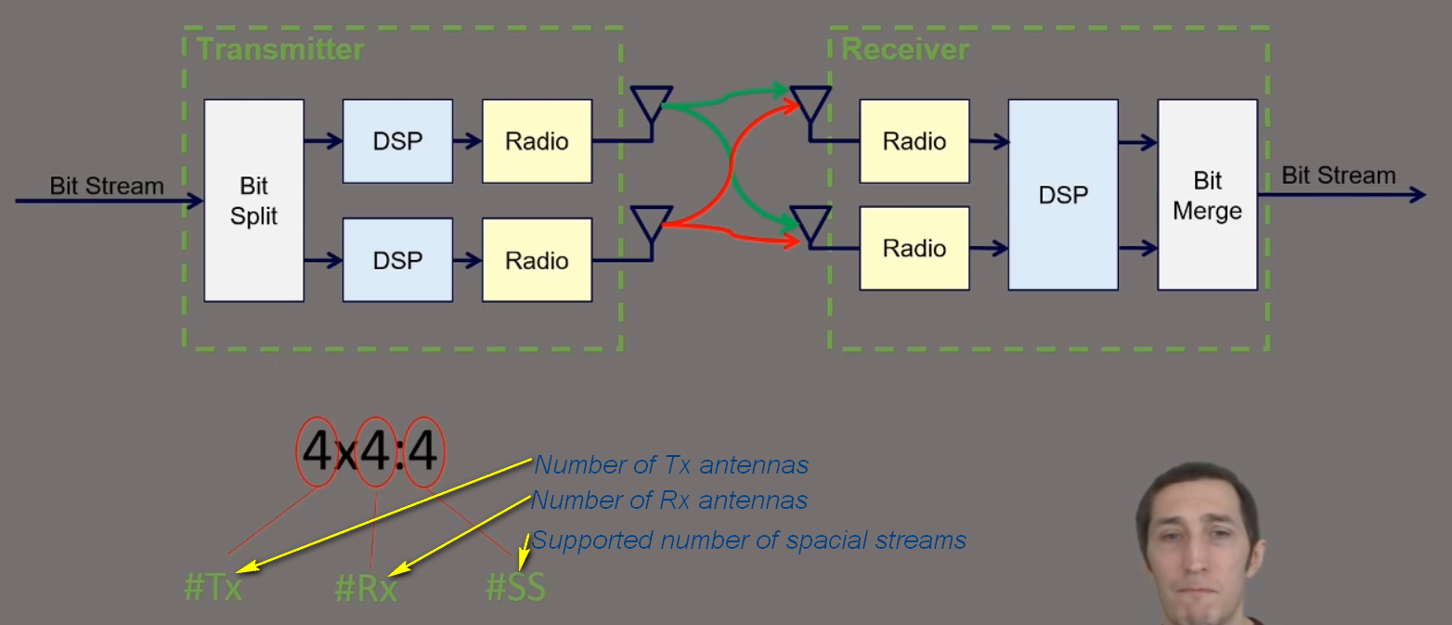

The AP will send the data which is a bit stream (0’s and 1’s) and feed into a Bit Splitter that will split the data that must be transferred to different to be sent on different streams. Then it will pass through the DSP (Digital Signal Processing) and will do the digital to analog conversion and then send the analog data via the antennas.
Once the signal it transmitted the signal is received from the other end on both antennas (red and green arrows), the AP is clever enough to know the same data stream received on both antennas are duplicates but will use them for error correction that is caused by noise for example.

RF Modulation:
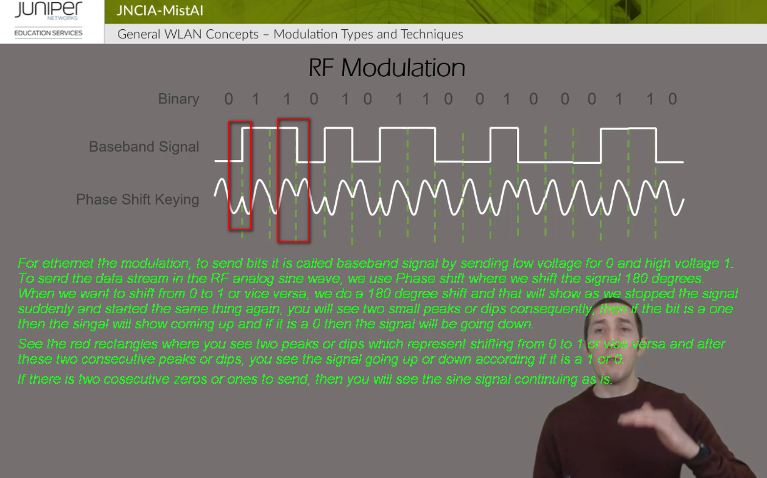

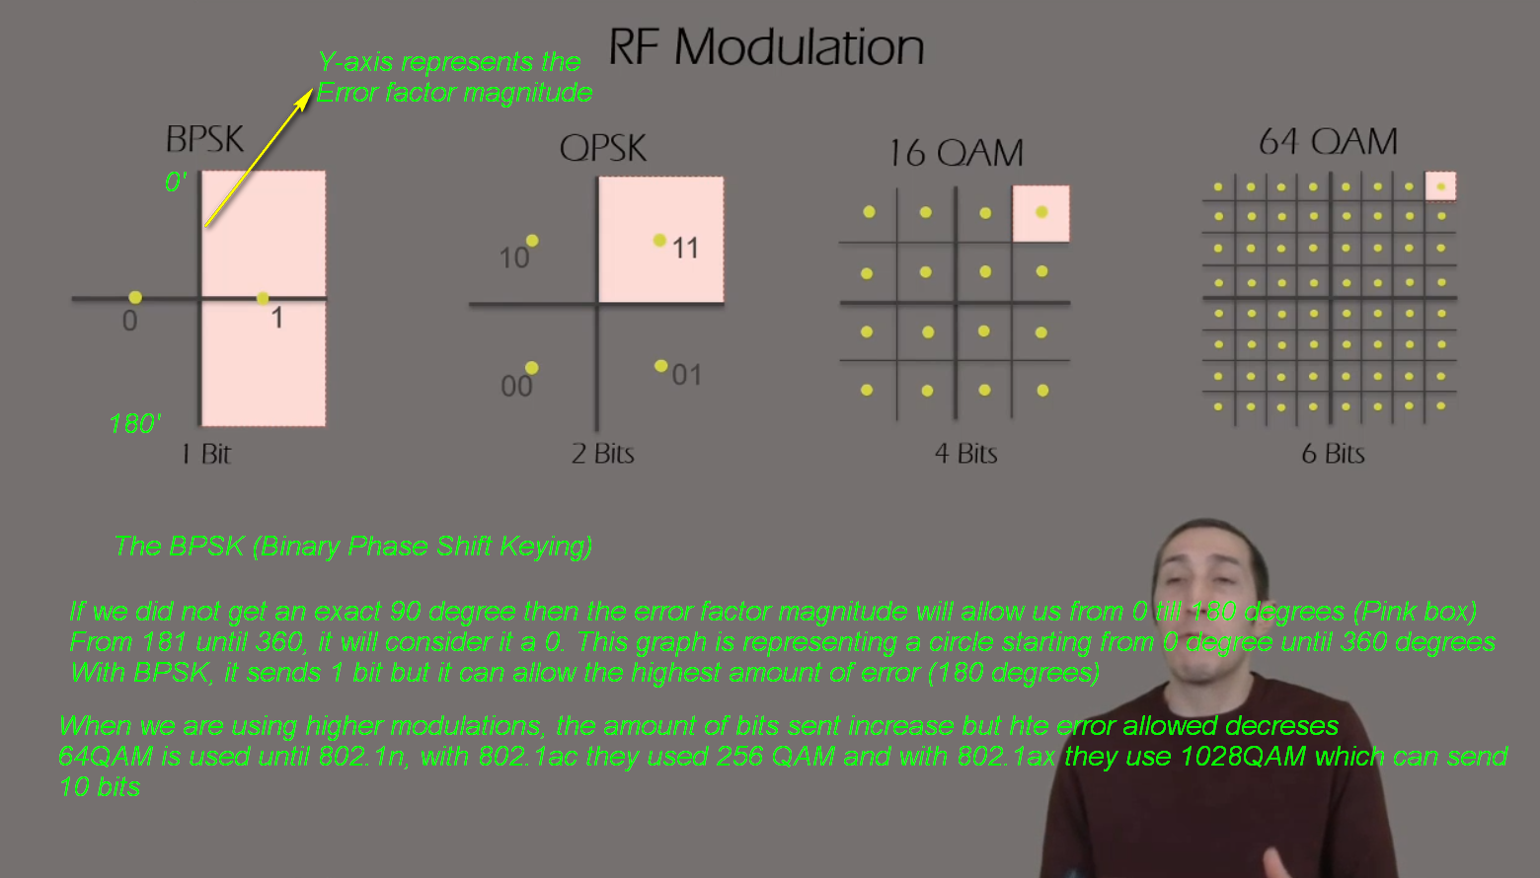

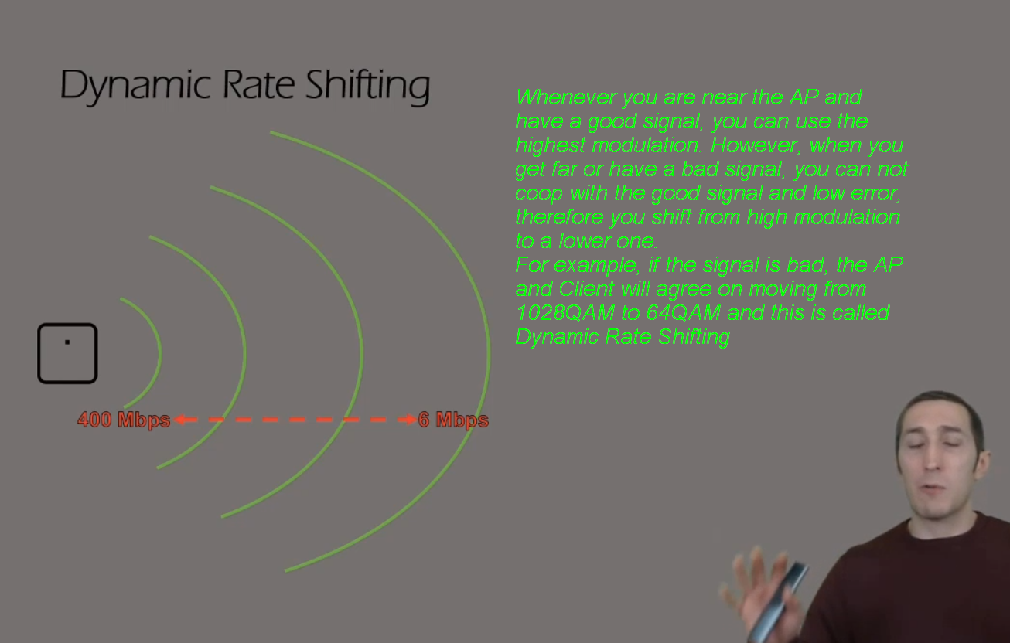

2- Wi-Fi Standards

IEEE defines 802.11 WLAN MAC and PHYSICAL specifications; in IEEE you don’t see the word WiFi because it is an Alliance and not standard.
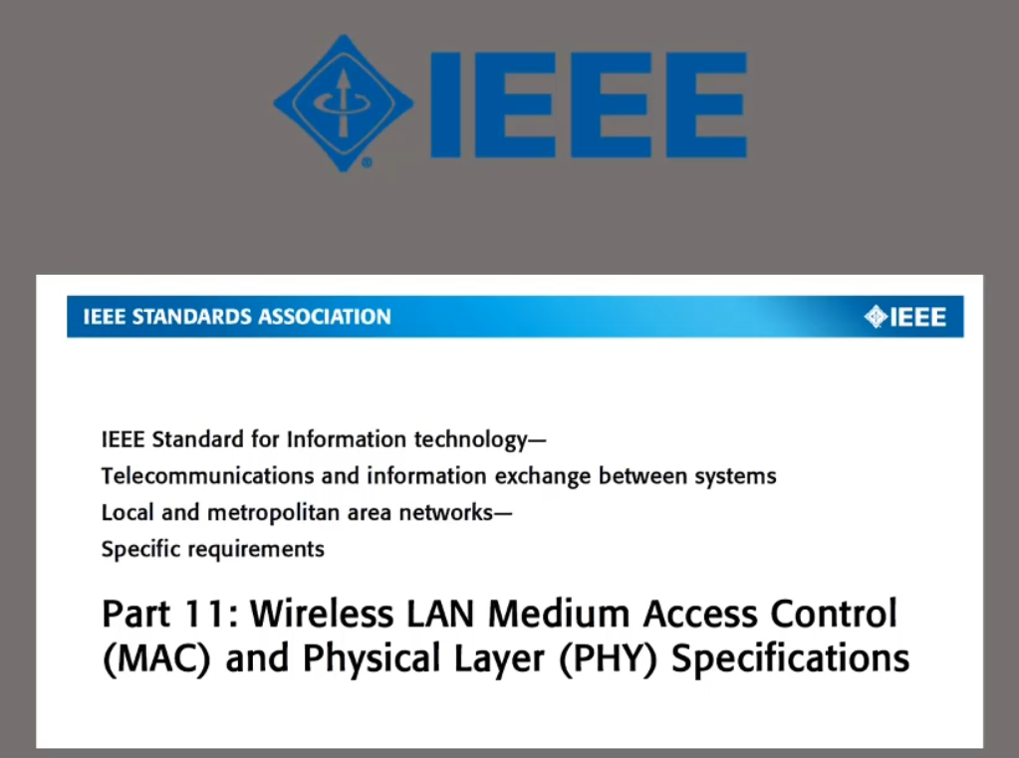
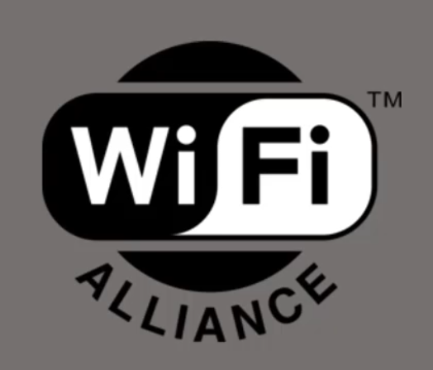
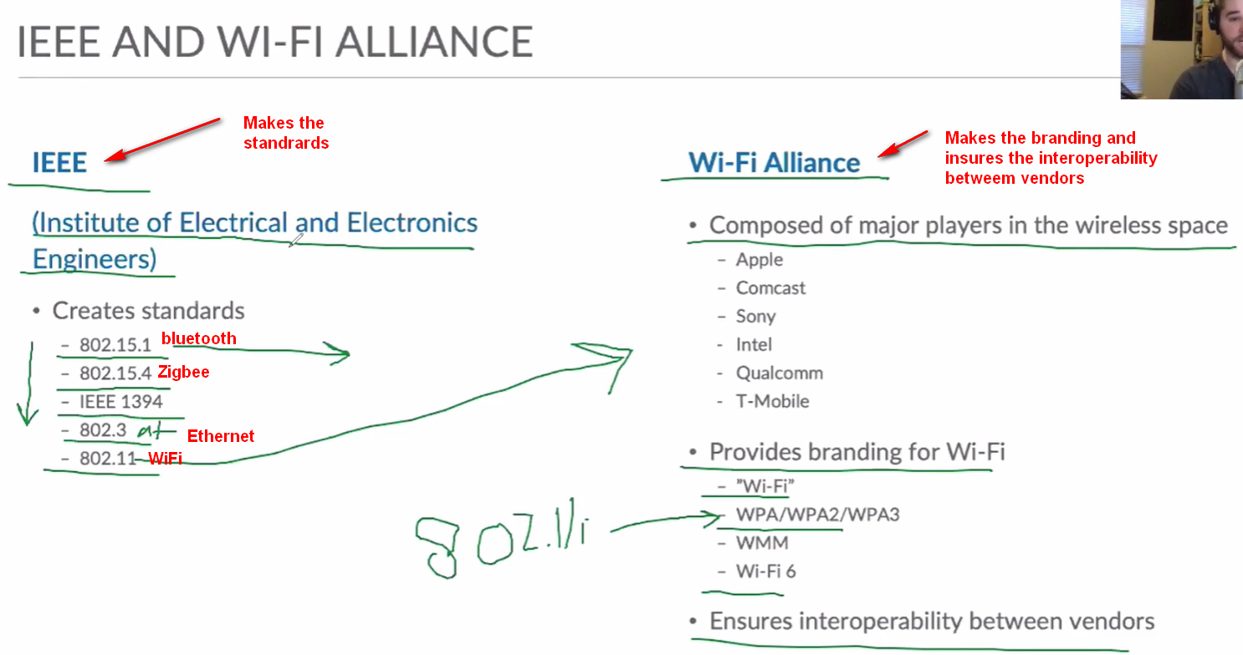

802.11 IEEE Physical Layer (Amendments):
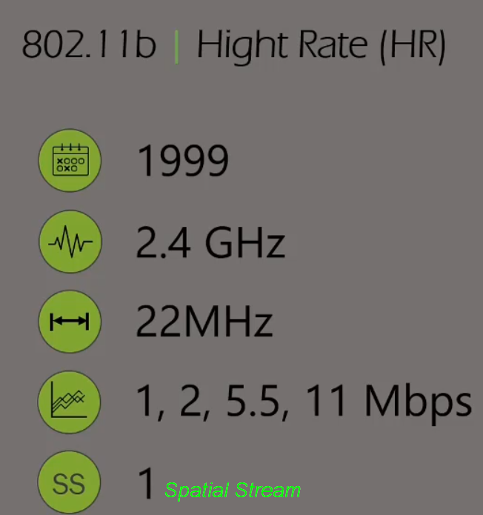

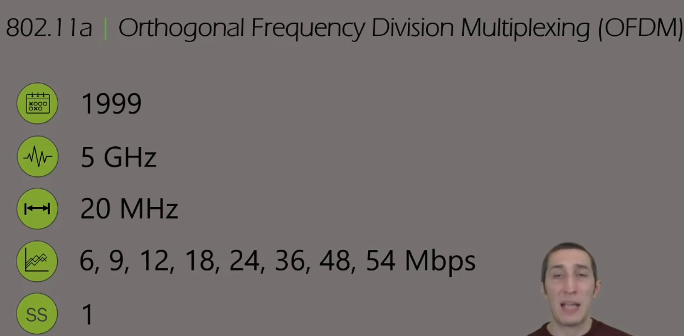

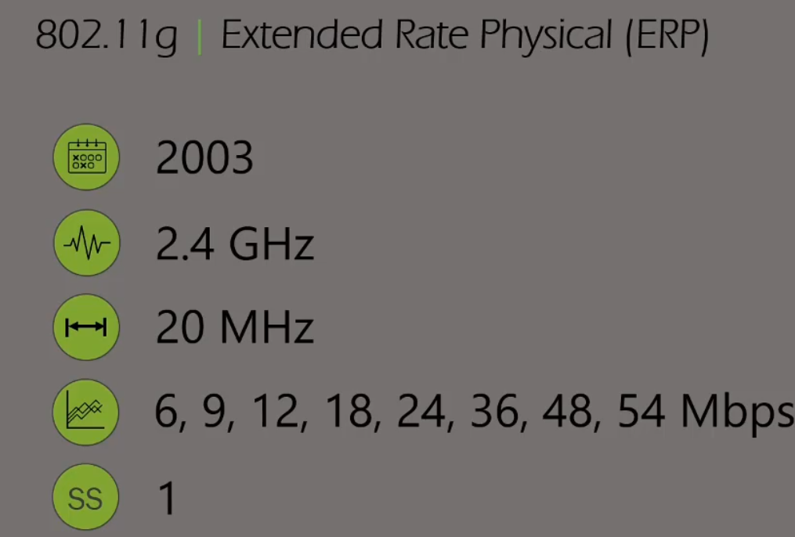
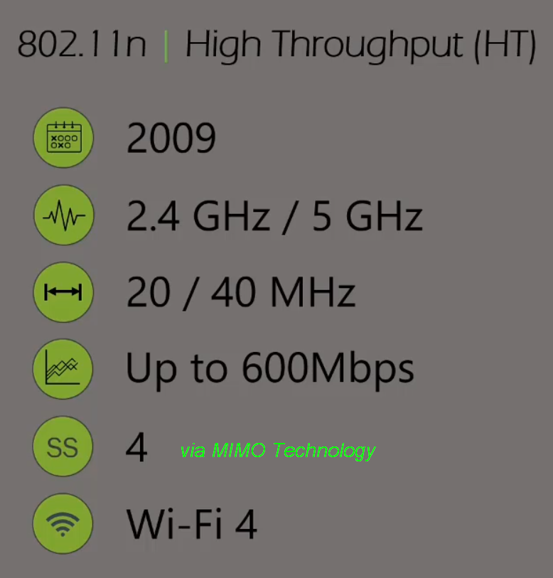
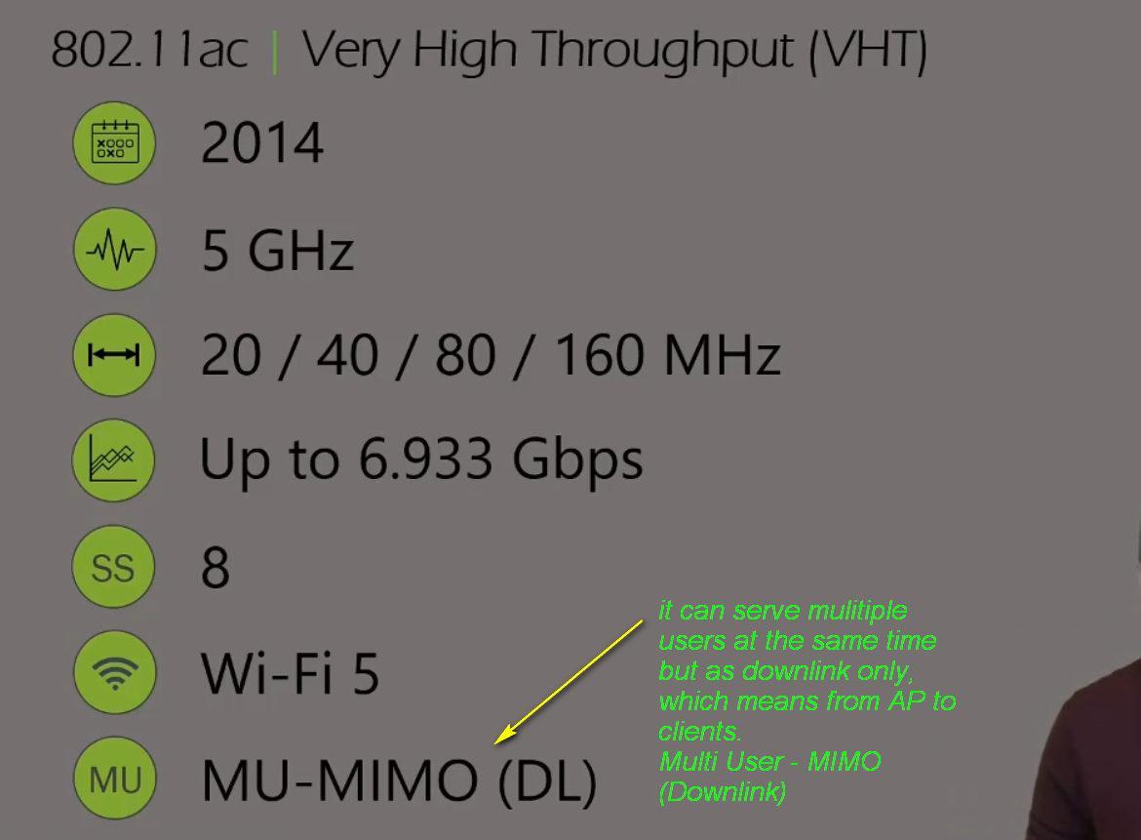

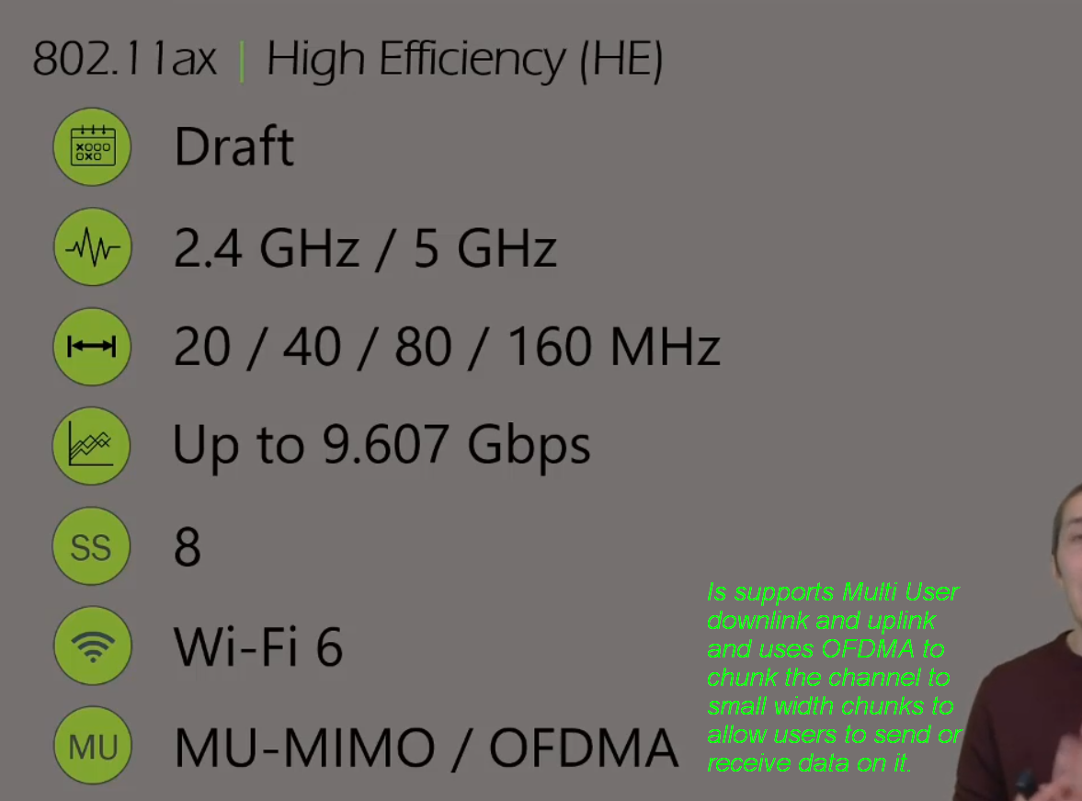

Security Options:

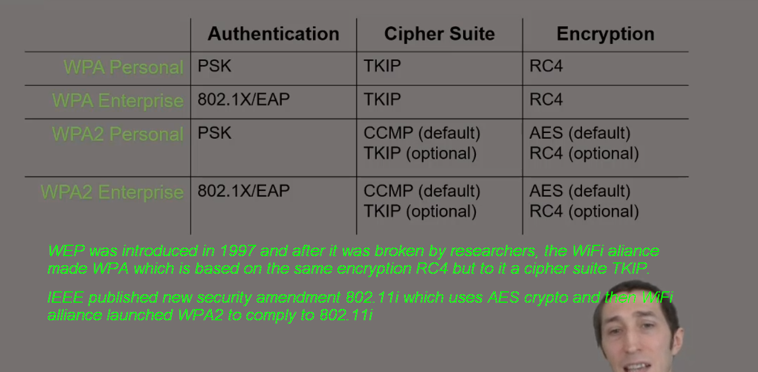

3- WLAN LIFECYCLE
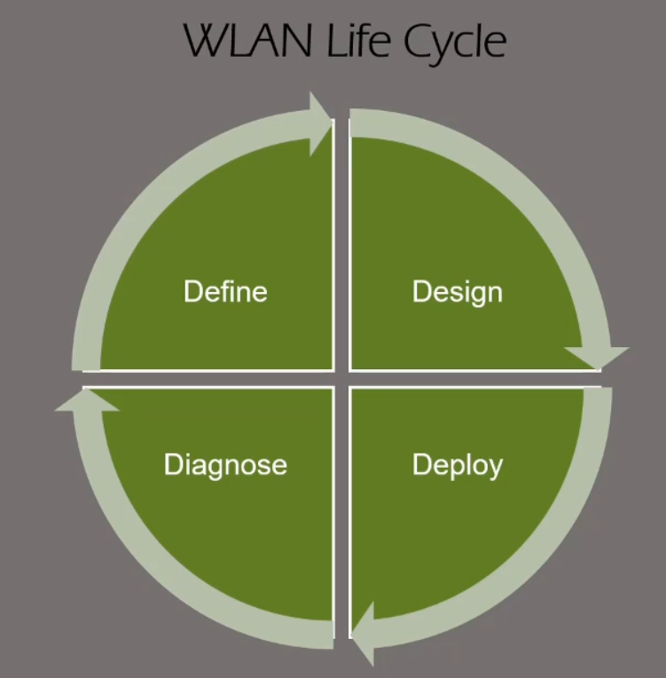

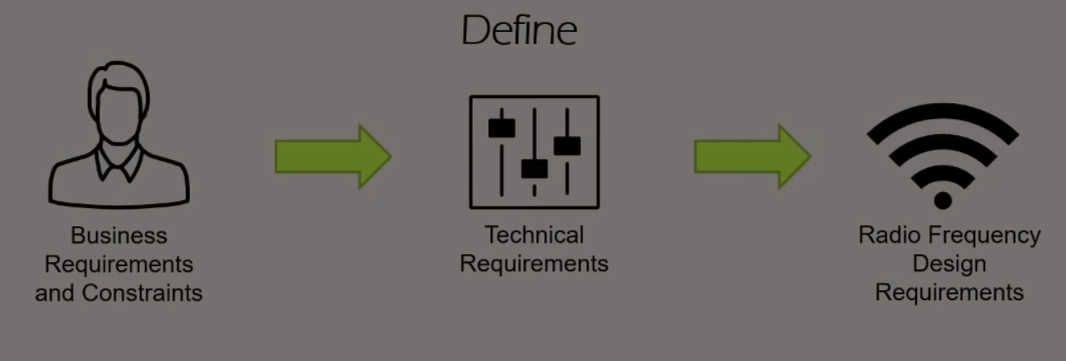
Primary coverage is the AP that has the strongest signal in that area and secondary is the neighbor AP that has the second strongest signal in that specific area. Secondary coverage needed simply as a method of providing RF roaming and redundancy. If one AP fails the secondary coverage coming from the neighbor, AP can support the clients in that area. For sure, the neighbor AP that is providing secondary coverage must be operating in a different channel to not interfere with the primary AP.
Therefore, in 2.4GHz we avoid designing for secondary coverage since we only have three non-overlapping channels whereas in 5GHz we have a lot more which gives us flexibility in designing secondary coverage and channel without causing interference.

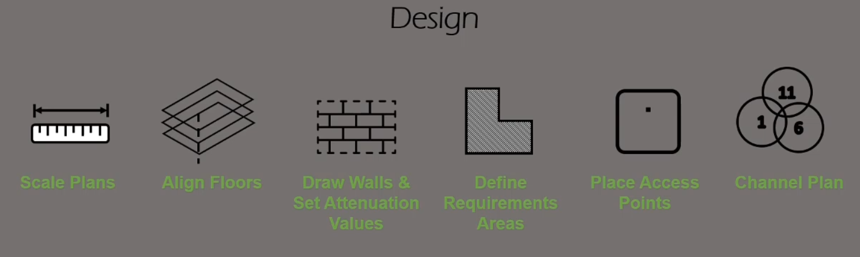

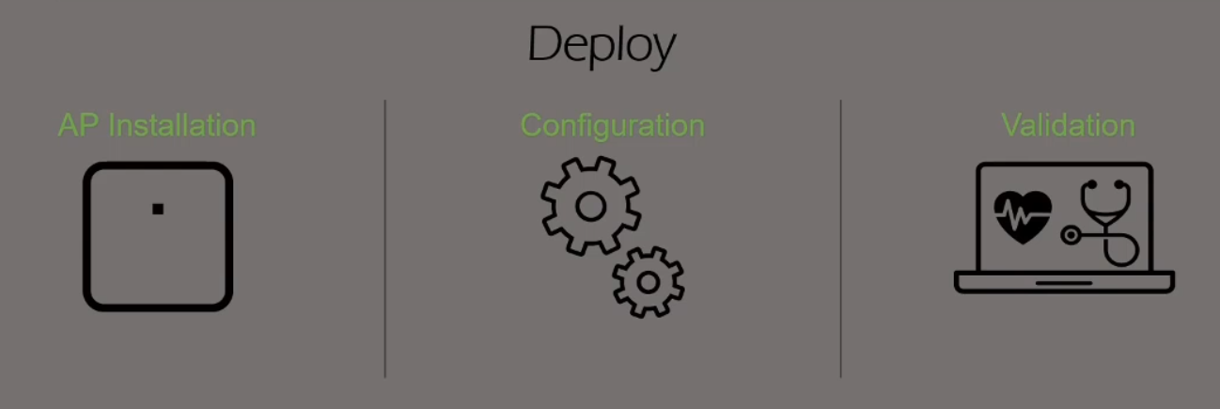

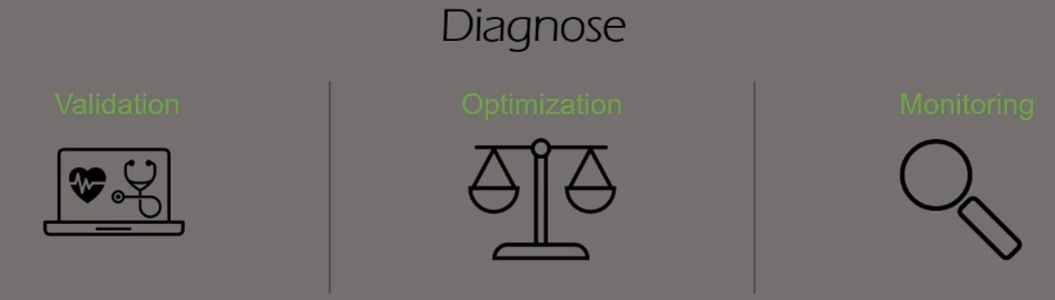

4- Mist AI Components

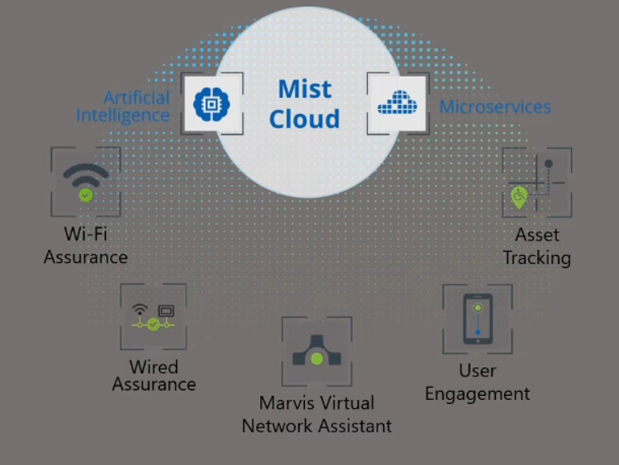
User Engagement license is required for every BLE radio that will transmit BLE advertisement packets
Asset Tracking license is required for every BLE radio to enable its receive and monitor capability

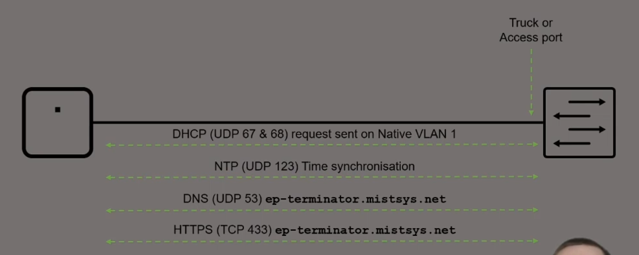

Once the AP powered up and has Ethernet connected, it will do the following step:
1- Request for DHCP on the untagged VLAN (never minds if the port is access or trunk)
2- Synchs the time with the NTP server
3- Requests the DNS of the ep-terminator.mistsys.net which is the DNS name of mist cloud
4- Last step to create an SSH connection to mist cloud

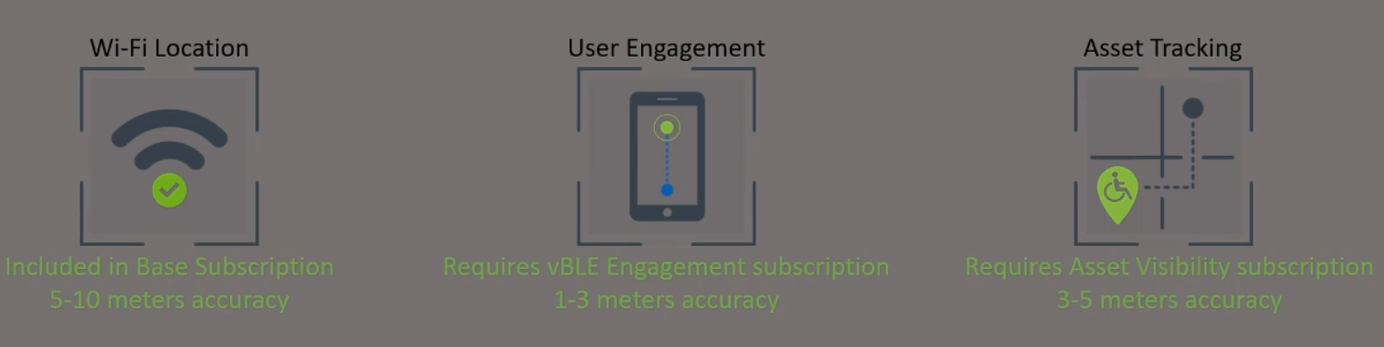

1- WiFi assurance can locate connected and non-connected devices with accuracy of 5-10m
2- User Engagement enables the BLE to send advertisement packet to users that run MIST SDK APP and provides the highest accuracy of 1-3m. The drawback of this license is locations services is available only for devices running MIST SDK APP
3- Asset Tracking enables the MIST BLE radio to listen to third party BLE antennas such as a BLE asset tag on boxes and estimates the location.
User Engagement allows transmit of advertisement packets from MIST BLE radio to MIST SDK Application. However, Asset Tracking allows Mist BLE radio to listen to third party advertisements coming from assets and then estimates their location.
User Engagement Mist BLE sends advertisement capability
Asset Tracking Mist BLE receives advertisement capability

5- Mist AI Configuration
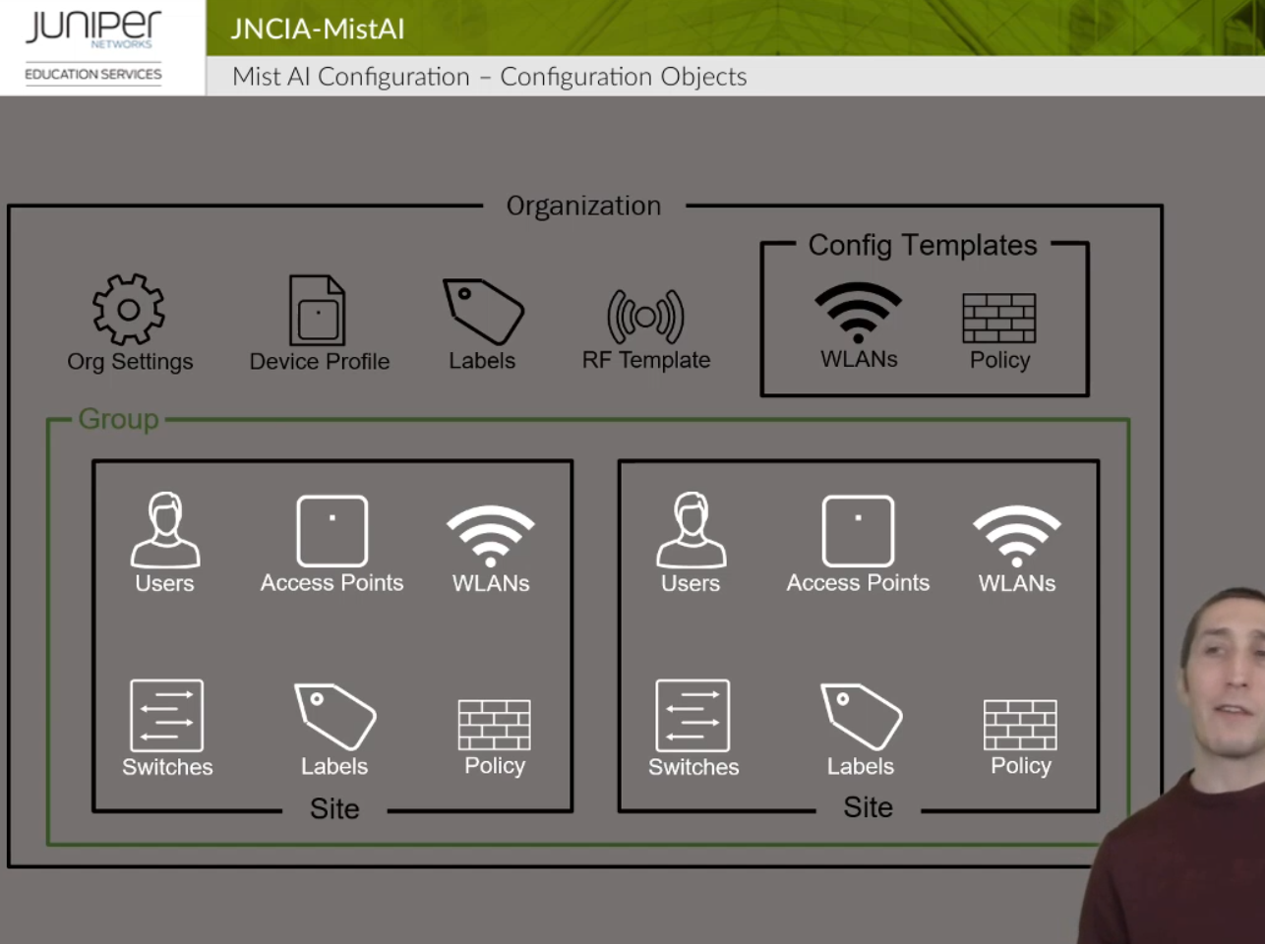

Organization configs will be applied to all sites and site groups and you can to that by clicking on the Organization Tab below. In Config templates under organization you can specify if you want to apply to specific sites instead of all of them.
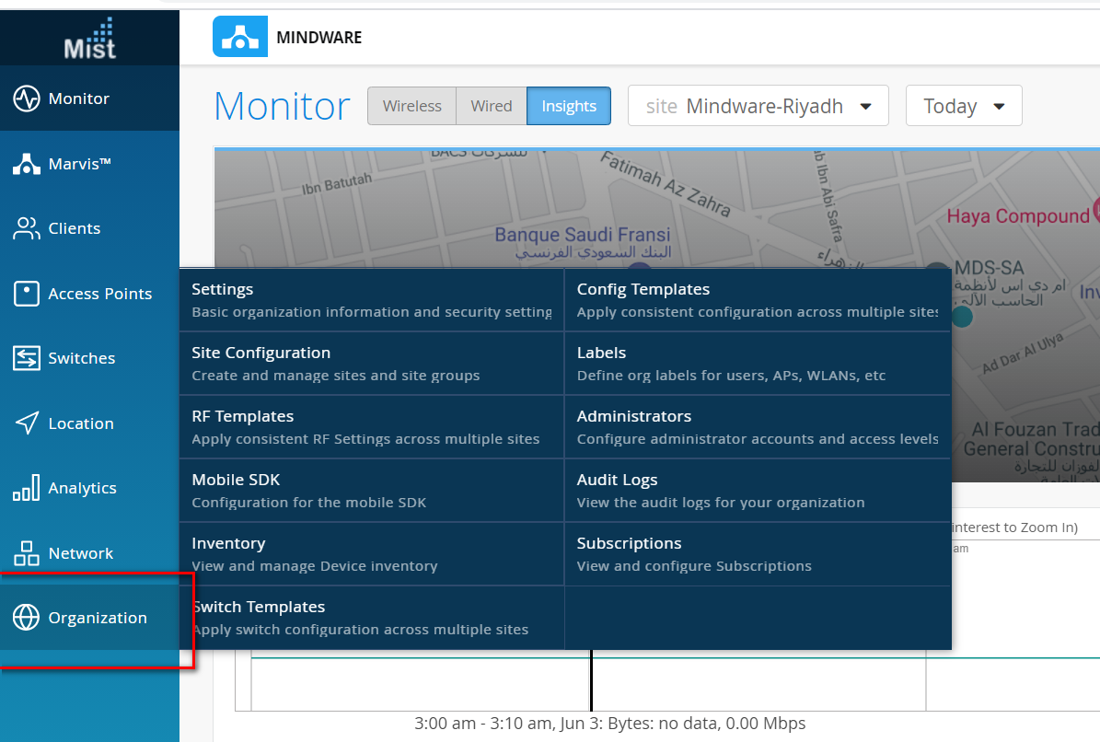

Configuration for sites done under Network and you can specify which site you want to apply to.
Sites can be grouped under a site group.
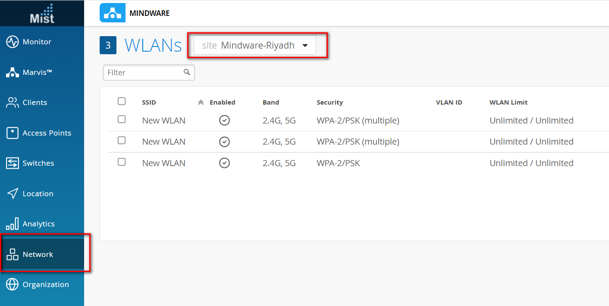

You can configure labels under Organization and Sites. Configs for Organization can only use organization labels and same thing for sites.

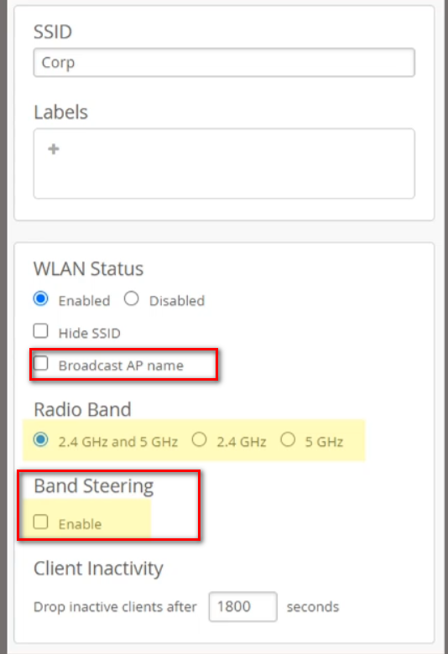
Once you hide SSID, it will not respond to probe requests and will not show in the list of available SSIDs on the devices. It is not consider a secure way to protect your SSID since anybody with a protocol analyzer can know the SSID name.
If you enable Broadcast AP name, this will advertise the AP name in the SSID and this will only be seen by WiFi tools, this is usually used for site surveys where you want to know what AP is broadcasting the SSID.
If you choose “2.4GHz and 5 GHz” this will enable dual band SSID and will broadcast the same SSID on both bands. When you choose this option it is preferred to enable band steering which tries to steer client to use 5GHz instead of 2.4GHz, but is not successful always.

Configure the user vlan of WLAN:
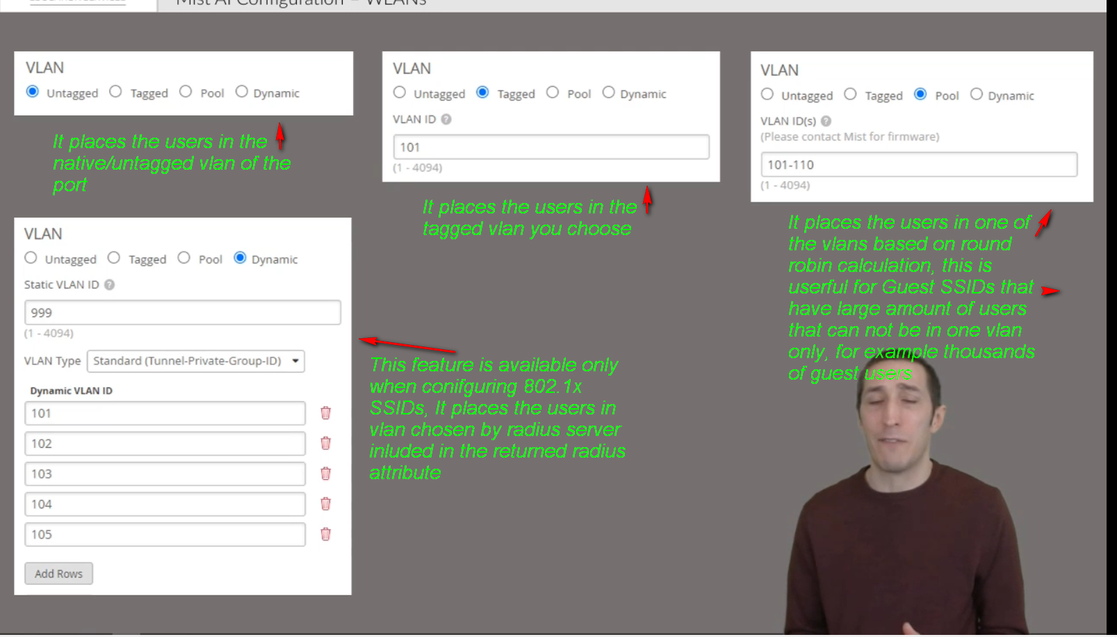

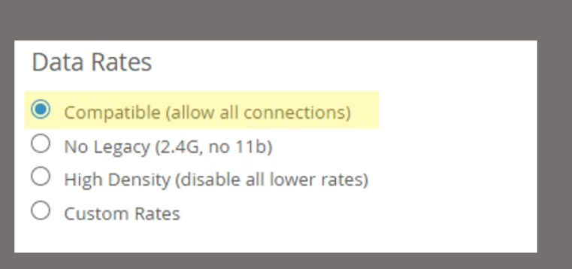
1- Compatible: it allows all types of data rates and insures that all legacy devices are supported, but at a cost that enabling slow rates affect the performance. For example, 802.11b has 22 MHz channels that overlap with the 20MHz channels of the rest of 802.11 amendments.
2- No Legacy disables the 802.11b data rates (1, 2, 5.5 and 11 mpbs)
3- High Density: it disables all data rates lower than 18 Mbps; this encourages clients to roam in high density of deployed APs.
4- Custom rates: allows you to enable or disable certain chosen rates shown below:
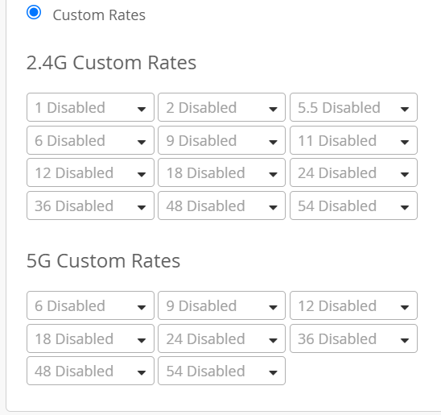

Mist Security:
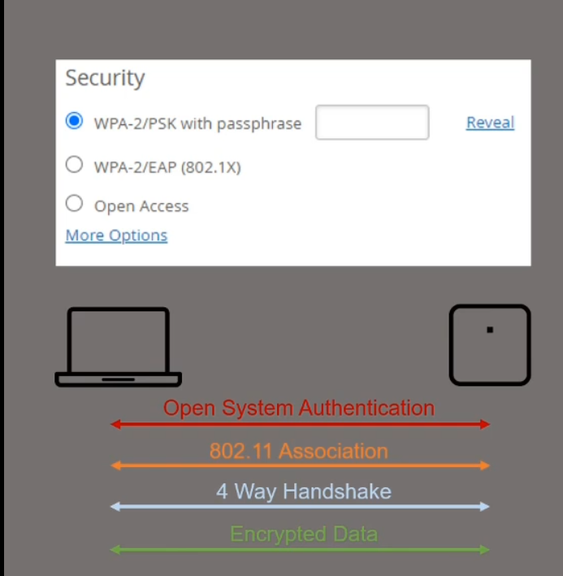

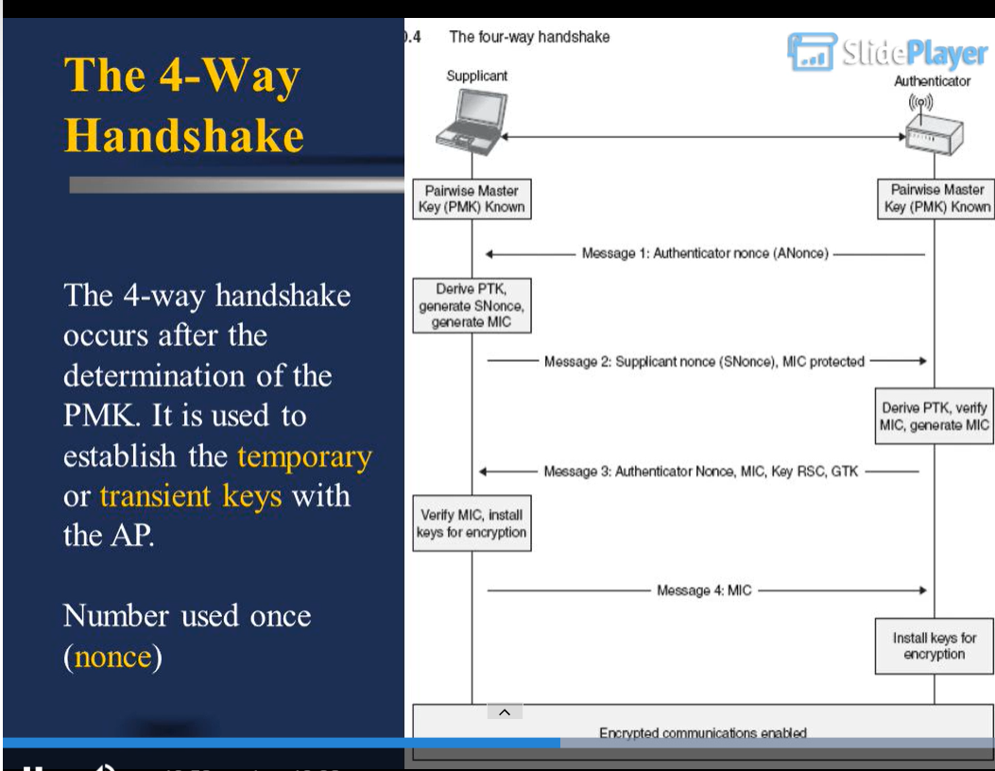
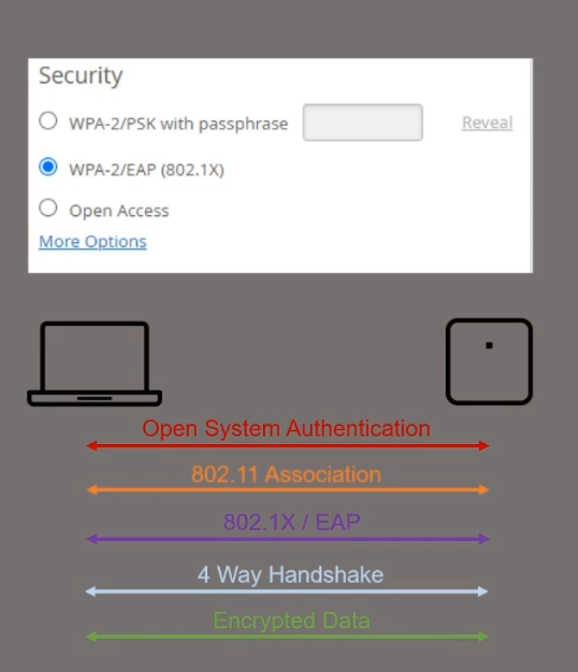

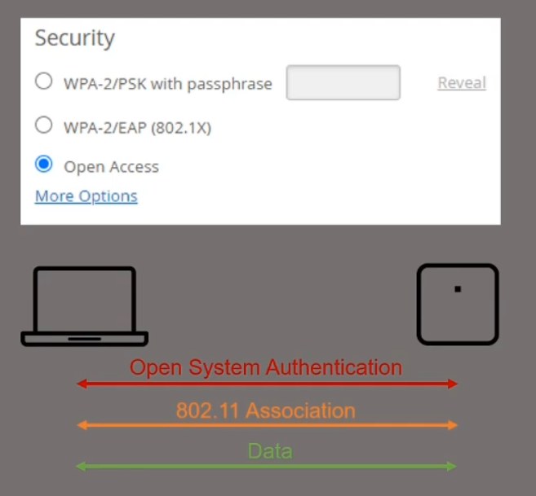

You can use multiple passwords for the same SSID and assign each password to one or group of users.
It is very useful for IoT devices that don’t support 802.11x since we configure the password and link it to a specific MAC address
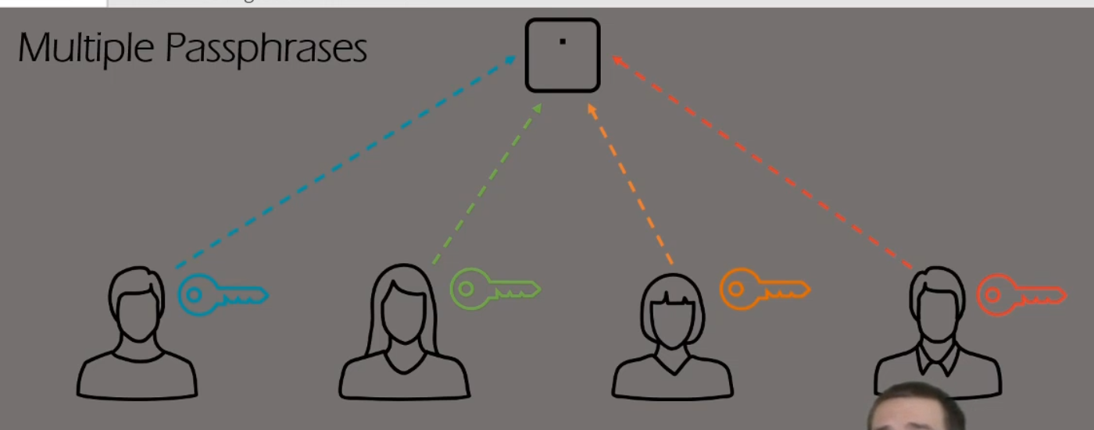

If we enable Personal WLANs (this feature is available only if enable multiple passphrases) then all the devices sharing the same PSK will be able to communicate together, however they are prohibited to communicate with other users having a different PSK.
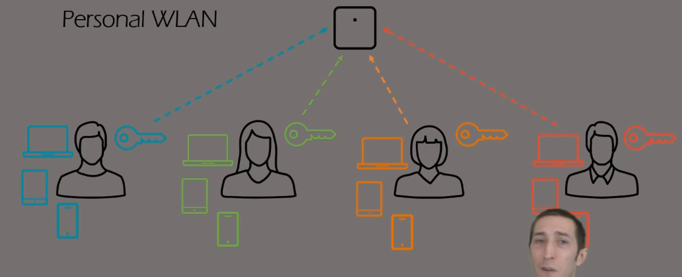

Guest Captive Portal:
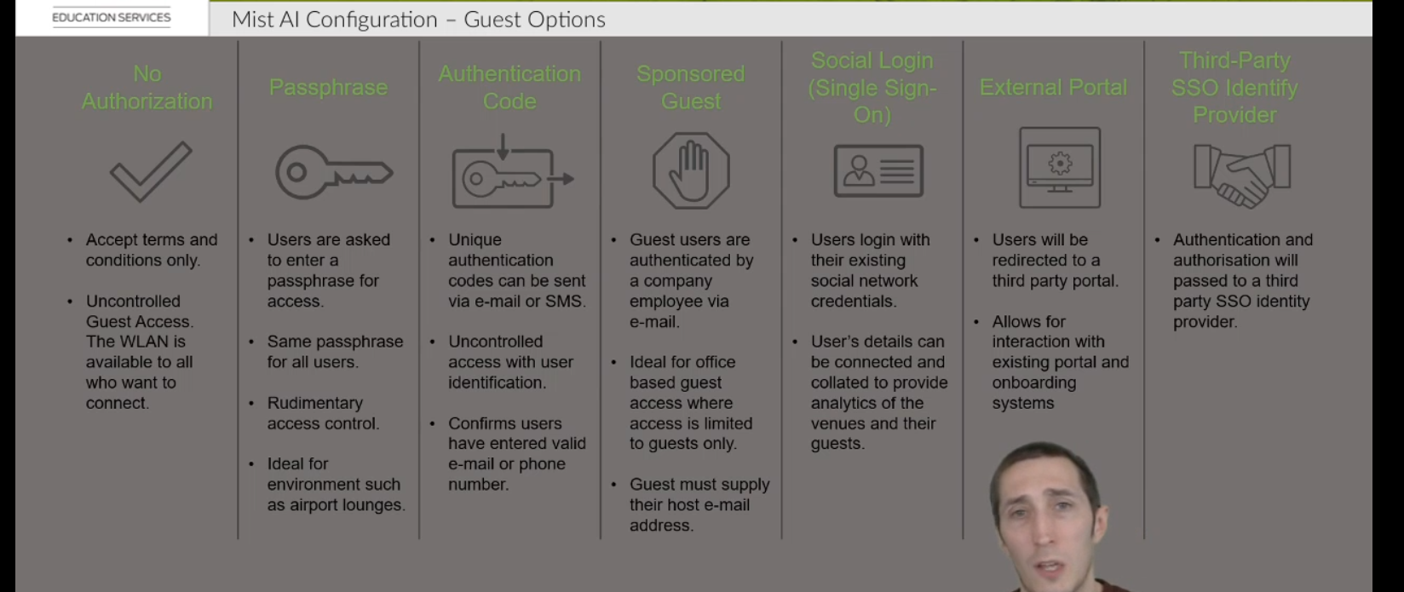

6- WLAN Monitoring

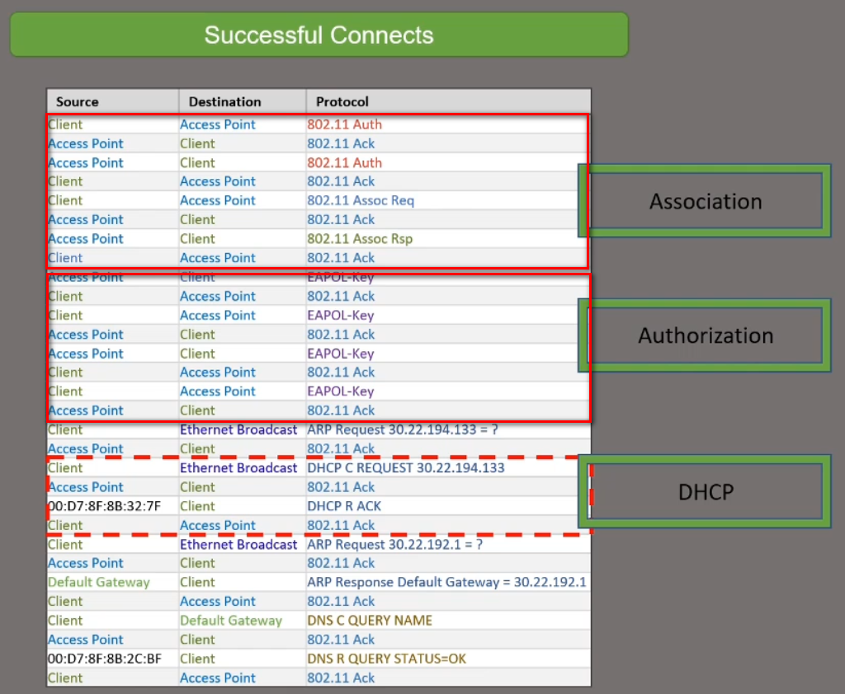
DHCP classifier check if the client received an IP
Authorization classifier checks if the client has gone through 802.1x EAP or PSK Authentication
Association classifier checks if the client has gone through 802.11 Authentication and Association

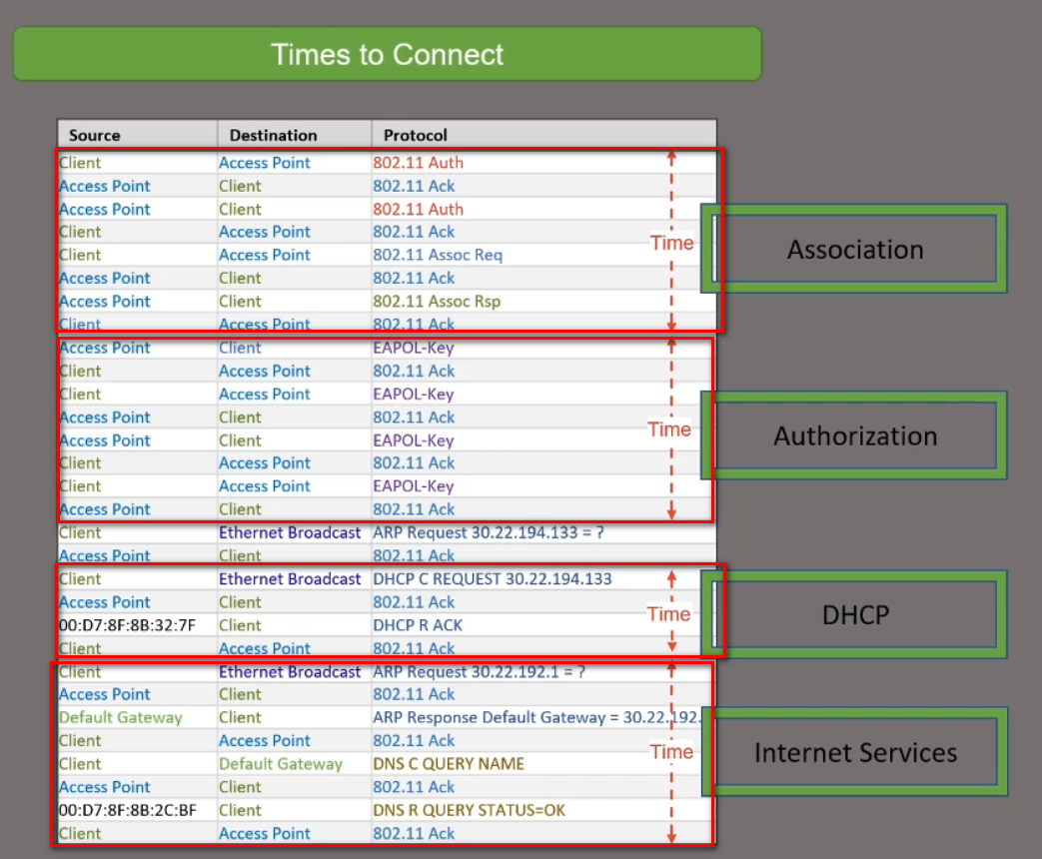
Association classifier checks the time it took the client to go through 802.11 Authentication and Association
DHCP classifier check the time it took the client to receive an IP
Authorization classifier checks the time it took the client to go through 802.1x EAP or PSK Authentication

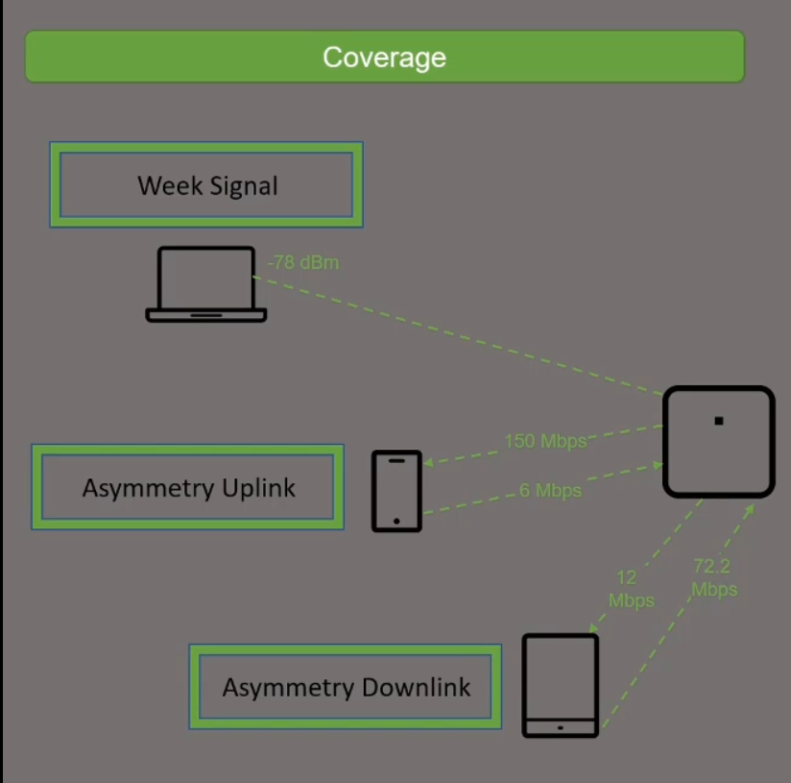
This SLE is to check if you have enough APs

Asymmetry indicates there is a power level mismatch between the client & AP. Since APs are capable of higher power levels than a client, if power levels are set too high, then there is a chance that the low powered client is not heard by the AP, resulting in an asymmetry uplink issue.

As the received signal strength gets lower it gets closer to the background noise level. This makes it more difficult for the radio in your device to differentiate between the desired signal and the noise. Eventually data errors occur and the data bits need to be resent thus slowing down the data speed. Radios can also negotiate a slower speed with the wireless access point to improve the reliability of the data.

1- Better signal strength implies higher Signal to Noise Ratio (SNR) at the receiver, and thus less errors (more number of successful transmissions);
2- The maximum achievable data rate depends on SNR Shannon–Hartley theorem. So for a fixed error rate, the data rate can be increased as signal strength increases.
3- Increasing the SNR makes the transmitted symbols more robust against noise and produces a stronger RF link. This allows for more advanced modulation methods and increases the amount of data transmitted, i.e. better videos and less errors.
Different modulation schemes (Data Rates) are applied for different signal levels.
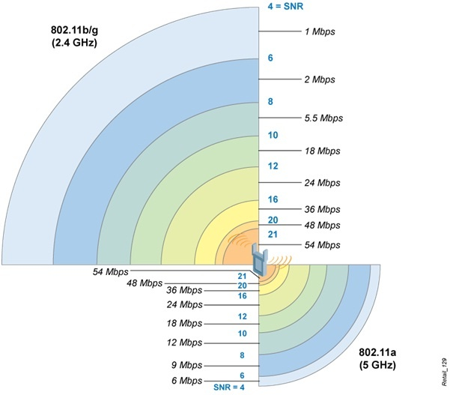

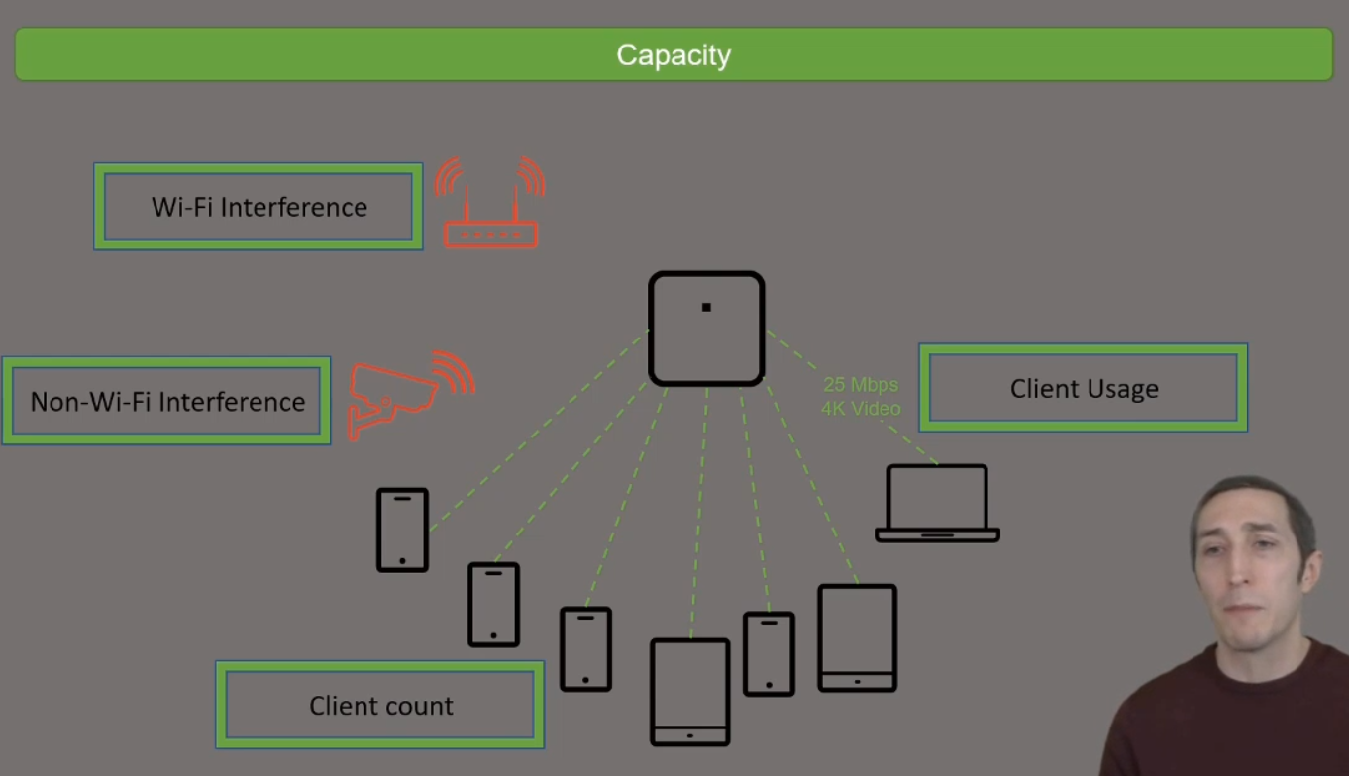
Capacity means is there enough RF lest in the channel for more users.
Wireless capacity relates to the number of users who can use your wireless simultaneously in one place, and how (and at what rate) they are using bandwidth. ... In these locations it's important to maximise WiFi capacity to meet the needs of all users in the network, taking into account potential traffic at peak hours
If once user is consuming huge data then this will affect the RF availability for others.
This SLE measure the amount of time it takes a user successfully roam to another AP.
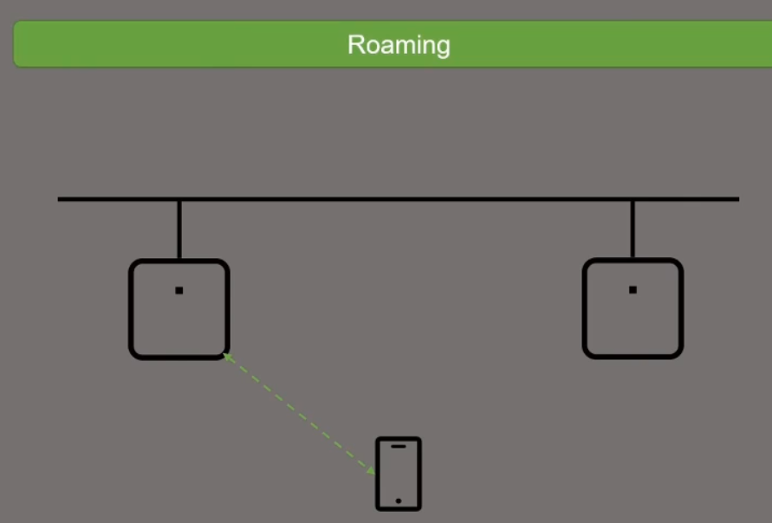

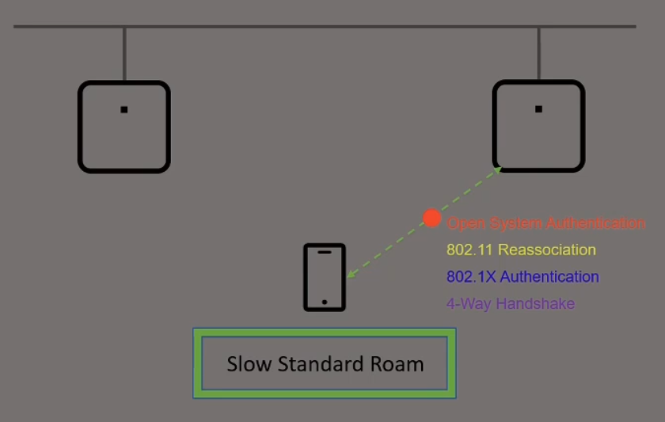
It measures the time for the client to perform a full standard roam including the four steps mentioned.

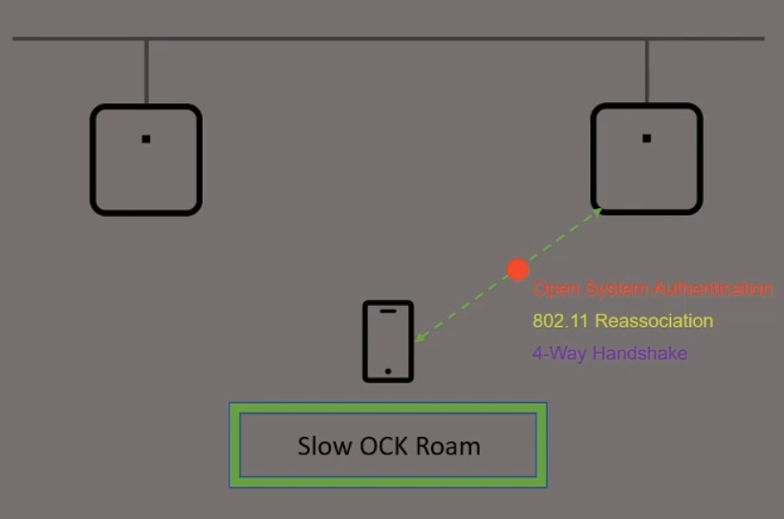
It measures the time for the client to perform OCK roam including the three steps mentioned. OCK skips the 802.1x authentication for faster roaming

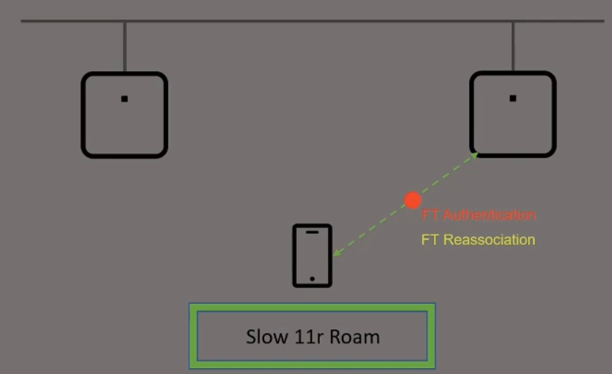
It measures the time for the client to perform OCK roam including the two steps mentioned. 802.11r skips the 802.1x authentication for faster roaming and merges the 4-way handshake in the frames on the two steps mentioned.

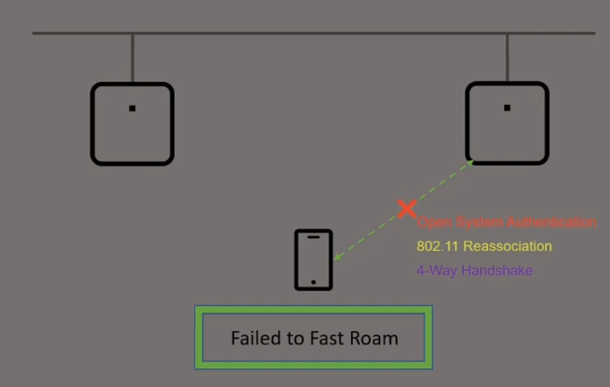
It looks for situations where the client tried to fast roam and fails

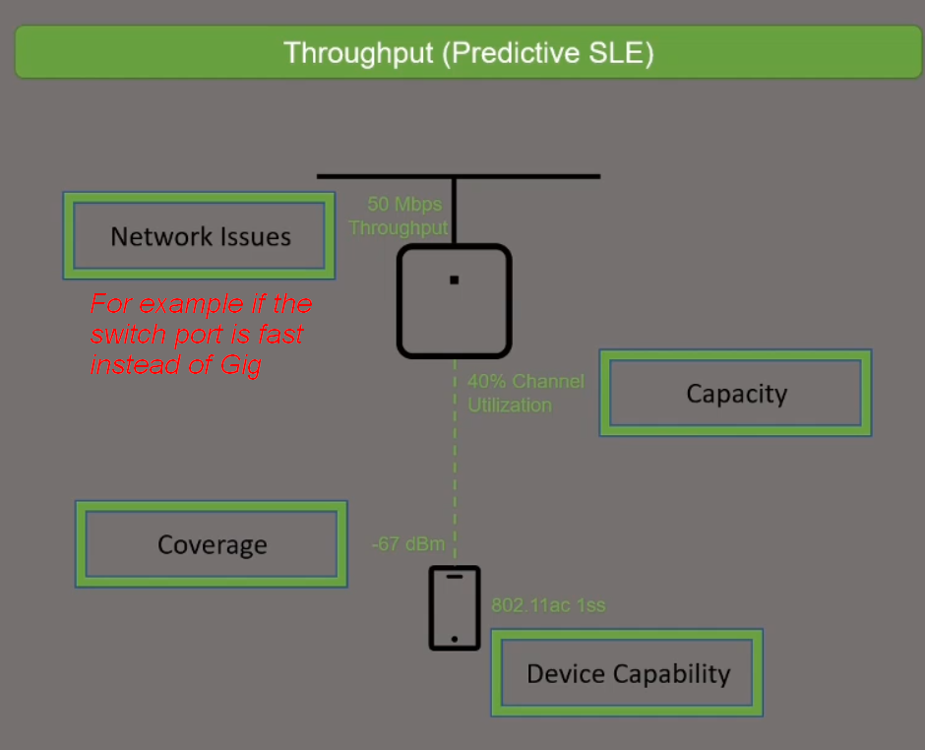

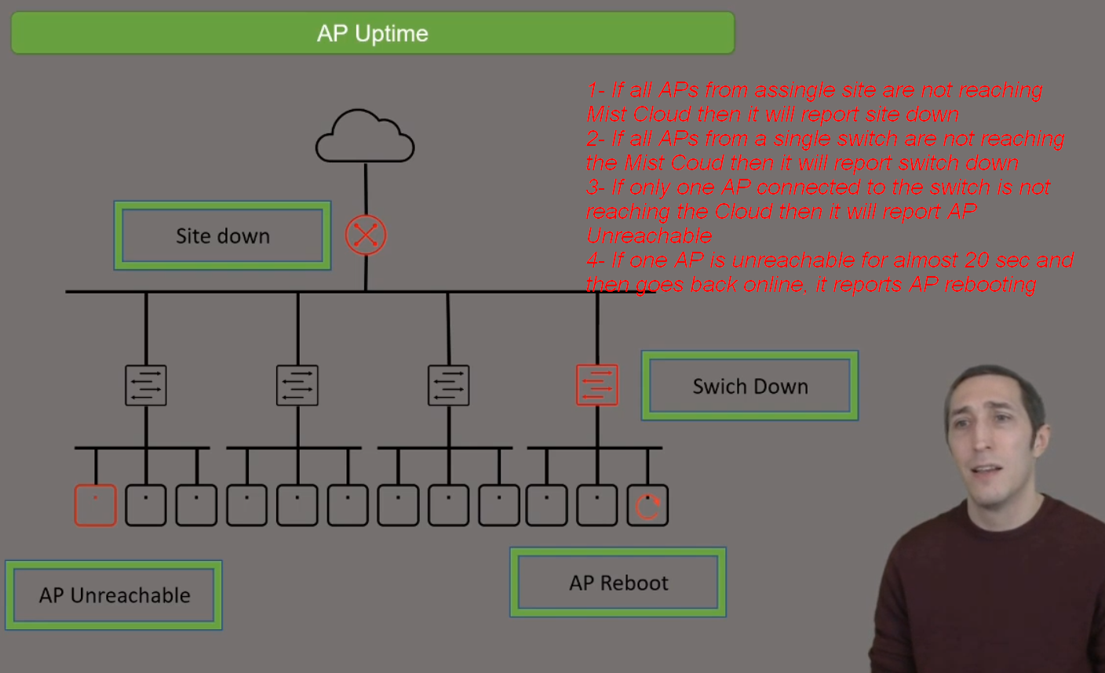

7- Wired Assurance

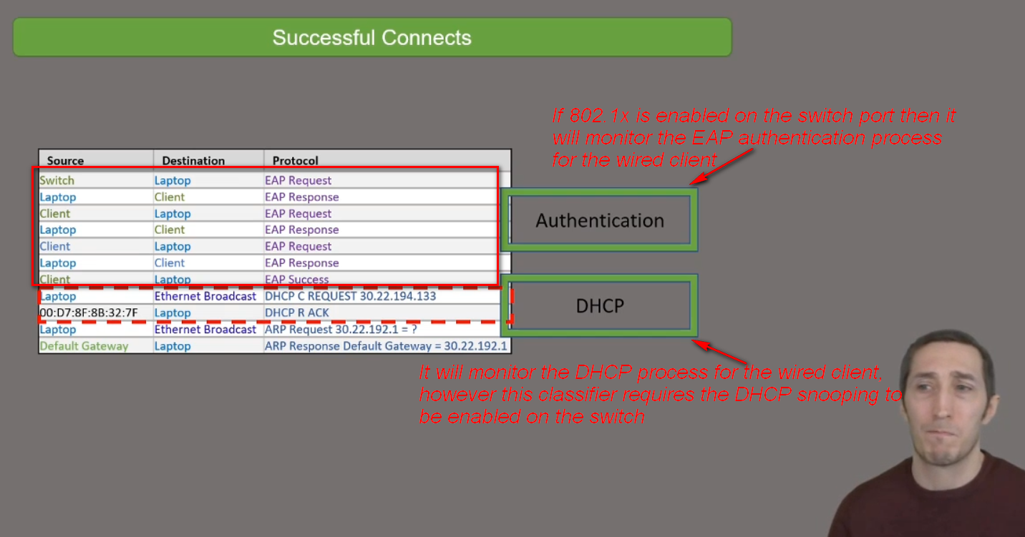

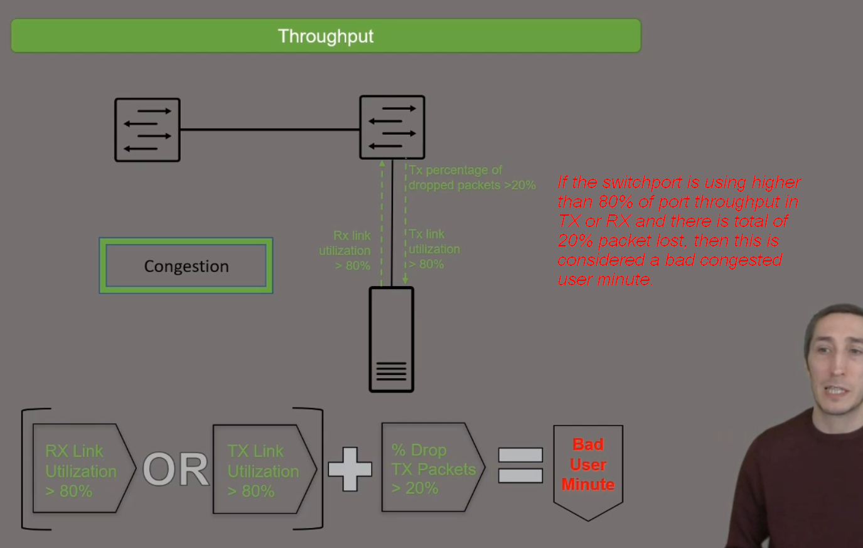

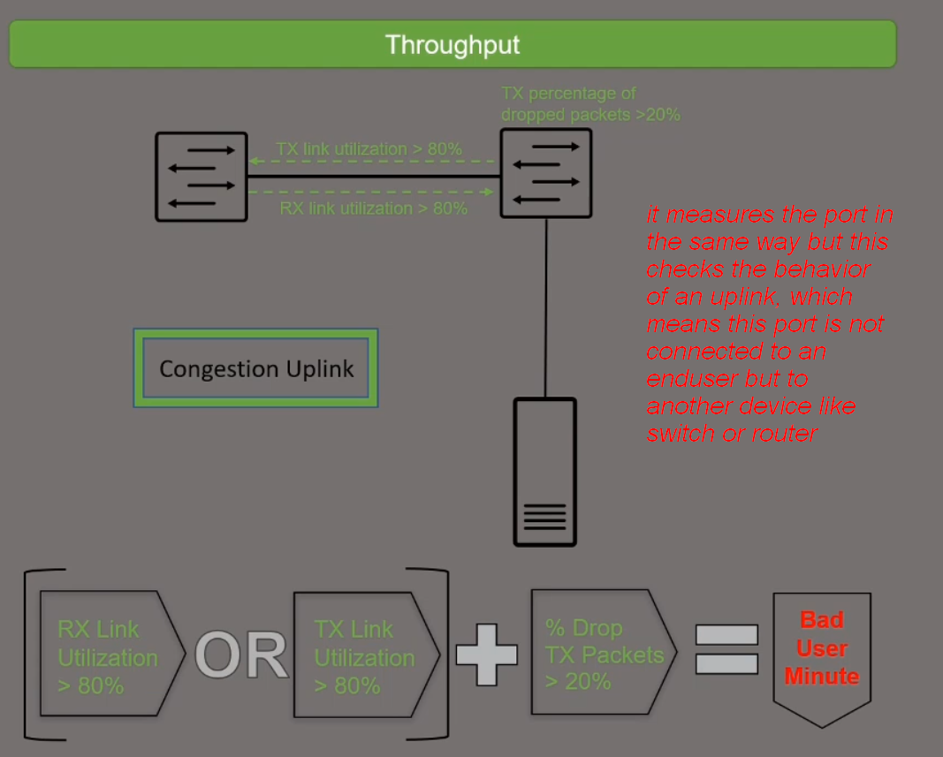

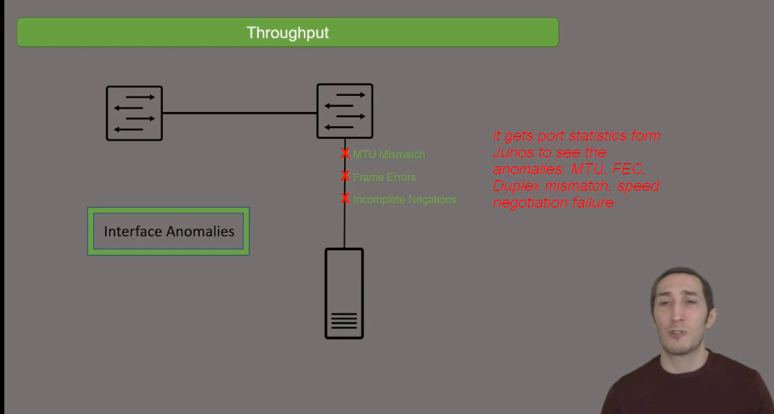
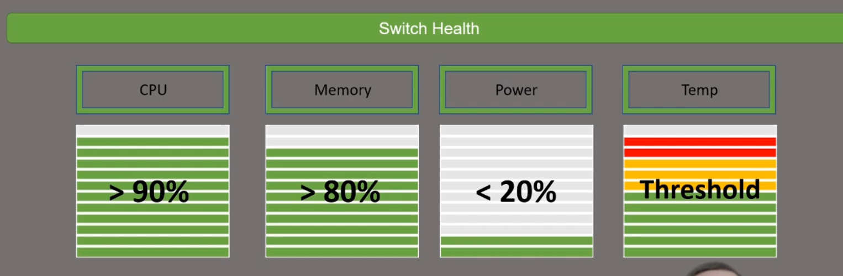

API Options to Communicate with MIST:
