Error Details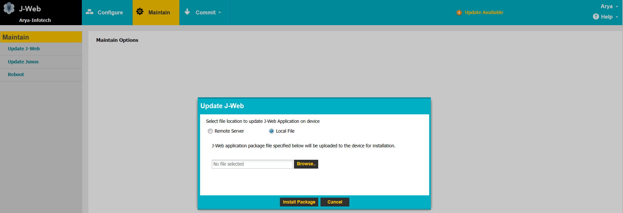
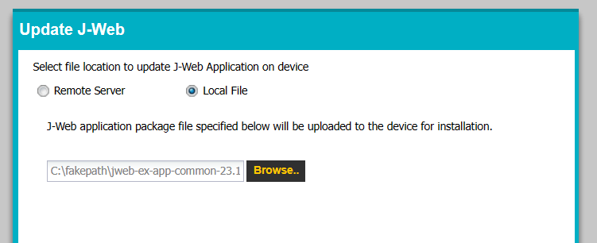
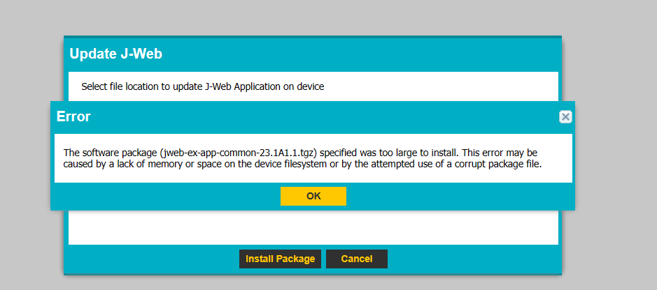
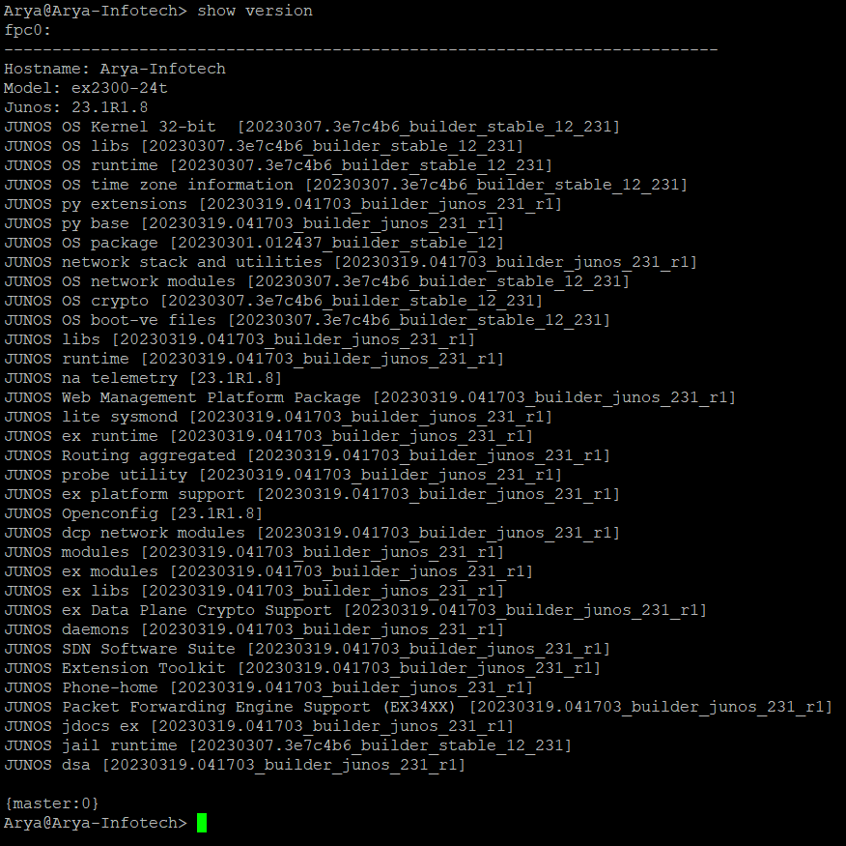
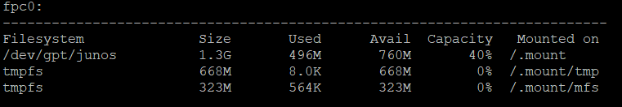
Current switch configuration
services {
ssh {
root-login allow;
client-alive-count-max 5;
client-alive-interval 20;
}
telnet {
connection-limit 5;
rate-limit 150;
}
netconf {
ssh;
rfc-compliant;
yang-compliant;
}
web-management {
http {
interface irb.10;
}
}
}
auto-snapshot;
time-zone Asia/Kolkata;
syslog {
file interactive-commands {
interactive-commands any;
}
file messages {
any notice;
authorization info;
}
}
processes {
dhcp-service {
traceoptions {
file dhcp_logfile size 10m;
level all;
flag packet;
}
}
}
}
chassis {
redundancy {
graceful-switchover;
}
}
interfaces {
ge-0/0/0 {
unit 0 {
family ethernet-switching {
vlan {
members 222;
}
storm-control default;
}
}
}
ge-0/0/1 {
description Venus;
unit 0 {
family ethernet-switching {
vlan {
members 222;
}
storm-control default;
}
}
}
ge-0/0/2 {
description Mercury;
unit 0 {
family ethernet-switching {
vlan {
members 222;
}
storm-control default;
}
}
}
ge-0/0/3 {
description Chandan-Nagar;
unit 0 {
family ethernet-switching {
vlan {
members 222;
}
storm-control default;
}
}
}
ge-0/0/4 {
description Siddharth-chwal;
unit 0 {
family ethernet-switching {
vlan {
members 222;
}
storm-control default;
}
}
}
ge-0/0/5 {
description "Rajesh Dubey";
unit 0 {
family ethernet-switching {
vlan {
members 222;
}
storm-control default;
}
}
}
ge-0/0/6 {
description Shekhar-Anna;
unit 0 {
family ethernet-switching {
vlan {
members 222;
}
storm-control default;
}
}
}
ge-0/0/7 {
description Mumbai-Bank;
unit 0 {
family ethernet-switching {
vlan {
members 222;
}
storm-control default;
}
}
}
ge-0/0/8 {
unit 0 {
family ethernet-switching {
vlan {
members 222;
}
storm-control default;
}
}
}
ge-0/0/9 {
unit 0 {
family ethernet-switching {
vlan {
members 222;
}
storm-control default;
}
}
}
ge-0/0/10 {
unit 0 {
family ethernet-switching {
vlan {
members 222;
}
storm-control default;
}
}
}
ge-0/0/11 {
unit 0 {
family ethernet-switching {
vlan {
members 222;
}
storm-control default;
}
}
}
ge-0/0/12 {
unit 0 {
family ethernet-switching {
interface-mode access;
vlan {
members 222;
}
storm-control default;
}
}
}
ge-0/0/13 {
unit 0 {
family ethernet-switching {
storm-control default;
}
}
}
ge-0/0/14 {
unit 0 {
family ethernet-switching {
storm-control default;
}
}
}
ge-0/0/15 {
unit 0 {
family ethernet-switching {
storm-control default;
}
}
}
ge-0/0/16 {
unit 0 {
family ethernet-switching {
storm-control default;
}
}
}
ge-0/0/17 {
unit 0 {
family ethernet-switching {
storm-control default;
}
}
}
ge-0/0/18 {
unit 0 {
family ethernet-switching {
storm-control default;
}
}
}
ge-0/0/19 {
unit 0 {
family ethernet-switching {
storm-control default;
}
}
}
ge-0/0/20 {
unit 0 {
family ethernet-switching {
storm-control default;
}
}
}
ge-0/0/21 {
unit 0 {
family ethernet-switching {
storm-control default;
}
}
}
ge-0/0/22 {
unit 0 {
family ethernet-switching {
interface-mode access;
vlan {
members default;
}
storm-control default;
}
}
}
ge-0/0/23 {
unit 0 {
family ethernet-switching {
vlan {
members IT;
}
storm-control default;
}
}
}
ge-0/1/0 {
unit 0 {
family ethernet-switching {
storm-control default;
}
}
}
xe-0/1/0 {
unit 0 {
family ethernet-switching {
storm-control default;
}
}
}
ge-0/1/1 {
unit 0 {
family ethernet-switching {
storm-control default;
}
}
}
xe-0/1/1 {
unit 0 {
family ethernet-switching {
storm-control default;
}
}
}
ge-0/1/2 {
unit 0 {
family ethernet-switching {
storm-control default;
}
}
}
xe-0/1/2 {
unit 0 {
family ethernet-switching {
storm-control default;
}
}
}
ge-0/1/3 {
description Input;
unit 0 {
family ethernet-switching {
interface-mode trunk;
vlan {
members 222-223;
}
storm-control default;
}
}
}
xe-0/1/3 {
unit 0 {
family ethernet-switching {
storm-control default;
}
}
}
irb {
unit 0 {
family inet {
dhcp {
vendor-id Juniper:ex2300-24t:JZ0217250019;
}
}
family inet6 {
dhcpv6-client {
client-type stateful;
client-ia-type ia-na;
client-identifier duid-type duid-ll;
vendor-id Juniper:ex2300-24t:JZ0217250019;
}
}
}
unit 10 {
family inet {
address 10.0.0.2/8;
}
}
}
vme {
unit 0 {
family inet {
dhcp {
vendor-id Juniper:ex2300-24t:JZ0217250019;
}
}
family inet6 {
dhcpv6-client {
client-type stateful;
client-ia-type ia-na;
client-identifier duid-type duid-ll;
vendor-id Juniper:ex2300-24t:JZ0217250019;
}
}
}
}
}
forwarding-options {
storm-control-profiles default {
all {
no-broadcast;
no-unknown-unicast;
no-multicast;
}
}
}
protocols {
router-advertisement {
interface vme.0;
interface irb.0;
}
lldp {
interface all;
}
lldp-med {
interface all;
}
igmp-snooping {
vlan default;
}
rstp {
interface ge-0/0/0;
interface ge-0/0/1;
interface ge-0/0/2;
interface ge-0/0/3;
interface ge-0/0/4;
interface ge-0/0/5;
interface ge-0/0/6;
interface ge-0/0/7;
interface ge-0/0/8;
interface ge-0/0/9;
interface ge-0/0/10;
interface ge-0/0/11;
interface ge-0/0/12;
interface ge-0/0/13;
interface ge-0/0/14;
interface ge-0/0/15;
interface ge-0/0/16;
interface ge-0/0/17;
interface ge-0/0/18;
interface ge-0/0/19;
interface ge-0/0/20;
interface ge-0/0/21;
interface ge-0/0/22;
interface ge-0/0/23;
interface ge-0/1/0;
interface xe-0/1/0;
interface ge-0/1/1;
interface xe-0/1/1;
interface ge-0/1/2;
interface xe-0/1/2;
interface ge-0/1/3;
interface xe-0/1/3;
}
loop-detect;
}
vlans {
IT {
description "Management ID";
vlan-id 10;
l3-interface irb.10;
}
Vikhroli-Office {
vlan-id 222;
}
WNET-Office {
vlan-id 223;
}
default {
vlan-id 1;
l3-interface irb.0;
}
}

