Site A firewall Configuration
Disabled Interface monitor for Ethernet3/0 under NSRP interface monitoring
Enabled Track IP under ethernet3/0 interface>Monitor
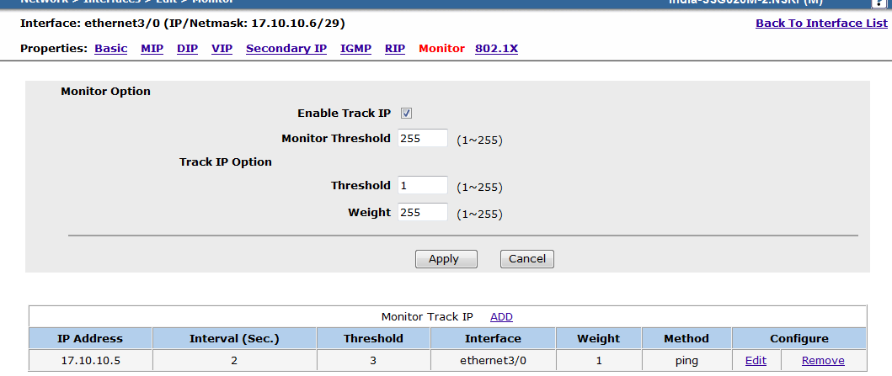
Routes for Site B
set route 192.168.88.0/21 interface ethernet3/0 gateway 17.10.10.5
set route 10.135.80.0/24 interface ethernet3/0 gateway 17.10.10.5
set route 10.0.84.0/22 interface ethernet3/0 gateway 17.10.10.5

Backup Routes for Site B
set route 192.168.88.0/21 interface tunnel.24 metric 2
set route 10.0.84.0/22 interface tunnel.24 metric 2
set route 10.135.80.0/24 interface tunnel.24 metric 2

Interface Configuration
set interface "ethernet3/0" zone "Trust"
set interface ethernet3/0 ip 17.10.10.6/29
set interface ethernet3/0 nat
set interface ethernet3/0 manage-ip 17.10.10.4
set interface ethernet3/0 monitor track-ip ip
set interface ethernet3/0 monitor track-ip ip 17.10.10.5 interval 2
unset interface ethernet3/0 monitor track-ip dynamic

Site B firewalls configuration

Disabled Ethernet3/0 interface monitor under NSRP
Enabled Track IP under ethernet3/0 interface>Monitor
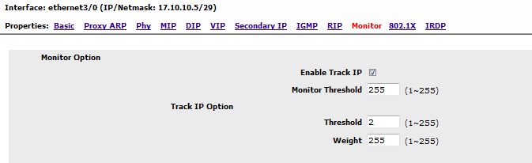
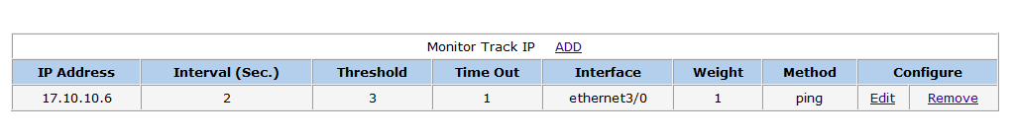

Static Routes for Site A
set route 192.168.160.0/21 interface ethernet3/0 gateway 17.10.10.6
set route 192.168.159.0/24 interface ethernet3/0 gateway 17.10.10.6
set route 192.168.116.0/24 interface ethernet3/0 gateway 17.10.10.6

Backup Routes for Site A
set route 192.168.160.0/21 interface tunnel.20 metric 2 description "Backup route for P2P link"
set route 192.168.48.0/21 interface tunnel.20 metric 2
set route 192.168.159.0/24 interface tunnel.20 metric 2

Interface Configuration
set interface "ethernet3/0" zone "Trust"
set interface ethernet3/0 ip 17.10.10.5/29
set interface ethernet3/0 nat
set interface ethernet3/0 monitor track-ip ip
set interface ethernet3/0 monitor track-ip threshold 2
set interface ethernet3/0 monitor track-ip ip 17.10.10.6 interval 2
unset interface ethernet3/0 monitor track-ip dynamic

