Starting at Junos version 15.1x53-D59.4 or 18.1…

Under Protocols remove layer2-control, nonstop-bridging for EX2300 only.

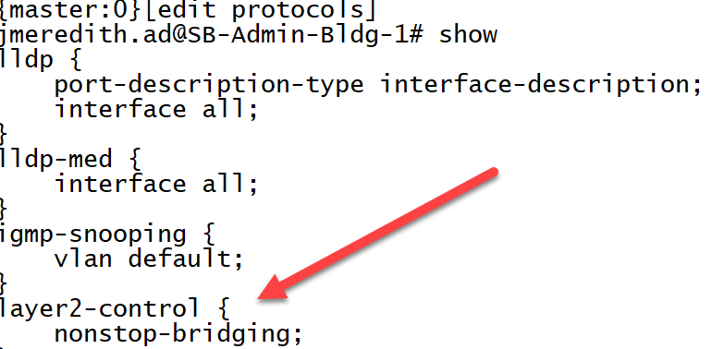

Under routing-options remove nonstop-routing for EX2300 only and only if it is there to be removed

Check time on all members using show system uptime be sure time is coordinated on all devices. This is most important when the unit is out of the box.

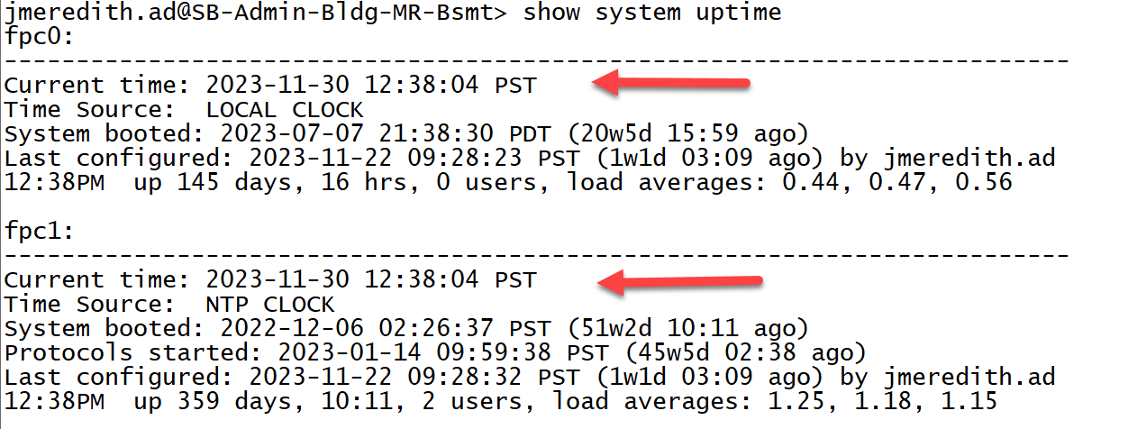

Perform system storage cleanup by entering the following commands:
root@juniper> request system storage cleanup -- be sure to use all-members at the end of the command when working with a stack

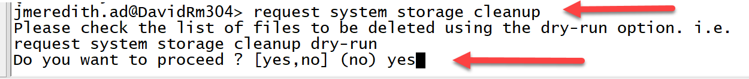
Type yes and hit enter

Once you hit enter below is just a sampling of what you might see. Note the red arrow pointing at fpc0, this clean up process will be for each member. So for a two member stack you will see fpc0, fpc1 and so on.

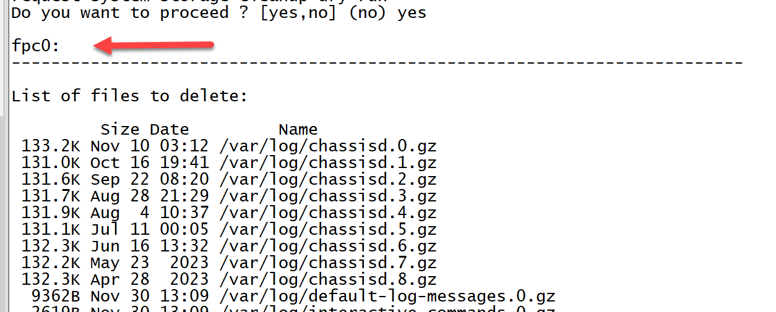

root@juniper> request system snapshot delete snap -- be sure to use all-members at the end the of the command and when working with a stack
Below is typically what you would see after entering the above command
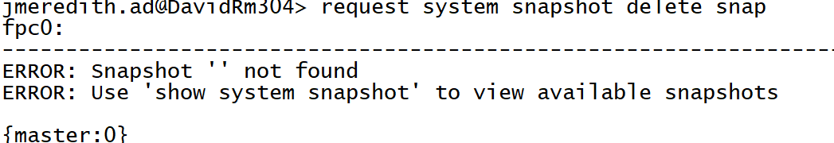

- Then check each member for any older versions of Junos packages that have been placed on the device. If there are any other packages other than the active one remove them from each member.

To check each member for older version of Junos follow the below process:

Enter the shell at the > prompt use start shell user root command and enter the root password.
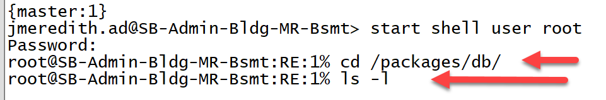
At the RE:0% Enter cd /packages/db/
Hit enter
Then Enter ls -l

If you see more than the active Junos then you must remove the older one from each switch.
Below is just a sample output.
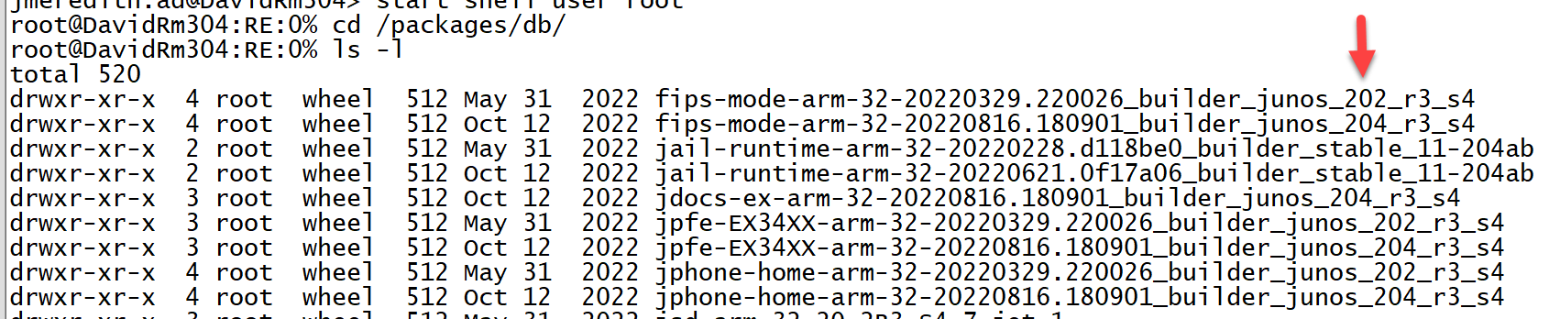

To remove old files perform the following steps on each member of a stack.
At the RE:0% Enter pkg setop rm previous
At the RE:0% Enter pkg delete old

Once you perform these steps enter ls -l again as you see below the older version of Junos 202_r3-s4 has been removed

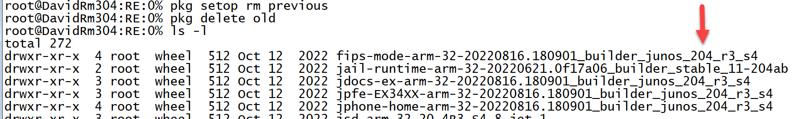

Once you have removed the older Junos from member 0 you will need to go back to the CLI.
At the RE:0% type exit then at the > prompt enter request session member 1 then enter the shell as you did above. You are now in the next member switch.

Then remove the older Junos files using the same commands above starting. After performing these steps you are now ready copy new files to your device.

- IMPORTANT: During my testing I performed this process twice. Once to prepare the switch for files and second after I upgraded to Junos 18.2.

The following procedure allow users to mount a USB device on EX/J/SRX/MX devices. This can be helpful if network connectivity is unavailable and you need to copy files to or from the device.

- Enter the shell as root:
  - user@switch> start shell user root
  - Password:
  - root@switch%

- Before inserting the USB device, perform the following:
  - root@% ls /dev/da*

Output of the command above
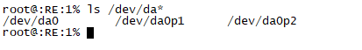

- Insert the USB drive in the USB port. The following output will be displayed:
  - root@% umass1: TOSHIBA TransMemory, rev 2.00/1.00, addr 3 da2 at umass-sim1 bus 1 target 0 lun 0 da2: Removable Direct Access SCSI-0 device da2: 40.000MB/s transfers da2: 983MB (2013184 512 byte sectors: 64H 32S/T 983C)
Enter ls /dev/da* at the root@%
Below should be output

Note: '/dev/da1s1' is the USB drive.

- Create a directory for the USB drive to mount to:
  - root@% mkdir /var/tmp/usb

- Mount the USB drive to the /var/tmp/usb directory:
  - root@% mount_msdosfs /dev/da2s1 /var/tmp/usb
  - root@% ls /var/tmp/usb images.tgz

Note: 'ls /var/tmp/usb' will show all the files in the USB drive.

- Copy any of the USB files to the /var/tmp/usb directory:
  - root@% cp /var/tmp/usb/images.tgz /var/tmp

Note: when upgrading to 18.2 you need to copy the os-package and package-hooks-ex in the same manor above
When coping all three files it can take a total time of about 3 minutes so be patient and wait for the prompt
  - root@% ls /var/tmp images.tgz

Note: 'ls /var/tmp/' will show all the files in the tmp location.

If all the files have been successfully copied form the usb to the /var/tmp location then remove the USB by performing the following step.

- Now unmount the USB drive after the file is completely copied:
  - root@% umount /var/tmp/usb
Once you enter the command you will see some sort of output below this is normal

root@% umass1: at uhub0 port 1 (addr 3) disconnected (da1:umass-sim1:1:0:0): lost device (da1:umass-sim1:1:0:0): removing device entry umass1: detached

Note: Wait about seven seconds to pull the usb out of the device

Adding new software to a Junos device:

Once you have copied the necessary files to your Junos device we must add the software and reboot the device to activate the new Junos

Install the two packages by using the request system software add" command:

root@juniper> request system software add /var/tmp/os-package.tgz
root@juniper> request system software add /var/tmp/package-hooks-ex.tgz
Adding these two only take seconds
Install the Junos OS release software by using the no-copy, unlink, and force options under the request system software add command:
root@juniper> request system software add /var/tmp/junos-arm-32-18.2.R3-S2.9.tgz force unlink no-copy
NOTE: If running virtual chassis remove the no-copy this will Allow software to be pushed to other switches.

Important: Once you have upgraded to 18.2.R3-S2.9 do not use the unlink command as your Junos will not copied to other members in the stack

The process of adding a new software can take up to 20 minutes (In my test I used a stack of two) so times may vary.

Once the new software has been added you will need to reboot all members in the stack. The reboot can take up to 10 minutes

Once the stack is up and you are on Junos version 18.2.R3-S2.9 you will need to remove the following:
os-package
package-hooks-platform

To delete the two packages by using the request system software delete command:
root@juniper> request system software delete os-package
root@juniper> request system software delete package-hooks-platform
Once the files have been removed you must reboot all members of the stack this could take between
7-10 minutes

Now that you are running on Junos 18.2.R3-S2.9 you will be using the force, no-validate command for Junos upgrades. DO NOT USE the unlink command this will not work and you will end up with a stack that us two different Junos versions.

Note: that when working remotely on devices that the login screen appears about 3 minutes before MST (Master) light appears on the master.

To move the next version of Junos we can go from 18.2.R3-S2.9 straight to whatever version we want (This is pending) When moving to the next version I did perform the following steps below. These are the same steps as above just abbreviated and does not include the os-packages or package-hooks-ex

- Perform storage clean up on all members
- Delete snap all members
- Check all members for old Junos versions if there are old version perform the same steps as above to remove older Junos versions from each switch in the stack
- Copy new Junos this will just over 1 minute
- Request software add, be sure to use the force, no-validate commands DO NOT USE the unlink command this will take maybe 10 minutes
- Request system reboot all-members to get to the login screen was about 12 minutes
- To have the Master (MST) light appear on the switch was about 3 minutes after that

